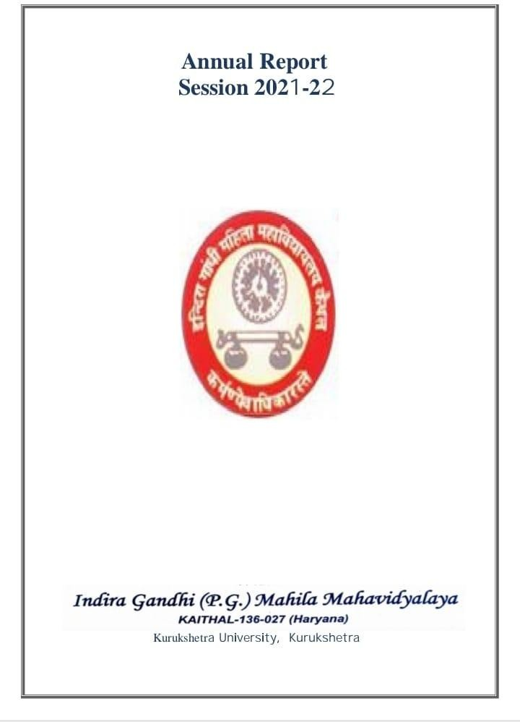
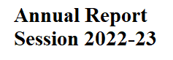
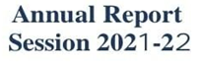
NAACAccrediationCertificateofCycle-1
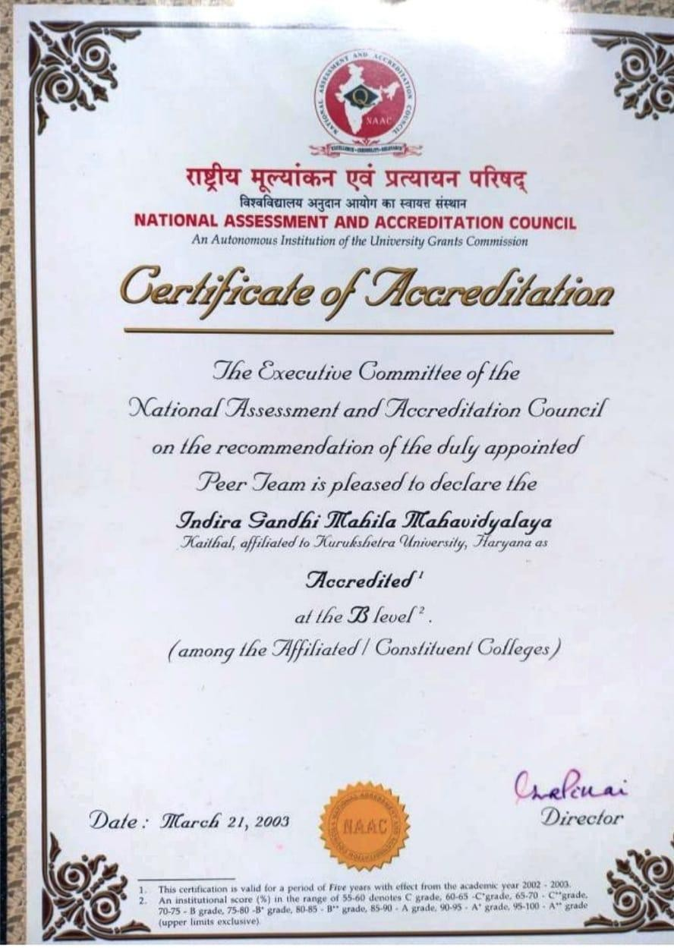

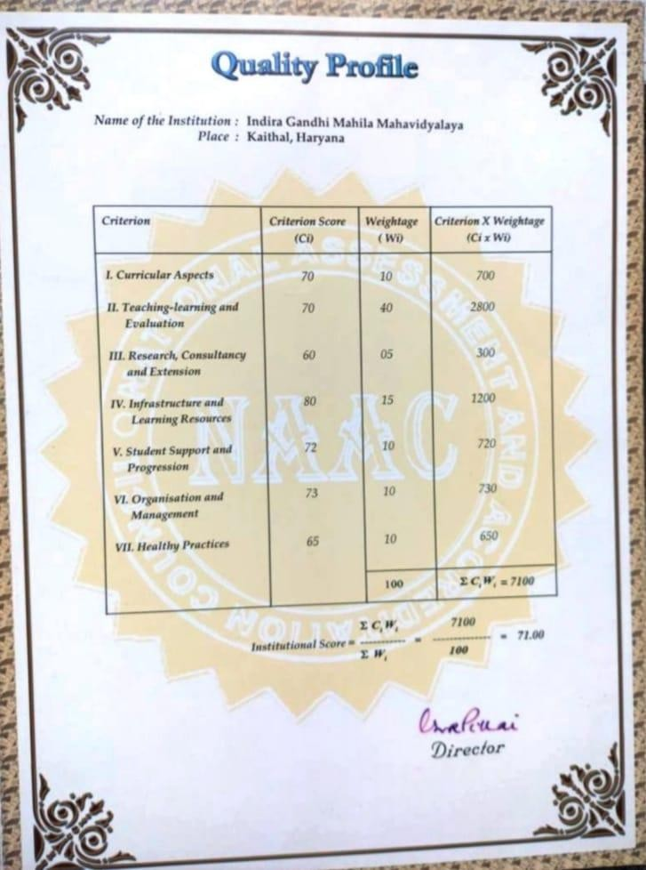

3

NAACAccrediationCertificateofCycle2

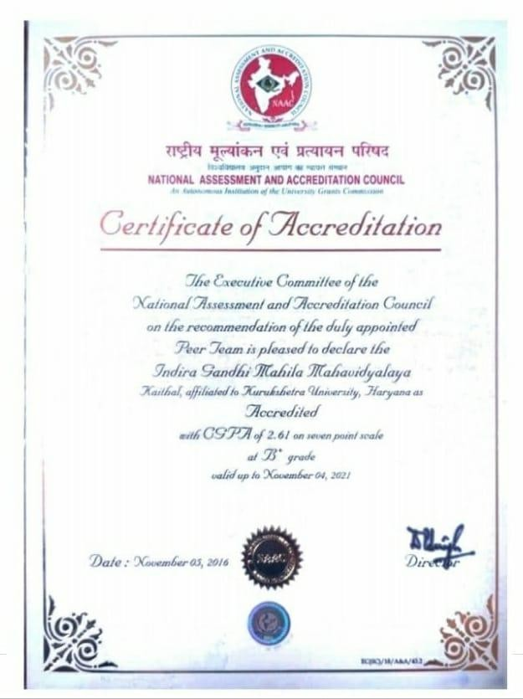

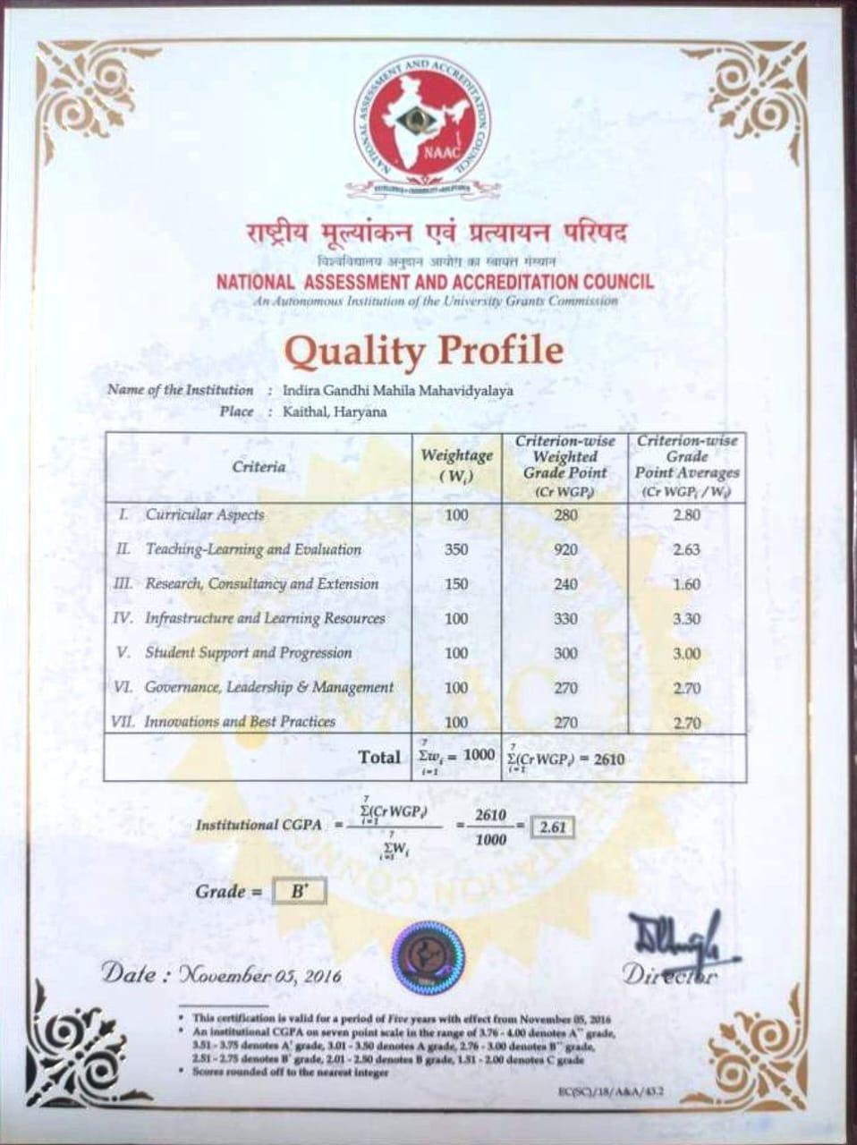

Smt. Indira Gandhi (Prime Minister of India)hasrightly said:
“Education is a liberating force and in our age it is also a democratizing force , cutting across the barriers of caste and class , smoothing but inequalities imposed by birth and other circumstances”
Indira Gandhi P.G Mahila Mahavidyalaya, a pioneer institute proving its excellence still without flinching by providing quality education for the last 52 years. Named after the name of a rare personality, Mrs. Indira Gandhi and established in 1970 by a great social activist and the then finance minister, Late (Smt.) Om Prabha Jain. In this challenging venture, she was supported by worthy members of Bal Shiksha Samiti Mahashai Brijlal, Sh. Ram Gopal Latka, Sh. Bhagwan Dass and Sh. Mohan Bahadur Khurania, advocate and liberal donor Seth Durga Prasad and others.The foundations tone of the college was laid by Sh. Bansi Lal, the then Chief Minister on 10th April, 1970.
In the very first year of its inception 200 girls were enrolled which was an encouraging start by our college. In the beginning it was affiliated to Panjab University, Chandigarh. Pre- University and B.A-1 and 2nd were immediately introduced and highly qualified staff was appointed. Three storied building of the college is designed by Sh. B.P Mathur, senior Architect of Panjab University, Chandigarh. In 1973 College Day was celebrated and synchronized with the birthday of our Prime Minister Smt. Indira Gandhi. This event was enlightened by the then Union Minister for Tourism and Civil Aviation Dr. Sarojni Mahishi.
In these five progressive decades of progression, our College possesses a group of well-equipped buildings: Administrative Block with software networking, Pt. ChiranjilalSharmaScienceBlock,NewconstructedBlock,ComputerizedLibrary, Smt, Om Prabha Jain Commercial Art block, Lala Amarnath Khurania Commerce Block, Multipurpose Block, Evening Block, Sport Room, NSS Room, Auditorium, Play ground, New Post graduate Block, O.P Jindal Memorial Gym, Dr. Shanno Devi Seminar Hall, Rajiv Arora Memorial fitness Hall, well equipped functional English Lab, Three AC Computer Lab with internet facility, Four AC staff rooms, reading room, fully equipped Medical/Non-Medical Science labs, Canteen etc.
Evening college has been introduced with the sincere efforts of our benevolent Management and dedicated Principal. Our college contributes to transform young girls to be women with all the qualities so that they can radiate in the cultural and social horizons. A holistic environment is provided here to all the girls and

approximately 2924 are enrolled in the morning and evening. Different streams at U.G level (B.A,B.sc(Med,Non-med,Computer science),B.com.B.C.A) have been introduced . Our college got P.G status by opening regular MA English, Economics, M.Com, M.sc, Math and P.G.D.C.A. The beginning of B.Sc Medical/ Non. Medical computer has a boon for the girls of nearby villages. Top positions in the university are the proofs that Management, Principal and staff have performed with excellence to achieve desired goal in the world of cut throat competition.
Our governing body is working very efficiently for the welfare of the college under the guidance of our unopposed President, Sh. Ram Bahadur Khurania. The day since Sh. Jagdish Bahadur Khurania has taken the charge of Mahila Mahavidyalaya Samiti, as an elected President of Samiti, the college has been adding new dimensions of achievement and progress. From the time of Smt. Om Prabha Jain, Sh. Mohan Bahadur Khurania has been a source of inspiration for all. Our college is nurturing the girls students by focusing on slogan ‘Beti Bachao,Beti Padhao’.
Our College is awarded with B+ grade CGPA 2.61 by NAAC team in September, 2016. To maintain effective student learning our faculty combined their efforts with new strategies, administered the curriculum and proved their excellence in each & every way. Students also responded in a very disciplined manner. These efforts became fruitful as a result of the instructions as well as resources provided by the Governing body.We aim to lead these girls students in their pursuit of excellence and create an institution that fulfills educational and professional demands of the evolving world.

List of Committee & Cells

SNo. | CELL | INCHARGE
1.` | Women Cell | Ms.Monika Rani  Ms.Neeru
2 | Legal Literacy Cell | Ms. Alka Goel  Ms. Shweta Tanwar  Ms. Sapna  Ms. Aruna
3 | Sexual Harassment And Grievance Cell | Ms. Shweta Tanwar  Ms. Sakshi  Ms. Jyoti Saini
4 | Red Ribbon And Red Cross | Ms. Priyanka Bindlish  Ms. Ritu Gupta
5 | NSS Advisory | Ms. Hemlata  Ms. Renu Bala
6 | Alumni | Ms. Seema Suneja  Ms. Ankita Nagpal  Ms. Aruna  CALL SUPPORT  01746-222336
7 | Road Safety Club | Ms. Shweta Tanwar  Ms. Manju  Ms. Ankita Nagpal
8 | Anti Ragging | Ms. Lalisha  Ms. Neha Gupta
9 | Employment/Placement Cell | Ms. Priyanka Bindlish  Ms. Priyanka Goel  Ms. Dimple
10 | Electoral Club | Ms. Seema Goel
11 | IQAC | Mr. Silender  Ms. Monika  Ms. Arti Mendiratta  Ms. Ankita Goel  Ms. Shweta Gupta  Ms. Nandita
12 | ICCASH | Ms. Arti Mendiratta  Ms. Neelam  Ms. Nandini
13 | Parent-Teacher Association | Ms. Priyanka Bindlish  Ms. Monika Guglani  Ms. Meenakshi
14 | Reception | Ms. Monika Guglani  Ms. Meenakshi  Ms. Priyanka Bindlish  Ms. Alka Goel
15 | Discipline | Ms. Reena  Ms. Renu Bala  Mr. Suresh
16 | Daily Report | Ms. Seema Suneja  Ms. Amarjyoti
17 | Photography | Ms. Seema Suneja  Ms. Srishti  Ms. Amarjyoti
18 | Library Advisory | Ms. Seema Goel  Ms. Priyanka Bindlish
19 | General Function | Ms. Monika Guglani  Ms. Seema Suneja  Ms. Manju  Ms. Renu Sharma  Ms. Priyanka Bindlish
20 | Magazine | Ms. Monika Guglani
21 | Annual Report | Ms. Monika Guglani  Ms. Prikanka Bindlish  Ms. Meenakshi  Ms. Seema Suneja  Ms. Lalisha
22 | Sports | Ms. Reena
23 | Swami Vivekananda Youth Cell | Ms. Monika Mittal  Ms. Nandita
24 | Beautification And General Cleanliness | Ms. Deepika  Ms. Aruna
25 | Website Upgradation | Ms. Srishti  Ms. Monika Bhardwaj
26 | UGC | Mr. Amaranth
27 | Cultural Affairs | Mr. Dhramveer  Ms. Aruna
28 | Examination
29 | Student Welfare&Counselling Committee | Ms. Monika Mittal  Ms. Nandita
30 | Grievance Redressal And Committee Or Redressal Of Complaints Of Female Employee Cell | Ms. Monika Guglani  Ms. Seema Suneja
31 | Hospitality | Ms. Seema Goel  Ms. Deepika
32 | Canteen Committee | Mr. Amaranth  Mr. Anil
33 | Cycle Stand | Mr. Dinesh
34 | Sanitation/Cleanliness | Ms. Sudesh  Ms. Deepa
35 | Press And Publicity | Ms. Seema Suneja  Ms. Amarjyoti
36 | Tour Committee | MS. Monika Guglani  Ms. Priyanka Bindlish  Ms. Meenakshi
37 | Scrap | Ms. Seema Goel  Mr. Rajender Saini
38 | Sound | Mr. Dharmveer
39 | Building | Mr. Anil
40 | University Work | Mr. Silender
41 | Research Cell | Mr. Silender  Ms. Shweta  Ms. Anisha  Ms. Neha Goel
42 | SC/BC Cell | Mr. Dhramveer  Mr. Suresh
43 | Tobacco Free Educational Institutional | Ms. Nandini  Ms. Neelam  Ms. Chetna
44 | Purchasing Cell | Ms. Seema Goel  Ms. Priyanka Bindlish
45 | NEP Committee | Dr. Silender  Ms. Shweta Gupta  Ms. Anisha  Ms. Neha Goel
46 | Time Table | Ms. Priyanka Bindlish  Ms. Meenakshi  Ms. Monika Guglani  Ms. Neha Gupta
47 | Results | Ms. Lalisha  Ms. Sudesh  Ms. Priyanka  Ms. Meenakshi
48 | Exam Duty | Ms. Monika Guglani  Ms. Priyanka Bindlish  Ms. Meenakshi
49 | Green, Energy and Environment Audit | Ms. Priyanka Goel  Ms. Anisha Grover  Ms. Neha Goel  Ms. Suwesha Gulati  Ms. Pooja  Ms. Suman Goel
50 | Code of Conduct Committee | Ms. Ankita Goel (Superviser)  Ms. Meenakshi  Ms. Priyanka Bindlish  Ms. Neha Gupta  Mr. Amarnath Goel  Ms. Monika Mittal  Ms. Kusum  Ms. Anju
51 | Psychological Services/Counselling Services | Ms. Neeru Garg  Ms. Shweta Tanwar


(UniversityToppers2022-2023)

MA English 2nd Sem
Students Name | Father’s Name | Class | Class Roll No. | Marks  % | Position | Mobile  No. | Picture
Prachi Sharma | Ramkesh Kumar | MA English 2nd Sem | 22196152012 | 371/500  74.2% | 10th | 7494885907 | 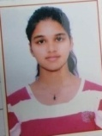

MA ECO 1st Sem
Students Name | Father’s Name | Class | Class Roll No. | Marks  % | Position | Mobile  No. | Picture
Ritu Goel | Durga Das | MA Eco 1st sem | 222196151015 | 370/500  74 % | 6th | 7495008661 | 

MA ECO 2nd Sem
Students Name | Father’s Name | Class | Class Roll No. | Marks  % | Position | Mobile  No. | Picture
Kajal | Mahavir | MA Eco  2nd sem | 22219615115 | 74.2% | 6th | 8813985174 | 

MA ECO 3rd Sem
Students Name | Father’s Name | Class | Class Roll No. | Marks  % | Position | Mobile  No. | Picture
Neha | Mahinder Singh | MA Eco 3rd sem | 221196151003 | 396/500  79.2 % | 2nd | 8295609540 | 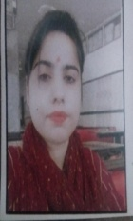
Annu | Ramphal | MA Eco 3rd sem | 221196151019 | 390/500  78 % | 5th | 857007796 | 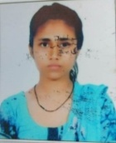
Kajal | Najra Ram | MA Eco 3rd sem | 221196151008 | 383/500  76.6% | 7th | 8708433758 | 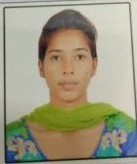
Kavita | Ved prakash | MA Eco 3rd sem | 221196151005 | 377/500  75.5 % | 9th | 9306206819 | 

MA ECO 4th Sem
Students Name | Father’s Name | Class | Class Roll No. | Marks  % | Position | Mobile  No. | Picture
Anu Sharma | Rampal | MA Eco 4th sem | 221196151019 | 1572/2000  78.6 % | 2nd | 8570077962
Kajal | Najra Ram | MA Eco 4th sem | 221196151008 | 1524/2000  76.2% | 8th | 8708433758

M Com. 4th Sem
Students Name | Father’s Name | Class | Class Roll No. | Marks  % | Position | Mobile  No.
Pooja | Joginder Singh | M Com. 4th Sem | 221196168028 | 2076/2500  83.04 % | 6th | 8901312197 | 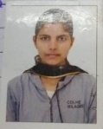

M.Sc 1st Sem
Students Name | Father’s Name | Class | Class Roll No. | Marks  % | Position | Mobile  No. | Picture
Pooja | Suresh | M.sc 1st sem | 222196175012 | 428/600  71.33 % | 3rd | 9817961304 | 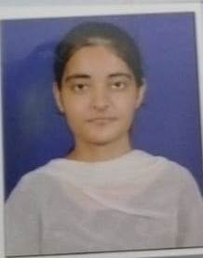
Sanjana | Vinod | M.sc 1st Sem | 222196175005 | 378/600  63 % | 9th | 8930483652 | 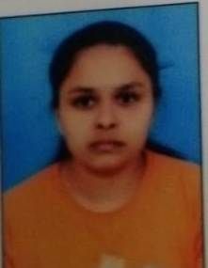

M.Sc 2nd Sem
Students Name | Father’s Name | Class | Class Roll No. | Marks  % | Position | Mobile  No. | Picture
Pooja | Suresh | M.sc 2nd sem | 222196175012 | 485/600  80.8 % | 6th | 9817961304

M.Sc 3rd Sem
Students Name | Father’s Name | Class | Class Roll No. | Marks  % | Position | Mobile  No. | Picture
Jyoti Rani | Krishan Kumar | M.sc 3rd sem | 221196175043 | 496/600  82.67 % | 2nd | 8814087026 | 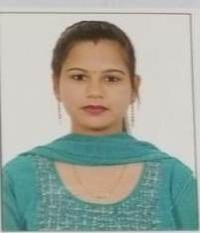
Kajal | Krishan Kumar | M.sc 3rd sem | 221196175035 | 492/600  82 % | 5th | 7404819056 | 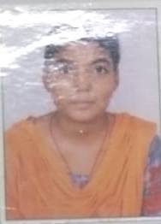

M.Sc 4thSem
Students Name | Father’s Name | Class | Class Roll No. | Marks  % | Position | Mobile  No. | Picture
Kajal | Krishan Kumar | M.sc 4th sem | 221196175035 | 502/600  83.6 % | 7th | 7404819056
Anju | Mahinder Singh | M.sc 4th sem | 221196175021 | 492/600  82% | 10th | 9896345349 | 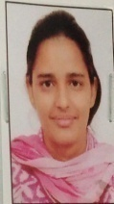

BAMC 3rd Sem
Name | Father’s Name | Class | Class Roll No. | Marks | Position | Mobile  No. | Picture
Sachleen preet Kaur | Punjab Singh | BAMC 3rd Sem | 1211963009037 | 368/500  73.6%. | 2nd in KUK | 7082641763 | 
Radhika | Rajesh Kumar | BAMC 3rd Sem | 1211963009029 | 366/500  73.2% | 3rd in KUK | 7717329214 | 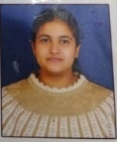
Aarti | Raghubir | BAMC 3rd Sem | 1211963009024 | 362/500  72.4% | 4th in K.U.K | 8683870651 | 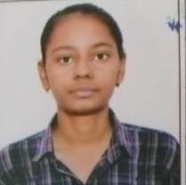
Gurpreet | Karam Singh | BAMC 3rd Sem | 1211963009034 | 354/500  70.8% | 8th in K.U.K | 9996487476 | 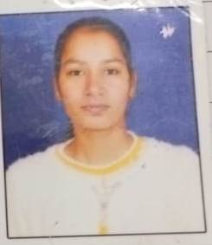

BAMC 6th Sem
Name | Father’s Name | Class | Roll No. | Marks | Position | Mobile  No. | Picture
Rinku | Rameshwar | BAMC 6th Sem | 120196009012 | 395/500  79%. | 4th in K.U.K | 7988642448 | 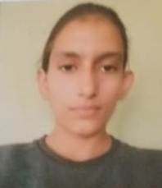
Simran preet kaur | Punjab Singh | BAMC 6th Sem | 120196009014 | 394/500  78.8% | 5th in KUK | 9466341763 | 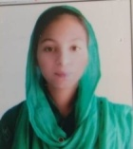
Monika | Sh. Suresh Kumar | BAMC 6th Sem | 120196009007 | 391/500  78.2% | 7th in KUK | 7206347176 | 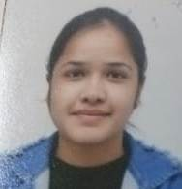

B.com 1st Sem
Name | Father’s Name | Class | Class Roll No. | Marks | Position | Mobile  No. | Picture
Preeti | Ram Niwas | B.Com 1st | 1221963003022 | 526/600  87.67 % | 2nd | 9812763509 | 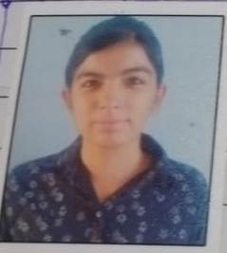
Saloni | Neeraj Gupta | B.Com 1st | 1221963003006 | 513/600  85.5 % | 6th | 9416384945 | 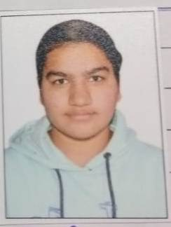

B.com 2nd Sem
Name | Father’s Name | Class | Class Roll No. | Marks | Position | Mobile  No. | Picture
Saloni | Neeraj Gupta | B.Com 2nd | 1221963003006 | 501/600  83.5 % | 6th | 9416384945

B.com 3rd Sem
Name | Father’s Name | Class | Class Roll No. | Marks | Position | Mobile  No. | Picture
Sohaniya | Balinder | B.com 3rd | 1211963003005 | 506/600  84.3 % | 9th | 9878755715 | 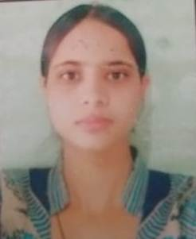

B.com 5th Sem
Name | Father’s Name | Class | Class Roll No. | Marks | Position | Mobile  No. | Picture
Ruby | Ram Niwas | B.com 5th | 120196003040 | 507/600  84.5 % | 2nd | 9812763509 | 
Annu | Balbir Singh | Bcom 5th | 120196003083 | 493/600  82.17 % | 7th | 8168089225 | 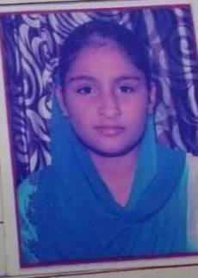

B.com 6th Sem
Name | Father’s Name | Class | Class Roll No. | Marks | Position | Mobile  No. | Picture
Ruby | Ram Niwas | B.com 5th | 120196003040 | 3111/3600  86.4 % | 1st | 9812763509

Bsc 1st Sem
Name | Father’s Name | Class | Class Roll No. | Marks | Position | Mobile  No. | Picture
Muskan | Naresh | Bsc. NM | 1221963015003 | 380/420  90.47 % | 1st | 8813831355 | 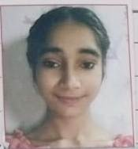
Khushbu | Sukhdev | Bsc CS | 1221963015039 | 335/400  83.75 % | 1st | 7496810910 | 
Loveleen | Kashmir Singh | Bsc M | 1221963030014 | 316/370  85.41 % | 2nd | 9053135318 | 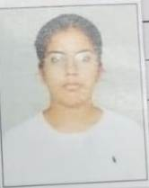
Kafi | Rohtash | Bsc M | 1221963030023 | 306/370  82.70 % | 5th | 8572830278 | 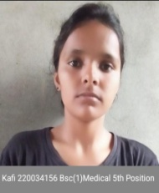
Kashish | Rajesh Kumar | Bsc CS | 1221963015032 | 305/400  76.25 % | 7th | 9034123008 | 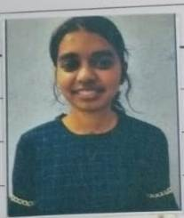
Renu | Suresh Kumar | Bsc CS | 1221963015014 | 303/400  75.75 % | 9th | 9729129095 | 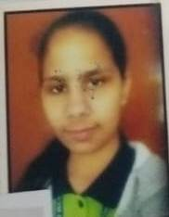
Mukan | Rajinder Singh | Bsc NM | 1221963015012 | 341/420  81.19 % | 10th | 9416308548 | 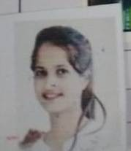

Bsc 2nd Sem
Name | Father’s Name | Class | Class Roll No. | Marks | Position | Mobile  No. | Picture
Kafi | Rohtash | Bsc M | 1221963030023 | 550/630  87.30 % | 4th | 8572830278 | 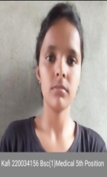
Loveleen | Kashmir Singh | Bsc M | 1221963030014 | 549/630  87.14 % | 5th | 9053135318
Muskan | Naresh | Bsc. NM | 1221963015003 | 508/580  87.58 % | 4th | 8813831355
Kashish | Rajesh Kumar | Bsc CS | 1221963015032 | 502/600  83.66 % | 5th | 9034123008
Payal | Manroop Singh | Bsc CS | 1221963015011 | 500/600  83.33 % | 6th | 9896674474 | 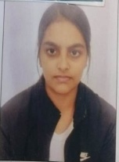
Khushbu | Sukhdev | Bsc CS | 1221963015039 | 498/600  83 % | 1st | 7496810910

Bsc 3rd Sem

Name | Father’s Name | Class | Class Roll No. | Marks | Position | Mobile  No. | Picture
Ritika | Yashpal | Bsc CS | 1211963015050 | 357/400  89.25 % | 1st | 7082180296 | 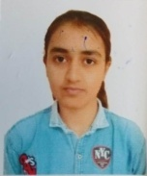
Mafi | Ramphal | Bsc NM | 1211963015015 | 352/420  83.81 % | 8th | 7015098521 | 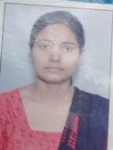
Sheetal | Raj Kumar | Bsc CS | 1211963015012 | 323/400  80.75 % | 10th | 8950733042 | 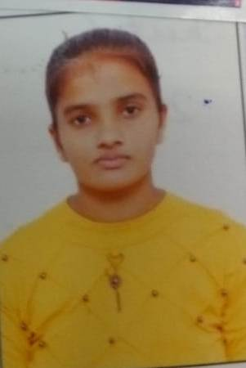

Bsc 4th Sem
Name | Father’s Name | Class | Class Roll No. | Marks | Position | Mobile  No. | Picture
Ritika | Yashpal | Bsc CS | 1211963015050 | 546/600  91 % | 2nd | 7082180296
Simran | Ravi Kumar | Bsc M | 1211963030016 | 569/630  90% | 7th | 7404192004 | 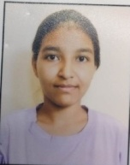

Bsc 5th Sem
Name | Father’s Name | Class | Class Roll No. | Marks | Position | Mobile  No. | Picture
Deepika | Jaipal Singh | Bsc M | 12019630040 | 277/320  86.56 % | 5th | 8570058938 | 
Tamanna | Rameshwar | Bsc M | 12019630007 | 274/320  85.63 % | 7th | 7206793073 | 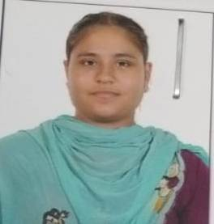
Sudha | Mahavir Singh | Bsc M | 12019630041 | 272/320  85% | 8th | 9728688151 | 
Nikita | Ramesh | Bsc CS | 120196015015 | 285/350  81.42 % | 5th | 9812321652 | 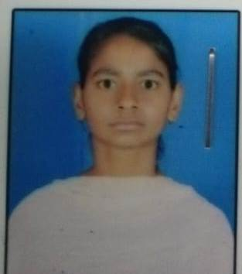

Bsc 6th Sem
Name | Father’s Name | Class | Class Roll No. | Marks | Position | Mobile  No. | Picture
Nikita | Ramesh | Bsc CS | 120196015015 | 2594/2900  89.44 % | 2nd | 9812321652
Samriti | Suresh | Bsc NM | 120196015019 | 2608/2900  89.93 % | 4th | 7404134681 | 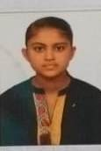
Neha | Jaipal | Bsc NM | 120196015072 | 2601/2900  89.68 % | 6th | 7206798171 | 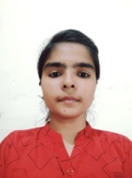

BA 1st Sem
Name | Father’s Name | Class | Class Roll No. | Marks | Position | Mobile  No. | Picture
Swati | Mahavir | BA | 1221962002079 | 339/400  84.75 % | 6th | 9416871135 | 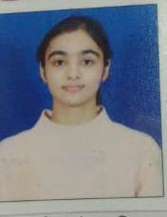
Sareya | Shishpal | BA | 122196002162 | 339/400  84.75 % | 6th | 7082677908 | 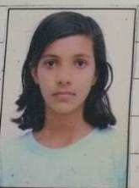
Komal | Krishan | BA | 1221962002030 | 335/400  83.75 % | 8th | 8750917642 | 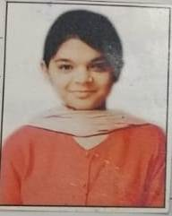
Muskan | Shishpal | BA | 1221962002134 | 334/400  83.5 % | 9th | 9318669795 | 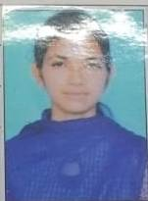
Khushi | Rohtas | BA | 1221962002069 | 333/400  83.25 % | 10th | 7988120842 | 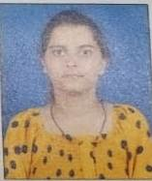
Anjali | Ram  partap | BA | 1221962002224 | 308/370  83.2 % | 10th | 9468072231 | 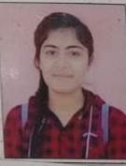

BA 2nd Sem
Name | Father’s Name | Class | Class Roll No. | Marks | Position | Mobile  No. | Picture
Priya Devi | Balwan | BA | 1221962002075 | 376/430  87.44 % | 3rd | 9068726692 | 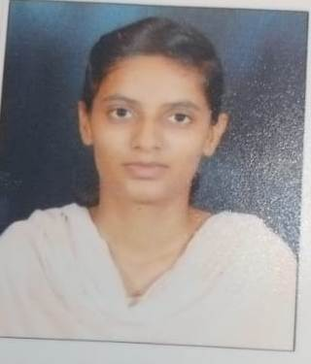
Komal | Krishan | BA | 1221962002030 | 346/400  86.5 % | 6th | 9728215097
Kajal | Lila Singh | BA | 1221962002367 | 369/430  85.8 % | 7th | 7419041944 | 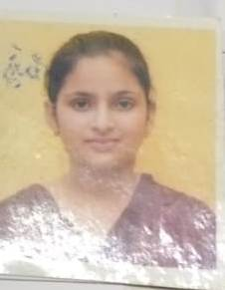
Muskan | Shishpal | BA | 1221962002134 | 343/400  85.75 % | 7th | 9578669795
Kajal | Satish | BA | 1221962002049 | 342/400  85.5 % | 8th | 9723215099 | 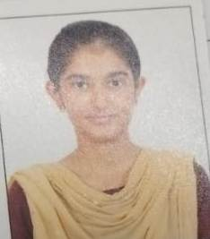
Karamit | Jagpal | BA | 1221962002021 | 395/470  84.4 % | 10th | 9463729262 | 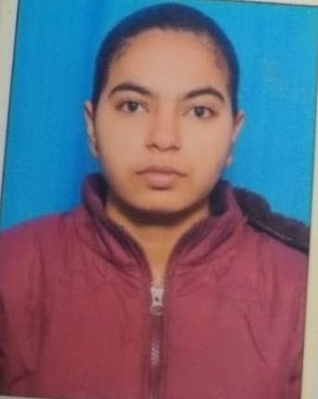
Ankita | Satpal | BA | 1221962002118 | 361/430  83.95 % | 10th | 8130998423 | 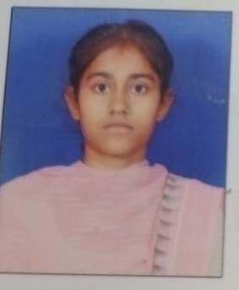
Pinki | Subhash | BA | 1221962002341 | 361/430  83.95 % | 10th | 9817160761 | 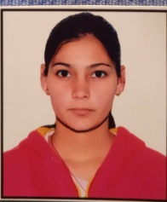
Tamana | Mohindar Singh | BA | 1221963071072 | 335/400  83.75 % | 10th | 7015458298 | 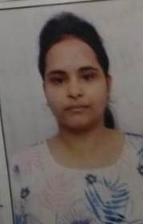

BA 3rd Sem
Name | Father’s Name | Class | Class Roll No. | Marks | Position | Mobile  No. | Picture
Sushmita | Sanjay Kumar | BA | 1211962002082 | 336/400  84 % | 5th | 9466270243 | 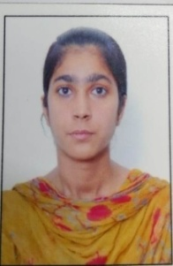
Nisha | Mahavir Singh | BA | 1211963071048 | 335/400  83.75 % | 6th | 7777077398 | 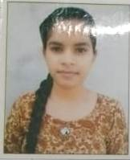
Minakshi | Prem parkash | BA | 1211962002281 | 313/375  83.46 % | 7th | 9306649883 | 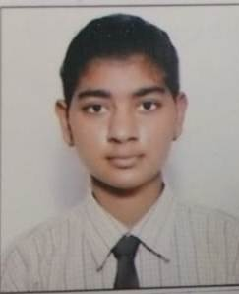
Anju | Ram Kumar | BA | 1211962002032 | 331/400  82.75 % | 10th | 9992152936 | 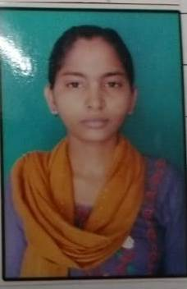

BA 4th Sem
Name | Father’s Name | Class | Class Roll No. | Marks | Position | Mobile  No. | Picture
Anu | Surender | BA | 1211962002299 | 368/425  86.5% | 5th | 8607554331 | 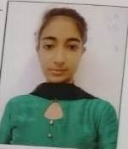
Sushmita | Sanjay | BA | 1211962002082 | 346/400  86.5 % | 5th | 9466270243
Maffi | Satpal | BA | 1211962002222 | 387/455  58 % | 8th | 8295958484 | 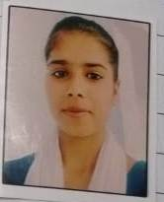
Salone | Jai Bhagwan | BA | 1211962002066 | 382/450  85 % | 8th | 8607969673 | 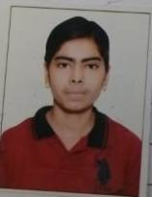
Vandana | Deepak | BA | 1211962002293 | 361/425  85 % | 8th | 9812209767 | 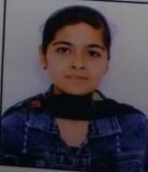
Nisha | Mahavir | BA | 1211963071048 | 340/400  85 % | 8th | 7777077398
Sakshi | Afal Singh | BA | 1211962002054 | 340/400  85 % | 8th | 8168983423 | 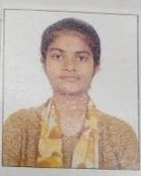
Kiren | Somdutt | BA | 1211962002023 | 338/400  84.5% | 9th | 9350639608 | 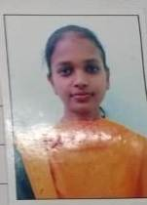

BA 5th Sem
Name | Father’s Name | Class | Class Roll No. | Marks | Position | Mobile  No. | Picture
Astha | Ranbir Singh | BA | 120196002142 | 354/400  88.5 % | 1st | 8053392275 | 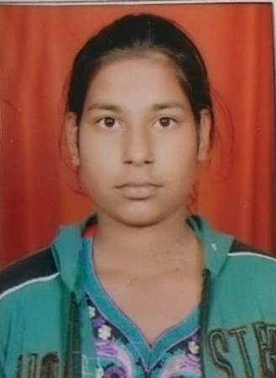
Kajal | Ramesh | BA | 120196002031 | 350/400  87.5 % | 4th | 9306848540 | 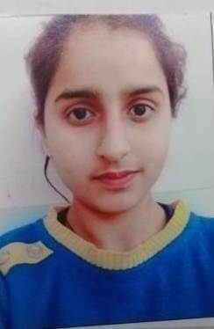
Kusum | Gani Ram | BA | 120196002007 | 349/400  87.25 % | 5th | 8168118658 | 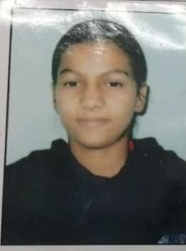
Komal | Raj Kumar | BA | 120196002142 | 322/370  87.2% | 6th | 9729768473 | 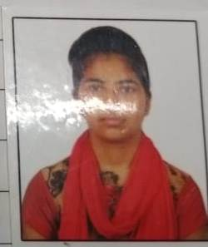

BA 6th Sem
Name | Father’s Name | Class | Class Roll No. | Marks | Position | Mobile  No. | Picture
Simran | Raj Rishi | BA | 120196002330 | 338/370  91.3 % | 1st | 7206071404 | 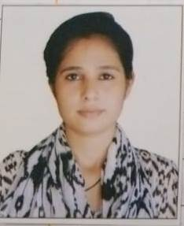
Pooja Devi | Satpal Singh | BA | 120196071082 | 351/400  87.8 % | 4th | 9729451449 | 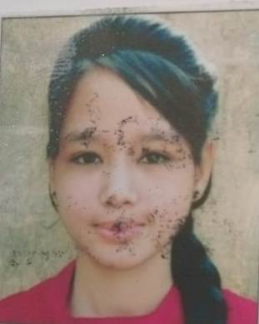
Sheetal | Krishan | BA | 120196002018 | 369/425  86.8 % | 6th | 7404603417 | 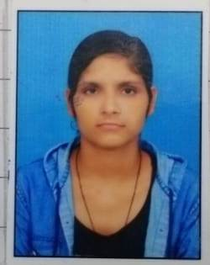
Astha | Ranbir Singh | BA | 120196002105 | 341/400  85.2 % | 9th | 8053392275
Pragati | Raj Kumar | BA | 120196002220 | 341/400  85.2 % | 9th | 7015107049 | 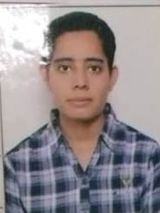
Preeti | Tara Chand | BA | 120196002017 | 341/400  85.2 % | 9th | 9996269344 | 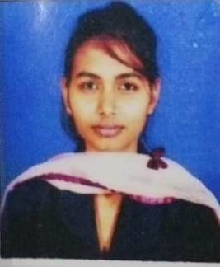
Sarbjeet | Krishan | BA | 120196002311 | 340/400  85.2 % | 9th | 8146859461 | 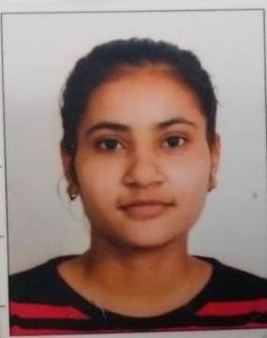
Kajal | Ramesh | BA | 120196002031 | 338/400  84 % | 10th | 9306848540
Komal | Raj Kumar | BA | 120196002142 | 361/430  84 % | 10th | 9729768473
Manju | Shamsher Singh | BA | 120196002092 | 357/430  83 % | 10th | 9350676496 | 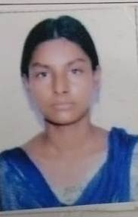
Renu | Hoshiar Singh | BA | 120196002358 | 310/370  83.7 % | 10th | 7206800324 | 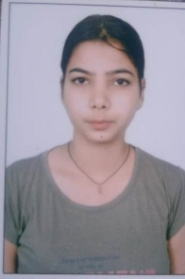

IGMMV focus on learner -centric education approach which uses different types of techniques that shift the role of teachers from contributors of information to providing student learning through appropriate practices . IQAC always encouraged teachers to utilize ICT tools , practical approach , demonstrative techniques in classroom and laboratories. To facilitate the students IQAC suggested new innovative methods for making teaching learning process effective and interactive after suggestions from IQAC various departments arranged different online activities to increase the interest of students and to make them better understand the concept . Various cells in the college are also take some efforts to initiate various online and offline activities( competition , quiz , webinars, extension lecture etc) to improve skills in students so one of the main objective of our educational institution is to create institute of excellence committed to provide quality education along with moral values and leadership qualities all girl students without any kind of discrimination.
Pass percentage of students
Year | Program name |  | Number of students appeared in final year examination | No. of students Passed in final year Examination |  | Pass percentage
2022 -  2023 |  | B.A. | 399 | 324 | 81.203%
2022 -  2023 |  | B.Com. | 122 | 96 | 78.688%
2022 -  2023 |  | B.Sc. (Non Medical+Medical) | 97 | 70 | 72.164%
2022 -  2023 |  | B.A. Mass Comm. | 36 | 20 | 55.555%
2022 -  2023 |  | BCA | 18 | 6 | 33.33%
2022 -  2023 |  | M.A. (Eco.) | 32 | 21 | 65.625%
2022 -  2023 |  | M.A.(English) | 35 | 20 | 57.142%
2022 -  2023 |  | M.Com | 59 | 53 | 89.830%
2022 -  2023 |  | M.Sc (Mathematics) | 51 | 25 | 49.019%
2022 -  2023 |  | PGDCA | 0 | 0 | 0
2022 -  2023 |  | Total | 849 | 635 | 74.793%

Cells and Departmental Activities 2022-23

Sr.  No. | Sub/ Deptt./ Cell | Competitio n/ Activity | Organized By | Topics | No. of Part. | Cross  -cutti ng Issues | Participa nts/  /Position Holders | Relevant Documents
1. | Women  Cell | Nukkad Natak Topic on Women Exploitation  , Sexual Harassment (09.12.2022  ) | I.G.M.M.V.  Kaithal | Women Exploitatio n, Sexual Harassmen t | 15 | Gend er | 15  participa nts | 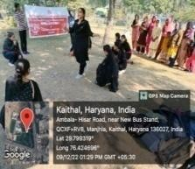
 | Women Cell | Online  Competition | Saraswati  Mahila | Innovation  and | 2 | Gend  er | Participa  tion | 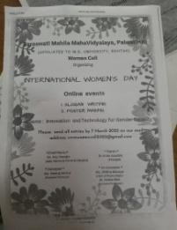
 |  | Slogan  Writing on International | Mahavidy alaya | Technology  for Gender Equality |  |  | Komal 1221963
 |  | Women’s | Palwal |  |  |  | 002010(S
 |  | Day Topic on |  |  |  |  | .F.)
 |  | Innovation
 |  | and |  |  |  |  | , Mehak
 |  | Technology |  |  |  |  | 1221962
 |  | for Gender |  |  |  |  | 002200
 |  | Equality |  |  |  |  | (B.A. I)
 |  | (07.03.2023)
 | Women Cell | Online  Poster | Saraswati  Mahila | Innovation  and | 1 | Gend  er | Participa  tion | 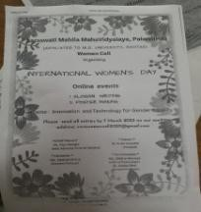
 |  | Making  Competition (07.03.2023) | Mahavidy alaya, Palwal | Technology  for Gender Equality |  |  | Priya 1211962  002068
 |  |  |  |  |  |  | B.A. IInd

 | Women Cell | National  Level Poster | R.K.S.D.  PG | (i) Save Girl  Child | 3 | Gend  er | 3rd  position | 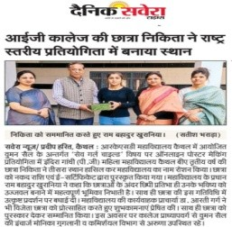
 |  | Making  Competition (05.02.2023) | College Kaithal | (ii) Equality and |  |  | Nikita  1201960
 |  |  |  | Education |  |  | 02343
 |  |  |  | for Girl |  |  | B.A. III
 |  |  |  | Child |  |  | Participa
 |  |  |  | (iii) Our |  |  | tion
 |  |  |  | Rights, Our  Future |  |  | Komal 1221963
 |  |  |  |  |  |  | 002010
 |  |  |  |  |  |  | B.A. I,
 |  |  |  |  |  |  | Priya
 |  |  |  |  |  |  | 1211962
 |  |  |  |  |  |  | 002068
 |  |  |  |  |  |  | B.A. II
 | Women Cell | National  Level Slogan | R.K.S.D.  PG | (i) Save Girl  Child | 2 | Gend  er | Participa  tion | 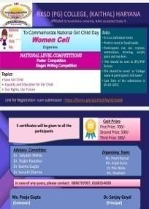
 |  | Writing  Competition (05.02.2023) | College Kaithal | (ii) Equality and |  |  | Ravina 1221962
 |  |  |  | Education |  |  | 002406B
 |  |  |  | for Girl |  |  | A I,
 |  |  |  | Child |  |  | Sarbjeet
 |  |  |  | (iii) Our |  |  | 1201960
 |  |  |  | Rights, Our |  |  | 02311 BA
 |  |  |  | Future |  |  | III
 | Women Cell | National  Level Online | Mukand  Lal | Digital  Innovation | 2 | Gend  er | 1st  position | 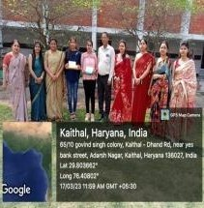
 |  | Poster | National | and |  |  | Bhavna
 |  | Making  Competition (08.03.2023) | College Yamuna Nagar | Technology for Gender Equality |  |  | 2211961  75009

M.Sc
Final

Participa tion
Khusboo 2221961
75004 (M.Sc P)
 | Women Cell | National  Level Online | Mukand  Lal | Digital  Innovation | 4 | Gend  er | 2nd  position | 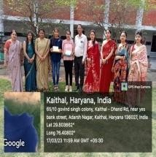
 |  | Slogan | National | and |  |  | Mehak
 |  | Writing  Competition (08.03.2023) | College Yamuna Nagar | Technology for Gender Equality |  |  | BA I  Participa tion
 |  |  |  |  |  |  | Khusboo
 |  |  |  |  |  |  | MSc. P,
 |  |  |  |  |  |  | Komal
 |  |  |  |  |  |  | BA I,
 |  |  |  |  |  |  | Vandana
 |  |  |  |  |  |  | BA I
 | Women Cell | National  Level Online | M.D.S.D.  College | Innovation  and | 3 | Gend  er | Participa  tion | 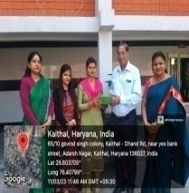
 |  | Poster  Making Competition on | Ambala | Technology for Gender Equality |  |  | Bhavna MSc.  Final ,
 |  | Innovation |  |  |  |  | Khusboo
 |  | and |  |  |  |  | MSc. P,
 |  | Technology
 |  | for Gender |  |  |  |  | 1st
 |  | Equality |  |  |  |  | position
 |  | (08.03.2023) |  |  |  |  | Usha
 |  |  |  |  |  |  | MSc. P

 | Women Cell | National  Level Online | Shah  Satnam Ji | Shaping the  World-Bette | 4 | Gend  er | Participa  tion | 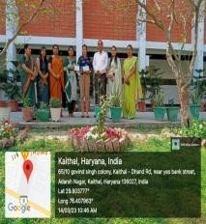
 |  | Essay  Writing Competition on Shaping | Girls College Sirsa | r for Women |  |  | Usha MSc. P,  Menka
 |  | the |  |  |  |  | MSc.
 |  | World-Better |  |  |  |  | Final,
 |  | for Women (
 |  | 08.03.2023) |  |  |  |  | 2nd
 |  |  |  |  |  |  | position
 |  |  |  |  |  |  | Akshita
 |  |  |  |  |  |  | BSc. I
 |  |  |  |  |  |  | 3rd
 |  |  |  |  |  |  | position
 |  |  |  |  |  |  | Kajal
 |  |  |  |  |  |  | MSc.
 |  |  |  |  |  |  | Final
 | Women Cell | International  Women’s | Govt. of  Haryana | To honour  women | Onlin  e | Gend  er | Students  from all | 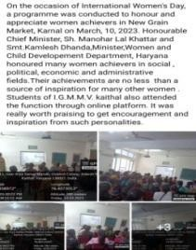
 |  | Day | at New | achievers | Parti |  | streams
 |  | Celebration  (10.03.2023) | Grain  Market, |  | cipat  ion |  | attended  the
 |  |  | Karnal |  |  |  | function
 |  |  |  |  |  |  | through
 |  |  |  |  |  |  | online
 |  |  |  |  |  |  | platform
 | Women Cell | Financial Wellness enhancemen | I.G.M.M.V.  Kaithal | Financial Wellness enhanceme | 80 | Gend er | All Faculty  Member | 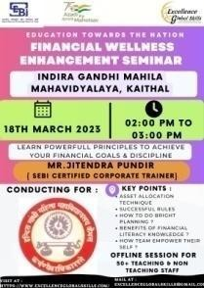
 |  | t Seminar  Offline Session (18.03.2023) |  | nt |  |  | s Participat ed  (Teaching
 |  |  |  |  |  |  | and Non
 |  |  |  |  |  |  | Teaching)

 | Women Cell | National  Level Online | Mata Sundri Khalsa Girls College Nissing Karnal | Gender  Equality | 4 | Gend  er | 1st  Position | 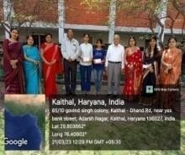
 |  | Poster | Mata Sundri Khalsa Girls College Nissing Karnal
 |  | Making on | Mata Sundri Khalsa Girls College Nissing Karnal |  |  |  | Komal
 |  | Gender  Equality | Mata Sundri Khalsa Girls College Nissing Karnal |  |  |  | 1221963
 |  | Competition | Mata Sundri Khalsa Girls College Nissing Karnal |  |  |  | 002010
 |  | (13.03.2023) | Mata Sundri Khalsa Girls College Nissing Karnal |  |  |  | BA I
 |  |  | Mata Sundri Khalsa Girls College Nissing Karnal |  |  |  | Participa
 |  |  | Mata Sundri Khalsa Girls College Nissing Karnal |  |  |  | tion
 |  |  | Mata Sundri Khalsa Girls College Nissing Karnal |  |  |  | Priya
 |  |  | Mata Sundri Khalsa Girls College Nissing Karnal |  |  |  | 1211962
 |  |  | Mata Sundri Khalsa Girls College Nissing Karnal |  |  |  | 002068
 |  |  | Mata Sundri Khalsa Girls College Nissing Karnal |  |  |  | BA II,
 |  |  | Mata Sundri Khalsa Girls College Nissing Karnal |  |  |  | Bhavna
 |  |  | Mata Sundri Khalsa Girls College Nissing Karnal |  |  |  | 2211961
 |  |  | Mata Sundri Khalsa Girls College Nissing Karnal |  |  |  | 75009
 |  |  | Mata Sundri Khalsa Girls College Nissing Karnal |  |  |  | MSc.
 |  |  | Mata Sundri Khalsa Girls College Nissing Karnal |  |  |  | Final
 |  |  | Mata Sundri Khalsa Girls College Nissing Karnal |  |  |  | 2nd
 |  |  | Mata Sundri Khalsa Girls College Nissing Karnal |  |  |  | Position
 |  |  | Mata Sundri Khalsa Girls College Nissing Karnal |  |  |  | Ravina
 |  |  | Mata Sundri Khalsa Girls College Nissing Karnal |  |  |  | 1221962
 |  |  | Mata Sundri Khalsa Girls College Nissing Karnal |  |  |  | 002406
 |  |  | Mata Sundri Khalsa Girls College Nissing Karnal |  |  |  | BA I
 | Women Cell | Enhancemen t Seminar on  “Education | I.G.M.M.V.  Kaithal | Education Towards the  Nation : | 50 | Gend er | 50  Faculty Member s Participat ed | 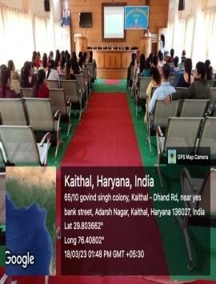
 |  | Towards the |  | Financial |  |  | 50  Faculty Member s Participat ed
 |  | Nation : |  | Wellness |  |  | 50  Faculty Member s Participat ed
 |  | Financial |  |  |  |  | 50  Faculty Member s Participat ed
 |  | Wellness” |  |  |  |  | 50  Faculty Member s Participat ed
 |  | (18.03.2023) |  |  |  |  | 50  Faculty Member s Participat ed

 | Women Cell | National Level Poster  Making | I.G.M.M.V.  Kaithal | Stand up for women | 28 | Gend er | 1st position  Shallu | 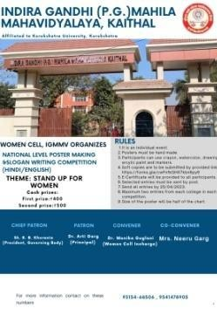
 |  | Competition |  |  |  |  | 1221561
 |  | under the |  |  |  |  | 0003039
 |  | theme |  |  |  |  | B.A. I
 |  | “Stand up |  |  |  |  | GCW,
 |  | for women” (25.04.2023) |  |  |  |  | Ghraund  a  2nd
 |  |  |  |  |  |  | position
 |  |  |  |  |  |  | Priya
 |  |  |  |  |  |  | 1219620
 |  |  |  |  |  |  | 02068
 |  |  |  |  |  |  | B.A. I
 |  |  |  |  |  |  | I.G.M.M.
 |  |  |  |  |  |  | V. Kaithal
 |  |  |  |  |  |  | 3rd
 |  |  |  |  |  |  | position
 |  |  |  |  |  |  | Jasleen
 |  |  |  |  |  |  | 2275982
 |  |  |  |  |  |  | 010
 |  |  |  |  |  |  | M.Sc.
 |  |  |  |  |  |  | CU, Chd
 | Women Cell | National Level Slogan  Writing | I.G.M.M.V.  Kaithal | Stand up for women | 16 | Gend er | 1st position  Nancy | 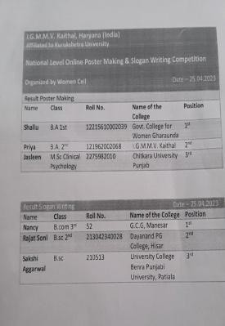
 |  | Competition |  |  |  |  | 52
 |  | under the |  |  |  |  | B.Com. III
 |  | theme |  |  |  |  | G.C.G.
 |  | “Stand up |  |  |  |  | Manesar
 |  | for women” (25.04.2023) |  |  |  |  | 2nd  position  Rajat
 |  |  |  |  |  |  | Soni
 |  |  |  |  |  |  | 2130423
 |  |  |  |  |  |  | 40028
 |  |  |  |  |  |  | B.Sc. II
 |  |  |  |  |  |  | DN P.G.
 |  |  |  |  |  |  | College,
 |  |  |  |  |  |  | Hisar
 |  |  |  |  |  |  | 3rd
 |  |  |  |  |  |  | position

Sakshi Aggarwal 210513 B.Sc.
PU
Patiala
2. | Legal | Power Grid | IGMMV, | Vigilance | 3 | Huma | 1st | 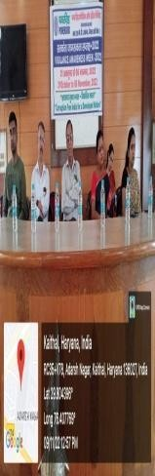
 | Literacy | Corporatio | Kaithal | Awareness |  | n | Position
 | Cell | n of India |  |  |  | Value | Sachleen
 |  | Ltd. |  |  |  | s | Kaur
 |  | Vigilance |  |  |  |  | BAMC II
 |  | Awareness |  |  |  |  | 1211963
 |  | (31.10.2022 |  |  |  |  | 009037
 |  | ) to  (6.11.2022) |  |  |  |  | 2nd
 |  |  |  |  |  |  | Position
 |  |  |  |  |  |  | SimranPr
 |  |  |  |  |  |  | eet Kaur
 |  |  |  |  |  |  | BAMC III
 |  |  |  |  |  |  | 1209600
 |  |  |  |  |  |  | 9014
 |  |  |  |  |  |  | 3rd
 |  |  |  |  |  |  | Position
 |  |  |  |  |  |  | Shivani
 |  |  |  |  |  |  | B.A I
 |  |  |  |  |  |  | 1221962
 |  |  |  |  |  |  | 002001
 | Legal | National | IGMMV, | Women | 21 | Gend | Participa | 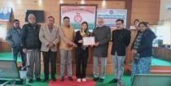
 | Literacy | Human | Kaithal | Empowerm |  | er | tion
 | Cell | Rights & |  | ent
 |  | Crime
 |  | Petrol
 |  | Bureau
 |  | (24-01-202
 |  | 3)
 | Legal | On The | Director | Female | 3 | Gend | 1st
 | Literacy | Spot | Higher | Foeticide |  | er | Position
 | Cell | Painting | Education |  |  |  | Priya
 |  | (04.02.2023 | Haryana |  |  |  | B.A 2nd
 |  | )

 |  |  | Shiksha |  |  |  | 1211962
 |  |  | Sadan  Sector-5 |  |  |  | 002068  2nd
 |  |  | Panchkula |  |  |  | Position
 |  |  |  |  |  |  | Ravina
 |  |  |  |  |  |  | B.A I
 |  |  |  |  |  |  | 1219620
 |  |  |  |  |  |  | 02406
 |  |  |  |  |  |  | 3rd
 |  |  |  |  |  |  | Position
 |  |  |  |  |  |  | Nikita
 |  |  |  |  |  |  | B.A III
 |  |  |  |  |  |  | 1219600
 |  |  |  |  |  |  | 2343
 | Legal Literacy Cell | Slogan | Director | Save Girl | 3 | Gend | 1st | 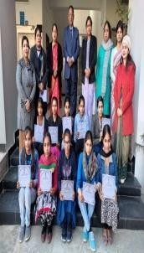
 | Legal Literacy Cell | Writing | Higher | Child |  | er | Position
 | Legal Literacy Cell | (04-02-202 | Education |  |  |  | Komal
 | Legal Literacy Cell | 3) | Haryana |  |  |  | B.A I
 | Legal Literacy Cell |  | Shiksha |  |  |  | 1221963
 | Legal Literacy Cell |  | Sadan  Sector-5 |  |  |  | 002010  2nd
 | Legal Literacy Cell |  | Panchkula |  |  |  | Position
 | Legal Literacy Cell |  |  |  |  |  | Mehak,
 | Legal Literacy Cell |  |  |  |  |  | B.A II,
 | Legal Literacy Cell |  |  |  |  |  | 1221962
 | Legal Literacy Cell |  |  |  |  |  | 002200
 | Legal Literacy Cell |  |  |  |  |  | 3rd
 | Legal Literacy Cell |  |  |  |  |  | Position
 | Legal Literacy Cell |  |  |  |  |  | Khushi,
 | Legal Literacy Cell |  |  |  |  |  | B.A
 | Legal Literacy Cell |  |  |  |  |  | II,121196
 | Legal Literacy Cell |  |  |  |  |  | 2002020
 | Legal | Essay | Director | Women | 3 | Gend | 1st | 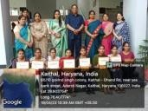
 | Literacy | Writing | Higher | Empowerm |  | er | Position
 | Cell | (04-02-202 | Education | ent |  |  | Meena
 |  | 3) | Haryana |  |  |  | M.Com,2
 |  |  | Shiksha |  |  |  | 2119616
 |  |  | Sadan  Sector-5 |  |  |  | 8021  2nd
 |  |  | Panchkula |  |  |  | Position
 |  |  |  |  |  |  | Sachleen
 |  |  |  |  |  |  | Kaur,BA

MC II,121196 3009037
3rd
Position Seema, B.Com III, 1201960
03092
 | Legal | District | B.R | Female | 2 | Gend | 1st
 | Literacy | level | Ambedkar | Foeticide |  | er | Position
 | Cell | Competitio | Govt.. |  |  |  | Raveena
 |  | n on the | College, |  |  |  | B.A
 |  | spot | Kaithal |  |  |  | I,122196
 |  | Painting  (06-02-202 |  |  |  |  | 2002406  3rd
 |  | 3) |  |  |  |  | Position
 |  |  |  |  |  |  | Priya, BA
 |  |  |  |  |  |  | II,121196
 |  |  |  |  |  |  | 2002068
 | Legal | District | B.R | Save Girl | 1 | Gend | 1st | 
 | Literacy | level | Ambedkar | Child |  | er | Position
 | Cell | Competitio | Govt.. |  |  |  | Komal
 |  | n on the | College, |  |  |  | B.A I
 |  | Slogan | Kaithal
 |  | Writing
 |  | (06-02-202
 |  | 3)
 | Legal Literacy Cell | District level Competitio n on the Essay Writing (06-02-202  3) | B.R  Ambedkar Govt..  College, Kaithal | Dowry System | 1 | Gend er | 3rd  Position  Sachleen Kaur,BA MC II 1211963  009037
 | Legal | District | B.R | Domestic | 2 | Gend | 1st
 | Literacy | Level PPT | Ambedkar | Violence |  | er | Position
 | Cell | Competitio | Govt.. | Against |  |  | Muskan
 |  | n | College, | Women |  |  | BCA II
 |  | (06-02-202 | Kaithal |  |  |  | (1211962
 |  | 3) |  |  |  |  | 011019)

1st
Position Anju BCA II (1211962
011003)
 | Legal | District | B.R | Fundament | 3 | Huma | 3rd
 | Literacy | Level Quiz | Ambedkar | al Rights, |  | n | Position
 | Cell | Competitio | Govt.. | Constitutio |  | Value | Ashu
 |  | n | College, | nal Values |  | s | B.A II
 |  | (06-02-202 | Kaithal |  |  |  | 1211962
 |  | 3) |  |  |  |  | 002185
 |  |  |  |  |  |  | 3rd
 |  |  |  |  |  |  | Position
 |  |  |  |  |  |  | Mansi
 |  |  |  |  |  |  | B.A III
 |  |  |  |  |  |  | 1201960
 |  |  |  |  |  |  | 02387
 |  |  |  |  |  |  | 3rd
 |  |  |  |  |  |  | Position
 |  |  |  |  |  |  | Mehak
 |  |  |  |  |  |  | B.A I
 |  |  |  |  |  |  | 1221962
 |  |  |  |  |  |  | 002200
 | Legal | Poster | IGMMV, | Law | 3 | Huma | 1st | 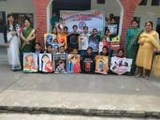
 | Literacy | Making | Kaithal | Awareness: |  | n | Position
 | Cell | Competitio |  | Our |  | Value | Komal
 |  | n |  | Responsibil |  | s | B.A I
 |  | (03-03-202 |  | ity |  |  | 1221963
 |  | 3) |  |  |  |  | 002010
 |  |  |  |  |  |  | 2nd
 |  |  |  |  |  |  | Position
 |  |  |  |  |  |  | Sarbjeet,
 |  |  |  |  |  |  | B.A II
 |  |  |  |  |  |  | 1201960
 |  |  |  |  |  |  | 02311
 |  |  |  |  |  |  | 3rd
 |  |  |  |  |  |  | Position
 |  |  |  |  |  |  | Priya, BA

 |  |  |  |  |  |  | II,121196 2002068
 | Legal Literacy Cell | Quiz Competitio n  (04-04-202  3) | IGMMV,  Kaithal | Women Related Issues | 1 | Wom en | 1st  Position Shivani Sakshi Kajal | 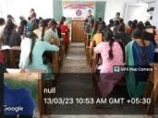
 | Legal | Declamatio | IGMMV, | Human | 3 | Huma | 1st | 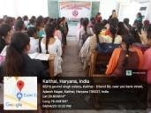
 | Literacy | n | Kaithal | Rights, |  | n | Position
 | Cell | Competitio |  | Violence |  | Value | Preeti
 |  | n |  | Against |  | s, | B.A. I
 |  | (31-03-202 |  | Women |  | Gend | 1221962
 |  | 3) |  |  |  | er | 002016  2nd
 |  |  |  |  |  |  | Position
 |  |  |  |  |  |  | Tamanna
 |  |  |  |  |  |  | B.A. II
 |  |  |  |  |  |  | 1211962
 |  |  |  |  |  |  | 002012
 |  |  |  |  |  |  | 3rd
 |  |  |  |  |  |  | Position
 |  |  |  |  |  |  | Ankita
 |  |  |  |  |  |  | B.A. III
 |  |  |  |  |  |  | 1221962
 |  |  |  |  |  |  | 002118
 | Legal | Division | Pt. | Save Girl | 1 | Gend | 1st | 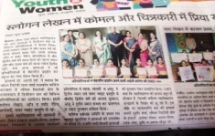
 | Literacy | Level | Chiranji | Child |  | er | Position
 | Cell | Slogan | Lal |  |  |  | (Certifica
 |  | Writing | Sharma |  |  |  | te + Rs.
 |  | Competitio | Govt. |  |  |  | 5100
 |  | n | College, |  |  |  | cash)
 |  | (18.04.2023 | Karnal |  |  |  | Komal
 |  | ) |  |  |  |  | B.A. I
 |  |  |  |  |  |  | 1221963
 |  |  |  |  |  |  | 002010
 | Legal | Division | Pt. | Female | 2 | Gend | 1st | 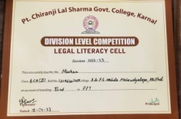
 | Literacy | Level On | Chiranji | Foeticide |  | er | Position
 | Cell | The Spot | Lal |  |  |  | (Certifica
 |  | Painting | Sharma |  |  |  | te + Rs.

 |  | Competitio | Govt. |  |  |  | 5100
 |  | n | College, |  |  |  | cash)
 |  | (18.04.2023 | Karnal |  |  |  | Priya
 |  | ) |  |  |  |  | B.A. II
 |  |  |  |  |  |  | 1211962
 |  |  |  |  |  |  | 002068
 |  |  |  |  |  |  | 2nd
 |  |  |  |  |  |  | Position
 |  |  |  |  |  |  | (Certifica
 |  |  |  |  |  |  | te + Rs.
 |  |  |  |  |  |  | 3100
 |  |  |  |  |  |  | cash)
 |  |  |  |  |  |  | Ravina
 |  |  |  |  |  |  | B.A. I
 |  |  |  |  |  |  | 1221962
 |  |  |  |  |  |  | 002406
 | Legal | Division | Pt. | Fundament | 3 | Huma | 2nd | 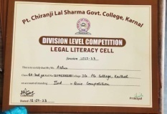
 | Literacy | Level Quiz | Chiranji | al Rights, |  | n | Position
 | Cell | Competitio | Lal | Constitutio |  | Value | (Certifica
 |  | n | Sharma | nal Values |  | s | te + Rs.
 |  | (18.04.2023 | Govt. |  |  |  | 4000
 |  | ) | College, |  |  |  | cash)
 |  |  | Karnal |  |  |  | Mahak
 |  |  |  |  |  |  | B.A. I
 |  |  |  |  |  |  | 1221962
 |  |  |  |  |  |  | 002200,
 |  |  |  |  |  |  | Ashu
 |  |  |  |  |  |  | B.A. II
 |  |  |  |  |  |  | 1211962
 |  |  |  |  |  |  | 002185,
 |  |  |  |  |  |  | Mansi
 |  |  |  |  |  |  | B.A. III
 |  |  |  |  |  |  | 1201960
 |  |  |  |  |  |  | 02387
 | Legal | Division | Pt. | Domestic | 1 | Gend | 3rd
 | Literacy | Level PPT | Chiranji | Violence |  | er | Position
 | Cell | Competitio | Lal | Against |  |  | (Certifica
 |  | n | Sharma | Women |  |  | te + Rs.
 |  | (18.04.2023 | Govt. |  |  |  | 3000
 |  | ) | College, |  |  |  | cash)
 |  |  | Karnal |  |  |  | Muskan
 |  |  |  |  |  |  | BCA II
 |  |  |  |  |  |  | 1211962
 |  |  |  |  |  |  | 011019

 | Legal | Online | Babu | Human | 19 | Huma | Participa | 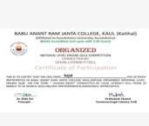
 | Literacy | National | Anant | Rights |  | n | tion
 | Cell | Level Quiz | Ram Janta |  |  | Value
 |  | Competitio | College |  |  | s
 |  | n | Kaul
 |  | (25-03-202 | Kaithal
 |  | 3 )
 |  | (26-03-202
 |  | 3)
 | Legal | State Level | Shri Mata | Domestic | 2 | Gend | 3rd | 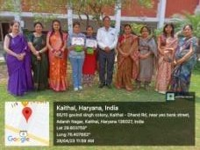
 | Literacy | Competitio | Mansa | Violence |  | er | Position
 | Cell | n | Devi | Against |  |  | Priya BA
 |  | (25.04.2023 | Govt.t. | Women |  |  | II(121196
 |  | ) | Sanskrit  Mahavidy |  |  |  | 2002068)  3rd
 |  |  | alaya |  |  |  | Position
 |  |  | Panchkula |  |  |  | Muskan
 |  |  |  |  |  |  | BCA II
 |  |  |  |  |  |  | (1211962
 |  |  |  |  |  |  | 011019)
 | Legal | State Level | IGMMV | Senior | 2 | Huma | 1st | 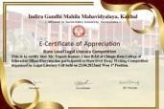
 | Literacy | Essay | Kaithal | Citizen and |  | n | Position
 | Cell | Writing |  | Human |  | Value | Yogesh
 |  | Competitio |  | Rights |  | s | ,B.Ed I
 |  | n |  |  |  |  | 22079
 |  | (25.04.2023 |  |  |  |  | 2nd
 |  |  |  |  |  |  | Position
 |  |  |  |  |  |  | Simranje
 |  |  |  |  |  |  | et,
 |  |  |  |  |  |  | B.A I
 |  |  |  |  |  |  | 1221963
 |  |  |  |  |  |  | 002041

 | Legal | State Level | IGMMV | Drugs | 2 | Huma | 1st | 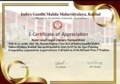
 | Literacy | Poster | Kaithal |  |  | n | Position
 | Cell | Making |  |  |  | Value | Komal
 |  | Competitio |  |  |  | s | B.A I
 |  | n |  |  |  |  | ,1221963
 |  | (25.04.2023 |  |  |  |  | 002010  2nd
 |  |  |  |  |  |  | Position
 |  |  |  |  |  |  | Kusum
 |  |  |  |  |  |  | B.A III,
 |  |  |  |  |  |  | 1204090
 |  |  |  |  |  |  | 02052
 | Legal | State Level | I.B.(P.G) | Legal | 2 | Huma | Participa | 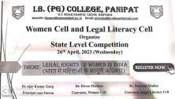
 | Literacy | Rangoli and | College, | Rights of |  | n | tion in
 | Cell | Poster | Panipat | Women in |  | Value | Rangoli
 |  | Making |  | India |  | s | Competit
 |  | Competitio |  |  |  |  | ion
 |  | n |  |  |  |  | Ravina
 |  |  |  |  |  |  | B.A. I
 |  |  |  |  |  |  | 1211962
 |  |  |  |  |  |  | 002406
 |  |  |  |  |  |  | Seema
 |  |  |  |  |  |  | B.A. I
 |  |  |  |  |  |  | 1211962
 |  |  |  |  |  |  | 00235
 |  |  |  |  |  |  | Participa
 |  |  |  |  |  |  | tion in
 |  |  |  |  |  |  | Poster
 |  |  |  |  |  |  | Making
 |  |  |  |  |  |  | Priya
 |  |  |  |  |  |  | B.A. II
 |  |  |  |  |  |  | 1211962
 |  |  |  |  |  |  | 002068
 |  |  |  |  |  |  | Komal
 |  |  |  |  |  |  | B.A. I
 |  |  |  |  |  |  | 1221963
 |  |  |  |  |  |  | 002010
3. | Sexual | Rally on | I.G.M.M. | Stop | 90-1 | Gend | All the | 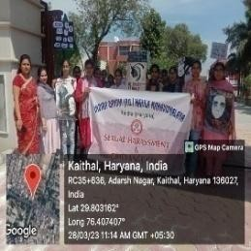
 | Harass | the theme | V.KAITH | Sexual | 00 | er | students
 | ment | Stop Sexual | AL | Harassment |  |  | actively
 | And | Harassment |  |  |  |  | participat
 | Grieva | (28.03.2023 |  |  |  |  | ed
 | nce | )
 | Cell

4. | Red | One day | Project | HIV/AIDS | 4 | Huma | Particip | 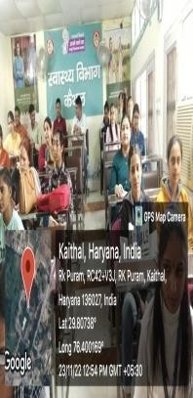
 | Cross | training | Director | and Drugs |  | n | ation
 | & Red | workshop | Haryana |  |  | Value | BCom III
 | Ribbon | of nodal | State |  |  | s | Payal
 | Cell | teachers | AIDS |  |  |  | 1201960
 |  | and peer | Control |  |  |  | 03108
 |  | educators | Society |  |  |  | Geeta
 |  | of Red | Swasthya |  |  |  | 1201960
 |  | Ribbon | Bhawan, |  |  |  | 03091
 |  | Club | Panchkula |  |  |  | Charu
 |  | (23-11-202 |  |  |  |  | 1201960
 |  | 2) |  |  |  |  | 03113
 |  |  |  |  |  |  | Srishti
 |  |  |  |  |  |  | 1201960
 |  |  |  |  |  |  | 03021
 | Red | 5 days | Indian | All Health | 4 | Huma | Particip | 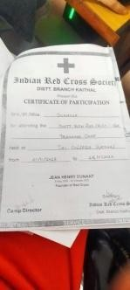
 | Cross | District | Red Cross | Related |  | n | ation
 | & Red | Level | Society, | Issues and |  | Value | BCom III
 | Ribbon | Youth Red | Kaithal | Disaster |  | s, | Pooja
 | Cell | Cross | Date- | Manageme |  | Envir | 1201960
 |  | Training |  | nt |  | onme | 03116
 |  | camp |  |  |  | nt & | BCom I
 |  | (21-11-202 |  |  |  | Sustai | Dhanisha
 |  | 2 to |  |  |  | nabilit | 1221963
 |  | 25-11-2022 |  |  |  | y | 003039
 |  | ) |  |  |  |  | Mehak
 |  |  |  |  |  |  | 1221963
 |  |  |  |  |  |  | 003038
 |  |  |  |  |  |  | Sunaina
 |  |  |  |  |  |  | 1221963
 |  |  |  |  |  |  | 003050
 | Red | Mehandi | Red Cross | Save Earth | 15 | Envir | 1st | 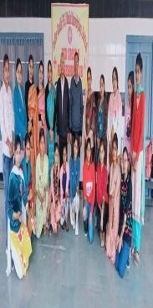
 | Cross | Competitio | & Red |  |  | onme | position
 | & Red | n On World | Ribbon |  |  | nt & | Mehar-B
 | Ribbon | AIDS | Cell |  |  | Sustai | com
 | Cell | Day(1-12-2 |  |  |  | nabilit | I(122196
 |  | 022) |  |  |  | y | 3003018)
 |  |  |  |  |  |  | 2nd
 |  |  |  |  |  |  | position
 |  |  |  |  |  |  | Sargam-
 |  |  |  |  |  |  | BA I
 |  |  |  |  |  |  | (1221962
 |  |  |  |  |  |  | 002408)

 |  |  |  |  |  |  | 3rd position Anjali-B A I(122196 3071002)
 | Red Cross & Red Ribbon Cell | Tree Decoration and Tree Plantation observance of World AIDS Day  campaign activities from 1st to 31  December( 12-12-2022  ) | Red Cross & Red Ribbon Cell | Environme nt Protection | 30 | Envir onme nt & Sustai nabilit y | Particip ation | 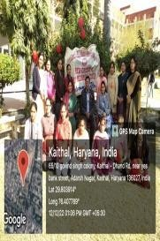
 | Red Cross & Red Ribbon Cell | HIV AIDS  awareness and Blood Testing Camp: Participants in Camp Testing of Students(16  -12-2023 | Red Cross & Red Ribbon Cell with District Red Cross society, Kaithal. | HIV AIDS  and other mental and health issues | 150  28 | Huma n Value s | Particip ation | 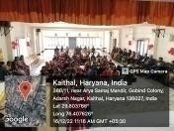
 | Red Cross & Red Ribbon Cell | Lecture on HIV/AIDS by , ICTC  Counselor Ms Sonia from CivilHospit al,Kaithal HIV  Testing  (30-1-2023) | Red Cross & Red Ribbon Cell with NSS | HIV/AIDS | 50 | Huma n Value s | Particip ation | 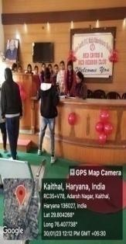

 | Red Cross & Red Ribbon Cell | First Aid Training under Disaster managemen t for welfare of society  (1 -2- 2023) | Red Cross & Red Ribbon Cell with 7th Battalion NDRF  team Bhatinda, Punjab | Conduct of Area Familiariza tion in Kaithal | 150 | Huma n Value s | Particip ation | 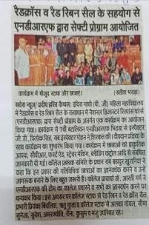
 | Red Cross & Red Ribbon Cell | Essay Writing along with Slogan Wrting Activity (27-03-202  3) | Red Cross & Red Ribbon Cell | Blood Donation, Cancer, Leprosy, Mental and Health Issues, First Aid and Disaster Manageme nt | 23 | Huma n Value s | Particip ation | 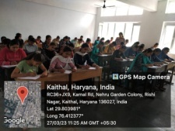
 | Red Cross & Red Ribbon Cell | Debate and Poster Making Competitio n in Observance of World Health Day(7-04-2 023) | Red Cross & Red Ribbon Cell with Commerc e Departme nt | Poster Making Impact of  Industries on Environme nt and Health of Human Beings  Debate Should food industries that are involved in genetically modified food items to be banned, Should | 15  8 | Envir onme nt & Sustai nabilit y, Huma n Value s | Poster Making: 1st position Muskan BCom I 1221963  003098  2nd position Anjali BCom III 1201960  03020  Debate: 1st position Sakshi | 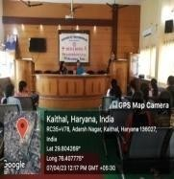

 |  |  |  | cosmetics be banned, Should animal testing be banned, Should we isolate AIDS  patients. |  |  | BCom III 1201960  03026  Rubi BCom III 1201960  03040
 | Red Cross & Red Ribbon Cell | State Level Online Poster Making Competitio n to celebrate “World Earth Day” (22-4-2023) | Youth Red Cross Cell of AHIR  College, Rewari | Environme nt | 5 | Envir onme nt & Sustai nabilit y | 1st position Ravina-B A  I-(12219 6200240  6)  3rd position Priya-BA II-(12119 6200206  8) | 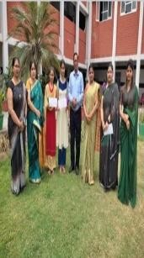

 | Red Cross & Red Ribbon Cell | National Level Online Slogan Writing Competitio n on Health, Service & Friendship in observance of “World Red Cross Day"(8-05-  2023) | I.G.M.M. V.,  Kaithal | Health, Service & Friendship | 56 | Huma n Value s | 2nd position Akshita- BSc I (1221963  015005) | 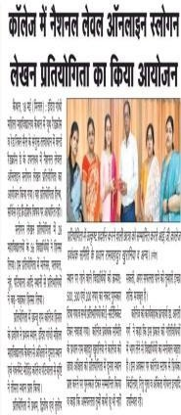
 | Red Cross & Red Ribbon Cell | National Level Online Poster Making Competitio n in celebration of World Red Cross Day(8-05-2 023) | Youth Red Cross of VaishMah ilaMahavi dyalaya, Rohtak | Humanity to Peace | 1 | Huma n Value s | 1st position  Akshita- BSc. I (1221963  015005) | 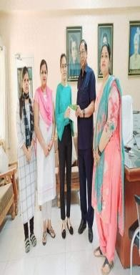
 | Red Cross & Red Ribbon Cell | National Level Online Poster Making Competitio n in celebration of World Red Cross Day(8-05-2 023) | Youth Red Cross of Dayanand MahilaMa havidyala ya, Kurukshet ra | Humanity, Change in Society through Red Cross, Selfless Service | 1 | Huma n Value s | 2nd position Akshita BSc. I (1221963  015005) | 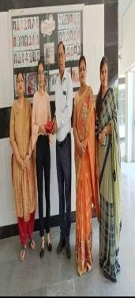

 | Red Cross & Red Ribbon Cell | National Level Online Slogan Writing Competitio n in celebration of World Red Cross Day(8-05-2 023) | Youth Red Cross of D. A.  V. College for Girls, Yamuna Nagar | Humanity, Impartiality  , Unity, Independen ce, Universalit y | 1 | Huma n Value s | 2nd position  Akshita- BSc. I (1221963  015005) | 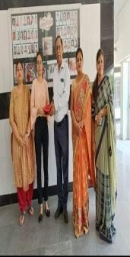
 | Red Cross and N.S.S. | Lecture on “Internation al Yoga Day” (21.06.2023  ) | I.G.M.M.  V. Kaithal | Importance of Yoga in One’s Life | 35  (All stude nts of N.S.  S.) | Envir onme nt & Sustai nabilit y | Particip ation | 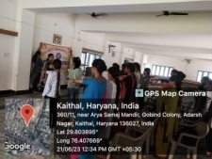
 | Red Cross & Red Ribbon Cell | National Level Online Slogan Writing Competitio n  On Topic Selfless Service & Humanity in observance of “World Red Cross day"(8-05-2 023) | I.B. (PG) College, Panipat under Youth Red Cross Cell | Selfless Service & Humanity | 1 | Huma n Value s | 1st position Simran Verma MCom Previous 2221961  68028 | 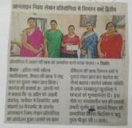

 | Red Cross and Red Ribbon Cell | Oath taking Ceremony on “Internation al Day Against Drug Abuse & Illicit Trafficking Nasha Mukt Abhiyan” (26.06.2023  ) | I.G.M.M.  V. Kaithal | Internation al Day Against Drug Abuse & Illicit Trafficking Nasha Mukt Abhiyan | All stude nts | Huma n Value s | All students | 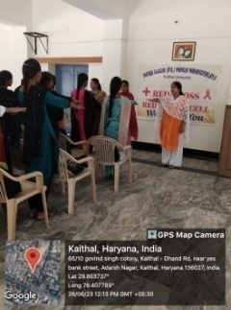
5. | NSS  Adviso ry  Cell | Har Ghar Tiranga Campaign( Awareness Rally)(13.08  .2022) | IGMMV,  Kaithal | Har Ghar Tiranga | 80 | Huma n Value s | Particip ation | 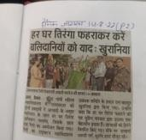
 | NSS  Adviso ry  Cell | Speech and Poem in Cultural Program (15-08-202  2) | IGMMV,  Kaithal | Har Ghar Tiranga | 100 | Huma n Value s | Particip ation | 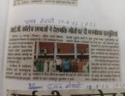
 | NSS  Adviso ry  Cell | Under the direction of Higher education dept.  Activity on Poshan maah(Sloga n Writing) (01-09-202  2) to | IGMMV,  Kaithal | Balanced Diet | 20 | Huma n Value s | Particip ation | 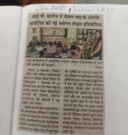

(30-09-202
2)
 | NSS  Adviso ry  Cell | Mega Swachta Drive  (19-10-202  2) | IGMMV,  Kaithal | Cleanliness | 80 | Huma n Value s | Particip ation | 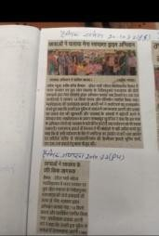
 | NSS  Adviso ry  Cell | National Integration Day (Slogan Writing and Oath Ceremony( 06-02-2023  ) | IGMMV,  Kaithal | Oath on Rashtriya Ekta | 40 | Huma n Value s | Particip ation | 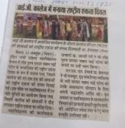
 | NSS  Adviso ry  Cell | Anti Tobacco Day ( Oath Ceremony  )(14-01-202  2) | IGMMV,  Kaithal | Oath on Anti Tobacco Day | 60 | Huma n Value s | Particip ation | 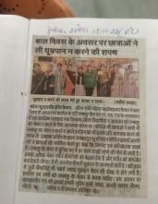
 | NSS  Adviso ry  Cell | National Youth Day (12-01-202  3) | IGMMV,  Kaithal | Life Achieveme nts of Swami  Vivekanand | 80 | Huma n Value s | Particip ation | 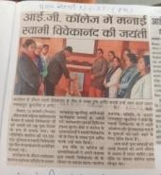
 | NSS  Adviso ry  Cell | Awareness About Traffic Rules  (18-01-202  3) | IGMMV,  Kaithal | Awareness About Traffic Rules | 80 | Huma n Value s | Particip ation | 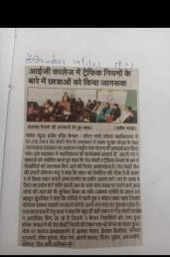
 | NSS  Adviso ry  Cell | Prakaram Diwas(Post er Making Competitio n  (23-01-202  3) | IGMMV,  Kaithal | Life Achieveme nt of Subhash Chandra Bose | 15 | Huma n Value s | 1st  Position  Priya  B.A II 1211962 002068  2nd  Position | 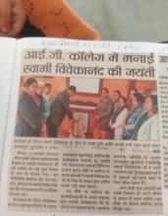

Khushi
B.A II 1211962 00020
 | NSS  Adviso ry  Cell | NSS Seven  Days-Night Camp,Tree Plantation , Oath Ceremony on voting awareness( 25-01-2023  )  to(31-01-20 23) | IGMMV,  Kaithal | Air  Pollution | 100 | Enviro  nmen t & Sustai nabilit y | Particip  ation | 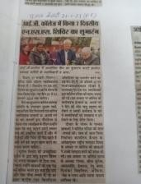
 | NSS  Adviso ry  Cell | Aids  Awareness camp(29-01  -2023) | IGMMV,  Kaithal | HIV/AIDS | 70 | Huma  n Value s | Particip  ation | 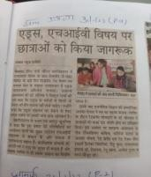
 | NSS  Adviso ry  Cell | Awareness Rally and Street play (28-01-202  3) | Village Chandana  , Kaithal | Air Pollution | 70 | Enviro nmen t & Sustai nabilit  y | Particip ation | 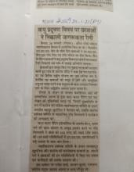
 | NSS  Adviso ry  Cell | Dialogue Competitio n on Panchpran (26-03-202  3 ) | Kurukshet ra university kuk | Nagriko Dwara Kartavya Palan ke Pnch Praan | 50 | Huma n Value s | 4th  Position  Renu,  B.A I | 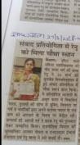
 | NSS  Adviso ry  Cell | One day camp(Arran ge a movie show of Bhim Rao Ambedkar for | IGMMV  Kaithal | Life Achieveme nts of Dr.  B.R.  Ambedkar | 100 | Huma n Value s | Particip ation | 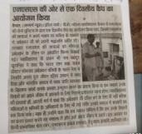

students)(1
4.04.2023)
6. | Alumni | Alumni Meet  (13-10-202  3) | IGMMV,  Kaithal | Alumni Meet | 160 | Huma n Value s | Particip ation | 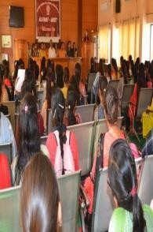
7. | Road Safety Club | Meeting (11.03.2023  ) | IGMMV,K  aithal | Road Safety | 05 | Huma n Value s | 5  faculty members | 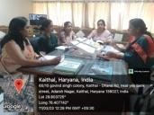
 |  | Road Safety Poem Competitio n (14.03.2023  ) | IGMMV,K  aithal | Road Safety | 06 | Huma n Value s | 1st  Position  Saloni  B.A II 66  2nd  Position  Khushi  B.A II 310  3rd  Position  Monika  M.A II 03 | 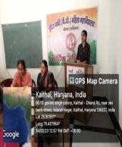
 |  | State Level Meeting at Sectreate (13.09.2023  ) | Police Departme nt | Road Safety Quiz Competitio n | 1 | Huma n Value s | Dr. Deepa Atri | 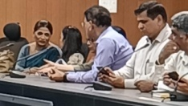

 |  | Road Safety Quiz Competitio n 13.10.2023 | IGMMV,K  aithal | Road Safety | 130 | Huma n Value s | 1st  Position Neha B.Sc II 1211963  015021  2nd  Position  Khushi  B.A I 1231349 383  3rd  Position  Muskan  B.A I 1231349 215 | 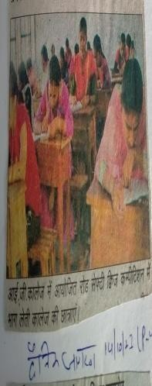
 |  | Road Safety Quiz Competitio n  (14-10-202  3) | Police Officer transport ation, kurukshet ra | Road Safety | 105 | Huma n Value s | 1st  Position Neha B.Sc II 1211963  015021  2nd  Position  Khushi  B.A I 1231349 383  3rd  Position  Muskan  B.A I | 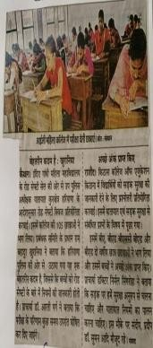

1231349
215
 |  | Road Safety Quiz Competitio n  (30-10-202  3) | Police Officer transport ation, kurukshet ra | Road Safety | 03 | Huma n Value s | 1st  Position Neha B.Sc II 1211963  015021  2nd  Position  Khushi  B.A I 1231349 383  3rd  Position  Muskan  B.A I 1231349 215 | 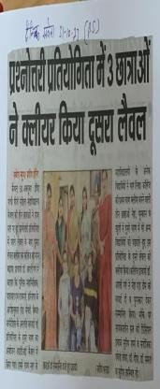
 |  | District Level Inter School Road Safety Quiz  Level-  (10-11-202  3) | Police Officer transport ation, kurukshet ra | Road Safety | 03 | Huma n Value s | 2nd  Position in District level Neha  B.A III 108  Khushi  B.A I 1231349 383  Muskan  B.A I | 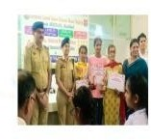

1231349
215
8. | Anti-R agging Cell | Poster Making Competitio n on Topic “Ragging is a crime” (01.05.2023  ) | I.G.M.M.  V.Kaithal | Ragging is a crime | 14 | Huma n Value s | 1st Position Manisha  B.A II 322  2nd Position Bhavna Msc(Fina l) 2211961  75009 | 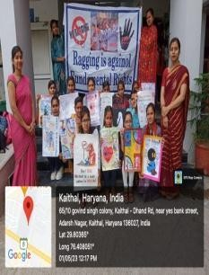
 | Anti-R agging Cell | State Level Cultural Fest(Poster Making Competitio n) (08.04.2023  ) | Dayanand Mahila Mahavidy alaya, Kurukshet ra | 1)The Effects of Ragging 2)Dress Code Ragging 3)Sexual Abuse 4)Anti Ragging Movement | 01 | Huma n Value s | Nikita BA III 343 | 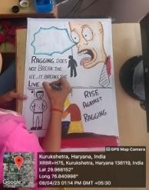
9. | Anti-to bacco cell | No smoking pledge on (14-11-202  2) | I.G.M.M.  V. Kaithal | No smoking pledge | U.G.  and P.G.  Stud ents | Huma n Value s | Particip ation | 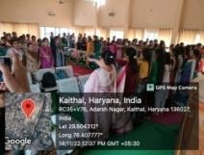

 | Anti- tobacco cell | Online State Level Poster Making and Slogan writing competition  (14-11-202  2) | Arya Kanya Mahavidy alaya , Shahabad Markanda | To spread awareness about the risk of tobacco use | 6 | Huma n Value s | Poster making 1st Position Ravina BA I  Slogan Writing 1st Position Komal Dahiya BA I | 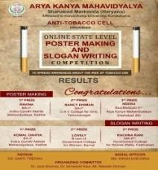  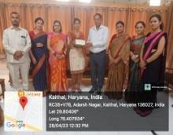
 | Anti-to bacco cell | Poster Making Activity “Stop Smoking Protect your Brain Health” (07-03-  2023) | I.G.M.M.  V. Kaithal | Stop Smoking Protect your Brain Health | 16  stude nts of UG  and PG  stude nts | Huma n Value s | Particip ation | 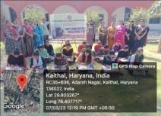
 | Anti-to bacco cell | National level online poster making competition topic “Choose Health not Tobacco” (08-03-202  3) | Mata SundriKh alsa girls college , Nissing,K arnal | Choose Health not Tobacco | 5 | Huma n Value s | Komal BA I  Ravina BA I | 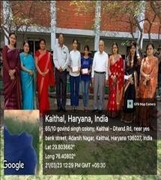
 | Anti-To bacco cell | Online Internationa l essay writing competition “ Role of modern women in drug  eradication | CISKMV  Dhand Dadwana Karnal | Role of modern women in drug eradication from the society | 2 | Huma n Value s | Bhawna | 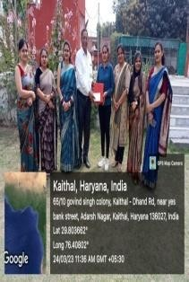

from the society” on (10-03-202
3)
10. | Elector al Club | Slogan Writing and Poem Writing on Topic “My Vote Matters” (04.08.2022  ) | I.G.M.M.  V. Kaithal | My Vote Matters | 4 | Huma n Value s | Particip ation | 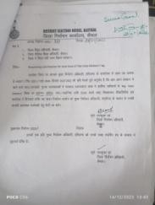
 | Elector al Club | Slogan Writing, Rangoli,Me handi,Speec h, Quiz Competitio n on Topic “Making Elections inclusive accessible and Participativ e” (01.11.2022  ) | I.G.M.M.  V. Kaithal | Making Elections inclusive accessible and Participativ e | 15 | Huma n Value s | Particip ation | 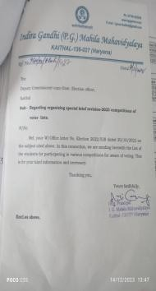
 | Elector al Club | District Level Essay Writing, Speech Competitio n on Topic “Making Elections inclusive accessible and Participativ e” (22.11.2022  ) | R.K.S.D.P  .G.  College, Kaithal | Making Elections inclusive accessible and Participativ e | 3 | Huma n Value s | Particip ation | 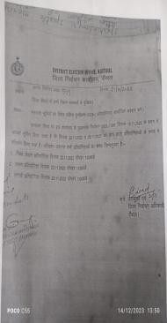

 | Elector al Club | District Level Rangoli Competitio n on Topic “Making Elections inclusive accessible and Participativ e” (25.11.2022  ) | R.K.S.D.P  .G.  College, Kaithal | Making Elections inclusive accessible and Participativ e | 2 | Huma n Value s | Particip ation | 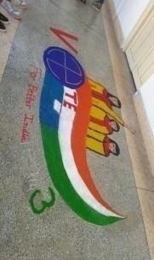
 | Elector al Club | Online State Level Poster Making Competitio n on Topic “ G20  India” (26.03.2023  ) | Mukand Lal National College Yamunana gar (Haryana) | G20 India | 1 | Huma n Value s, Envir onme nt & Sustai nabilit y | 1st Position Bhavna Msc(Fina l) 2211961  75009 | 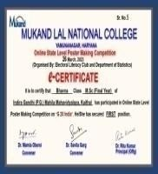
 | Elector al Club | Online National Quiz Contest on Theme: Law and Rights (India) (28.03.2023  ) | Mukand Lal National College Yamunana gar (Haryana) | Law and Rights (India) | 46 | Huma n Value s | Particip ation | 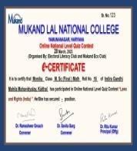
11. | IQAC | National Science Day Online Poster Making and Slogan Writing Competiti on | I.G.M. M.V.  College, Kaithal | 1)Scien ce saves lives  2)Futur e vision towards science | 2  0 | Profes sional Ethics | Poster Making  1st positio n  Preeti B.Sc. I  2nd positio | 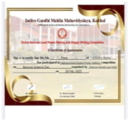

 |  | (28.02.20  23) |  |  |  |  | n Parmve er Kaur B.Sc.  III  Slogan Writing  1st positio n  Muskan B.Sc.  III  2nd positio n Geetanj aliB.Sc. III
 |  | National Level Online Essay Writing and Poster Making Competiti on (06.03.20  23) | I.G.M. M.V.  College, Kaithal | Mathemati cs is the Mother of Science | 32 | Profes sional Ethics | Partici pation  Akshita B.Sc. I  Bharti B.Sc I | 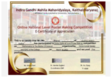
 |  | Late Lala Amarnath Khurania State Level | I.G.M. M.V.  College, Kaithal | 1)Women Empowerm ent: A Political Pretence | 80  par tici pan ts | Gend er, Huma n Value | 5  differen t activiti es were

 |  | Cultural Fest (25.03.20  23) |  | 2)Changing Scenario of Indian Culture 3)Impact of Social Media on Youth | fro m 16  diff ere nt coll ege s |  | there with 3 positio ns and 1  consola tion prize in each | 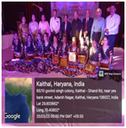
 |  | State Level Cultural Fest (08.04.20  23) | D.N.Col  lege, Kuruksh etra | Women Empowerm ent | 18 | Gend er | Poster Making  3rd positio n Priya  B.A. II  PPt  Consol ation  Akshita B.Sc. I | 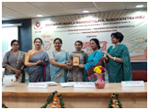
12. | ICCAS  H Cell | NukkarNat ak on the theme of “Women exploitation and harassment ” on (09⁻12-  2022) | I.G.M.M.  V.Kaithal | Women exploitatio n and harassment | M.A  Econ omic s stude nts | Gend er | Particip ation | 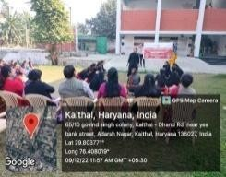
 | ICCAS  H Cell | Self defense training programme on  31-03-2023 | I.G.M.M.  V.Kaithal | Self defense | U.G  and P.G  stude nts | Gend er | Particip ation | 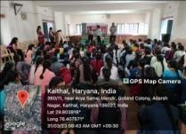

14. | Swami Viveka nanda Youth  Cell | National Youth Day  12-01-2023 | IGMMV,  Kaithal | Motivating the youth | All the stude nts | Huma n Value s | All the students | 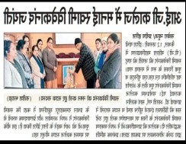
 | Swami Viveka nanda Youth Cell | Presentatio n Program  10-04-2023 | IGMMV,  Kaithal Departme nt of commerce | Presentatio n | 40 | Huma n Value s | B.Com. II  Students | 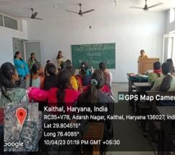
15. | Cultura l Affairs | Hawan Ceremony (22.08.2022  ) | IGMMV  Kaithal | Hawan Ceremony | 7 | Huma n Value s | Participa tion Tamanna B.Com II,  Neha  B.A. III, Sakshi BA III, Reshma BA III, Komal BA III, Monika BA III, Pooja BA II
 | Cultura  l Affairs | Talent Hunt Solo Song and Instrument Playing (1.10.2022) | IGMMV  Kaithal | Music | 13 | Profes sional Ethics | 1st  position Tamanna BCom II,  2nd position BCom I Navjot, 3rd position BA III  Shakshi, In Solo  Song | 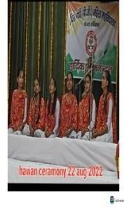

 | Cultura l Affairs | Zonal Youth Festival Folk Song Haryanvi solo (15.10.2022  to 17.10.2022) | Babu Anant Ram Janta College Kaul, Kaithal | Folk Song | 1 | Profes sional Ethics | Participa tion  BA I  Aarju 1221960  3002079 | 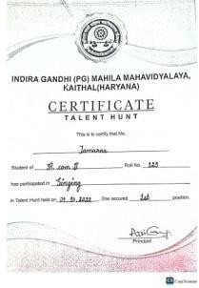
 | Cultura  l Affairs | Zonal Youth  Festival Solo Dance Haryanvi (15.10.2022  to 17.10.2022) | Babu  Anant Ram Janta College Kaul, Kaithal | Haryanvi  Culture | 1 | Profes  sional Ethics | Participa  tion  BA III  Komal 225 | 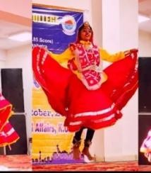
 | Cultura  l Affairs | Zonal Youth  Festival Group Song General (15.10.2022  to 17.10.2022) | Babu  Anant Ram Janta College Kaul, Kaithal | Music | 6 | Profes  sional Ethics | 3rd  position Khushi BA III,  Navjot BCom I, Aarzoo BA I,  Komal BSc. I,  Seema BA I,  Tamanna BCom II | 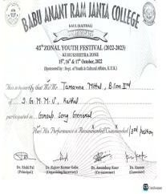
 | Cultura  l Affairs | Zonal Youth Festival Folk Song General (15.10.2022  to 17.10.2022) | Babu Anant Ram Janta College Kaul, Kaithal | Music | 1 | Profes sional Ethics | 3rd position  Navjot BCom I 1221963  003046 | 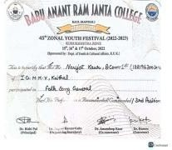
 | Cultura  l Affairs | Zonal Youth  Festival Folk Instrument al Solo (15.10.2022 | Babu  Anant Ram Janta College Kaul, Kaithal | Folk  Instrument al Solo | 1 | Profes  sional Ethics | 2nd  position Khushi BA III 1201960  02153 | 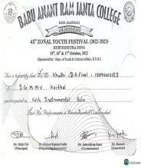

to
17.10.2022)
 | Cultura l Affairs | Zonal Youth Festival Group Song Haryanvi (15.10.2022  to 17.10.2022) | Babu Anant Ram Janta College Kaul, Kaithal | Haryanvi Group Song | 6 | Profes sional Ethics | 3rd position Khushi BA III,  AarzooB A I,  PoojaBA II,  NehaBA III | 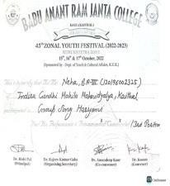
 | Cultura l Affairs | Zonal Youth Festival POP Song Haryanvi (15.10.2022  to 17.10.2022) | Babu Anant Ram Janta College Kaul, Kaithal | POP Song Haryanvi | 12 | Profes sional Ethics | 2nd position | 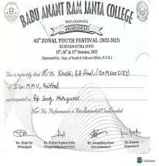
 | Cultura  l Affairs | NSS  Function Group Song (31.01.2023  ) | IGMMV  Kaithal | NSS  Function Group Song | 7 | Profes  sional Ethics | Participa  tion Khusi BA III, Neha BA III  Komal BA III,  Navjot BCom I, Pooja BA II, Aarju BA I, Anu BA II | 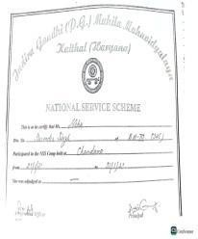
 | Cultura  l Affairs | Birth  Ceremony of Om Prabha Jain Group song (06.02.2023  ) | IGMMV  Kaithal | Life  Achieveme nts of Late Smt. Om Prabha Jain | 7 | Huma  n Value s | Participa  tion Khusi BA III, Neha BA III  Komal BA III,  Reshma BA III,  Pooja BA | 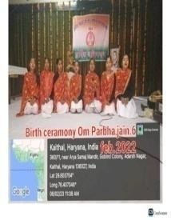

II, Aarju BA I, Anu
BA II
 | Cultura l Affairs | Shanno Devi Function Group Song (14.02.2023  ) | IGMMV  Kaithal | Life Achieveme nts of Late Smt.  Shanno Devi | 6 | Huma n Value s | Participa tion Khushi BA III,  Komal BA III,  NavjotBC om I, ReshmaB A III, AnuBA II,  Aarju BA I | 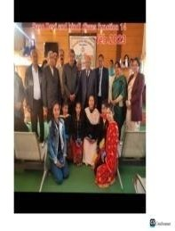
 | Cultura  l Affairs | State Level Cultural Festival General Folk Solo (25.03.2023  ) | IGMMV  Kaithal | Folk Song | 1 | Profes sional Ethics | 1st  Position Navjot BCom I 1221963  003046 | 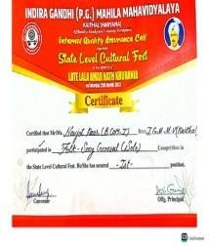
 | Cultura l Affairs | State Level Cultural Festival Folk Dance Solo (25.03.2023  ) | IGMMV  Kaithal | Folk Dance | 1 | Profes sional Ethics | 2nd  Position Rinku BA III  118 | 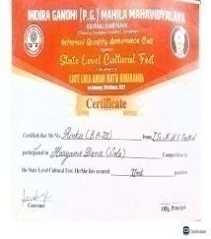
 | Cultura l Affairs | State Level Cultural Festival Gap Items Singing (25.03.2023  ) | IGMMV  Kaithal | Music | 8 | Profes sional Ethics | Participa tion KhushiBA III,  NavjotBC om I, ReshmaB A III,  SeemaBA I, Aarju BA I,  Pooja BA II | 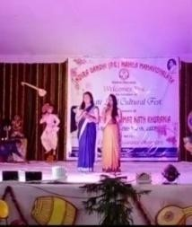

16 | Researc h Cell | PowerPoint Presentatio n on “How to conduct Research Work”  (06.12.2022  ) | I.G.M.M. V.  Kaithal | How to conduct Research Work |  | Profes sional Ethics | All M.A English, M.Com,  M.A Eco, Students Participat ed | 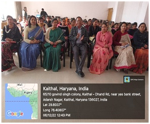
 | Researc h Cell | Online One day International Webinar Topic भगवदगीता : सां4ययोग  (30.04.2023) | Dept. of Sanskrit IGMMV  Kaithal | भगवदगीता :  सां4ययोग | 120 | Huma n Value s | Organize d by Sanskrit Departm ent | 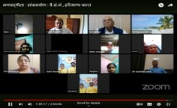
 | Researc h Cell | Seminar on “General Research Tactics”  By Dr. Suruchi Sharma Prof. RKSD College Kaithal (15.02.2023  ) | I.G.M.M. V.  Kaithal | General Research Tactics |  | Profes sional Ethics | All M.A English, M.Com,  M.A Eco, and M.sc Maths Students and Faculty Member s Participat ed | 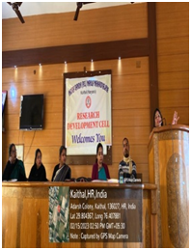
1. | Politica l Science | State Level Essay Writing Competitio n (10.12.2022  ) | Governme nt College for Women Karnal | The Political Rights of Women, Gender Equality | 5 | Gend er | 2nd Position Muskan  B.A. II 1221962 002134 | 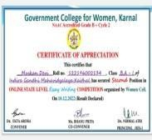

 | Politica l Science | National Level Quiz Competitio n (03.03.2023  ) | Aggarwal College Ballabgar h | G20  Nations | 30 | Profes sional Ethics | 2nd Position Neha BA IInd 1221962  002108 | 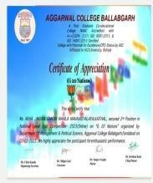
 | Politica l Science | Poster Making Competitio n (02.03.2023  ) | I.G.M.M.  V. Kaithal | Drug  De-addictio n, Right to Education | 19 | Huma n Value s | 1st Position Komal, 2nd Position Sarabjeet  , 3rd Position Priya | 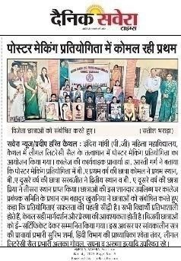
 | Politica l Science | State Level Yuva Samvad  (26.03.2023  ) | National Service Scheme KUK  University | Yuva Samvad | 2 | Profes sional Ethics | 4th Position Renu BA I | 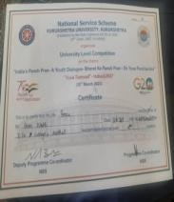
 | Politica l Science | Essay Writing Competitio n (10.03.2023  ) | I.G.M.M.  V. Kaithal | Legal Literacy: Responsibil ity of all | 13 | Huma n Value s | 1st Position Muskan  B.A. II 1221962 002134  BA Ist, 2nd Neha BA IInd | 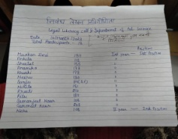
 | Politica l Science | National Level Online Quiz Competitio n (25.03.2023  ) | Babu Anant Ram Janta College Kaul Kaithal | Contributio n of Political Thinkers in Indian Freedom Struggle | 7 | Huma n Value s | Participat ed | 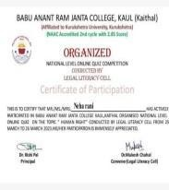

 | Politica l Science | National Level Online Quiz Competitio n (28.03.2023  ) | M.L.N.  College Yamuna Nagar | Laws and Rights (India) | 30 | Huma n Value s | Participat ion | 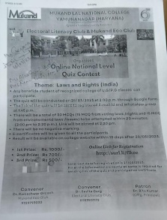
 | Politica l Science | Inter National Level Online Essay Writing Competitio n (10.03.2023  ) | Ch. Ishwar Singh Kanya Mahavidi alaya | Legal Literacy and Awareness | 10 | Huma n Value s | Participat ed
 | Politica l Science | District Level Skit Competitio n (27.10.2023  ) | IGMMV  Kaithal | Voter Registratio n : Why and how to do? | 10 | Huma n Value s | 3rd Mansi, Komal, Pooja, Nancy, Tanu Gill, Vani, Chahat, Payal,  Siwani, Sneha | 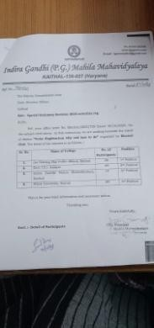
 | Politica l Science | State Level Quiz Competitio n (09.04.2023  ) | IGMMV  Kaithal | Fundament al Rights and Duties | 87 | Huma n Value s | 1st Position Dayanan d Mahila Mahavid yalya, Kuruksht ra  2nd Position IGMMV,  Kaithal DAV  College, Cheeka | 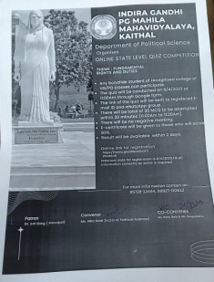

3rd Position Govt.
College, Narnaul
2. | Comme  rcial Arts | Painting  Competitio n | Talent  Hunt Organise d by I.G(PG).M  .M.V,  Kaithal. 01-10-202  2 | Traditional  Indian Art Azadi ka Amrit Mohotsav | 45 | Profe  ssion al Ethic s | 1st Prize  Sarbjeet  B.A III 1201960 02311  IInd Prize Sonia  B.A 2nd 12119620 02361 | 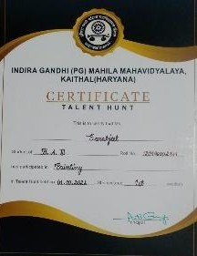
 |  | Poster Making Competitio n | I.G(PG).M  .M.V,  Kaithal. 01-10-202  2 | Global Warming, Climate Change, Women Empowerm ent  Azadi ka Amrit Mohotsav | 31 | Profe ssion al Ethic s | Ist Prize Priya  B.A 2nd 12119620 02068  IInd Prize Nikita  B.A 3rd 12119620  02343 | 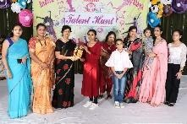  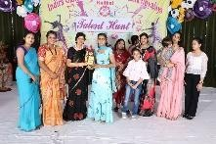
 |  | Cartooning Making competitio n | 45th Zonal Youth Festival (2022-23)  organize d at Babu Anant Ram Janta College, Kaul (Kaithal) . Sponsore d by  Departme | Satire on Politics | 01 | Profe ssion al Ethic s | Ist Prize (  Trophy+ Certifica te ) Geeta  B.A 1st 12219620 02086 | 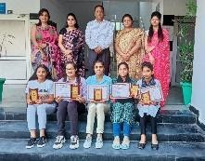

nt of Youth & Cultural Affairs Kurukshe tra Universit y,Kuruks hetra
15-10-202
2 to
17-10-202
2
 |  | Collage Making competitio n | Babu Anant Ram Janta College, Kaul (Kaithal) | Digital India | 01 | Profe ssion al Ethic s | Ist Prize (  Trophy+ Certifica te ) Komal  B.A 1st  12219630  02010 | 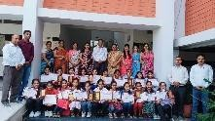
 |  | Installation | Babu Anant Ram Janta College, Kaul (Kaithal) | Atmanirbh ar Bharat | 04 | Profe ssion al Ethic s | 3rd Prize (Certific ate)  1.Niharik a  B.A 3rd 1201960 02311  - Komal B.A1st 12219630 02010  - Nikita B.A 3rd120196 002343 4. Rachna B.A1st 12219630  02064 | 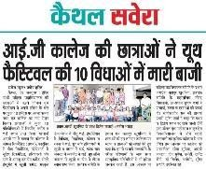

 |  | Poster Making competitio n | Online State Level Poster Making and Slogan Writing Competit ion organize d by  Anti-Toba cco Cell of Arya Kanya Mahavidy alaya, Shahabad Markand a(Haryan a).  14-11-202  2 | Anti-Tobac co | 05 | Hum an Value s | Ist Prize (E-Certif icate+Rs  .500/-)  Komal  B.A 1st 12219630 02010 | 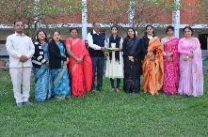
 |  | Slogan Writing competitio n | Arya Kanya Mahavidy alaya, Shahabad Markand a(Haryan  a) | Anti-Tobac co | 05 | Hum an Value s | Ist Prize (E-Certif icate+Rs  .500/-)  Ravina  B.A 1st 12219620 02406
 |  | Poster Making Competitio n | IGMMV,K  aithal organize d Poster Making competiti on on occasion of Subhas Chandra Bose’s 126th | Life Achievem ents of Subhash Chandra Bose | 15 | Hum an Value s | IstPrize Priya B.A  IInd12119 6200206  8  IInd Prize Khushi | 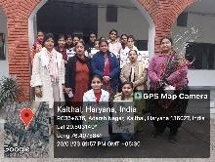  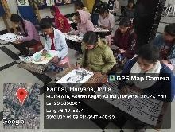

 |  |  | Jayanti, also known as Parakram Diwas .  20/01/202  3 |  |  |  | B.A IInd12119 6200020
 |  | On the spot painting | IGMMV,  Kaithal organized On the spot Painting & Slogan writing competiti on under Legal Literacy Cell on 03/02/20  23 | Female Foeticide, Child Labour, Drugs  De-addictio n, Senior Citizen Rights | 15 | Gend er, Hum an Value s | Ist Prize Priya B.A  IInd12119 6200206  8  IInd Prize Ravina  B.A 1st 12219620 02406  3rd Prize Nikita  B.A 3rd  1201960  02343 | 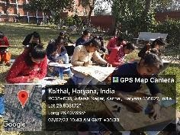
 |  | Slogan Writing Competitio n | IGMMV,  Kaithal 03/02/20  23 | Female Foeticide, Child Labour, Drugs  De-addictio n, Senior Citizen Rights | 15 | Gend er, Hum an Value s | Ist Prize Komal  B.A 1st 12219630 02010  IInd Prize Mehak  B.A 1st ( 12219620 02200)  IIIrd Prize Khushi B.A IInd12119 6200020 | 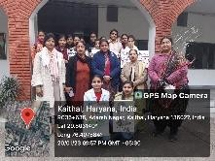

 |  | On the Spot Painting | District Level Competit ion organised by Dr. B. R.  Ambedka r Governm ent College, Kaithal under Legal Literacy Cell 06/02/20  23 | Save Girl Child | 02 | Gend er | 1st Prize (Certific ate) Ravina  B.A 1st 12219620 02406  IIIrd Prize (Certific ate) Priya B.A  IInd12119 6200206  8 | 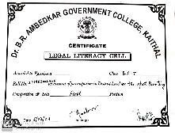  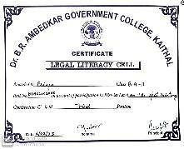  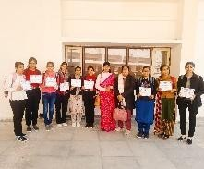  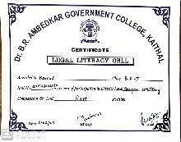  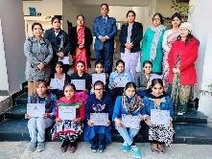
 |  | Slogan Writing Competitio n | District Level Competit ion organize d by Dr.  B. R. Ambedka r Governm ent College, Kaithal under Legal Literacy Cell 06/02/20  23 | Save Girl Child | 02 | Gend er | Ist Prize (Certific ate) Komal  B.A 1st 12219630 02010

 |  | Poster Making Competitio n | National Level Online Poster Making competiti on organize d by RKSD  college, Kaithal under women cell  27/02/23 | Save Girl Child, Equality and Education for Girl Child, Our Rights, Our Future | 05 | Gend er, Hum an Value s | 3rd Prize Nikita  B.A 3rd 1201960 02343 | 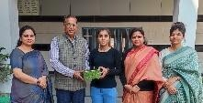  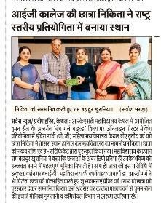
 |  | Poster Making Competitio n | IGMMV,K  aithal organize d Poster Making Competit ion under Legal Literacy Cell 03/03/202  3 | Drug de  -addiction  , Right to Education, Sexual Harassme nt | 16 | Hum an Value s, Gend er | Ist Prize (Certific ate) Komal  B.A 1st 12219630 02010  IInd Prize (Certific ate) Sarbjeet B.A3rd 1201960  02311  IIIrd Prize (Certific ate) Priya B.A  IInd12119 6200206  8 | 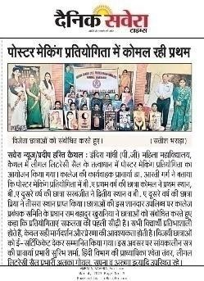  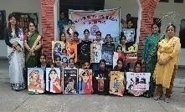  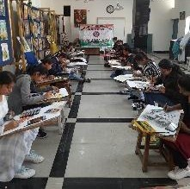

 |  | Poster Making Competitio n | National Level Online Poster Making and Slogan writing Competit ion organize d by Mukand Lal National College, Yamuna Nagar under Women Study Cell 17/03/202  3 | Innovation and Technolog y for Gender Equality | 04 | Gend er | IInd Prize Mehak  B.A 1st 12219620 02200 | 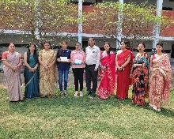
 |  | Slogan Writing Competitio n | Govt. College for Girls, Palwal, Kurukshe tra organize d National Level Poster Making & Slogan Writing Competit  ion | Save Mother Nature Earth | 02 | Envir onme nt and Susta inabil ity | Ist Prize Sarbjeet  B.A 3rd 1201960 02311  IInd Prize Komal  B.A 1st 12219630 02010 | 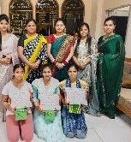

18/03/202
3
 |  | Poster Making Competitio n | Govt. College for Girls, Palwal, Kurukshe tra organize d National Level Poster Making & Slogan Writing Competit ion 18/03/202  3 | Save Mother Nature Earth | 02 | Envir onme nt and Susta inabil ity | IInd Prize Sonia  B.A 2nd 12119620 02361 | 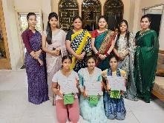
 |  | Poster Making Competitio n | National Level Online Poster Making Competit ion organize d by Mata Sundri Khalsa Girls College Nissing,K arnal Under Women Cell and Anti Tobacco Cell 21/03/202  3 | Choose Health not Tobacco,P ublic Health , Smoking Prevention s | 04 | Hum an Value s | Ist Prize (E-Certif icate+Rs  .500/-)  Komal  B.A 1st 12219630 02010/II nd Prize (E-Certif icate+Rs  .400/-)  Ravina  B.A 1st 12219620 02406 | 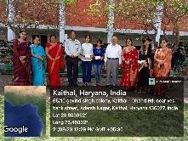

 |  | Poster Making Competitio n | Poster Making Competit ion Organize d by Ch.Ishwa r Singh Kanya Mahavidy alaya,Dha nd in Collabora tion of IGMMV,K  aithal  22-03-202  3 | Role of Women in Indian National Movement 1857-1947 | 07 | Gend er | Ist Prize Khushi B.A IInd12119 6200020  IIIrd Prize Sonia  B.A 2nd 12119620 02361 |   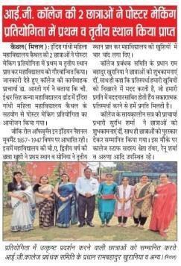
 |  | Painting competitio n | Commerc ial Art Departme nt organize d Painting competiti on on the occasion of World Water Day at IGMMV,  Kaithal. 22-03-202  3 | Save Water, Save Life | 11 | Envir onme nt and Susta inabil ity | Ist Prize Priya B.A  IInd12119 6200206  8  IInd Prize Komal  B.A 1st 12219630 02010 | 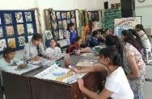  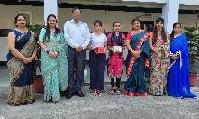

 |  | Poster Making Competitio n | IGMMV,K  aithal organize d State Level Cultural Fest in the memory of Late Lala Amar Nath Khurania under IQAC 25/03/202  3 | Impact of Social Media on Youth | 02 | Hum an Value s | IInd Prize(Ce rtificate  +  Trophy) Komal  B.A 1st 12219630 02010  Consolat ion  Prize (Gift) Priya B.A  IInd12119 6200206  8 | 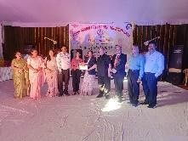  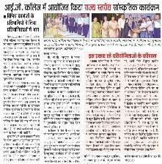
 |  | Poster Making | State Level Cultural Fest organize d by Dayanan d Mahila , Mahavidy alaya,Kur ukshetra 08-04-20  23 | Women Empower ment | 02 | Gend er | IIIrd Prize Priya B.A  IInd12119 6200206  8  Participa tion Nikita  B.A 3rd 1201960 02343 | 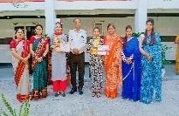
 |  | Best out of waste | Dayanan d Mahila , Mahavidy alaya,Kur ukshetra 08-04-20  23 | Decorative Item | 01 | Profe ssion al Ethic s | Participa tion Niharika  B.A 3rd 1201960 02311 | 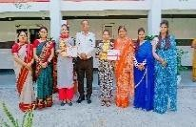

 |  | Collage Making | Dayanan d Mahila , Mahavidy alaya,Kur ukshetra 08-04-20  23 | G20 | 01 | Profe ssion al Ethic s | Participa tion Komal  B.A 1st 12219630 02010
 |  | Canvas Painting | Departme nt of Commerc ial Art of IGMMV,  Kaithal organize d 3 Days Painting worksho p on the occasion of “Internati onal Art Day.”  13-04-202  3 to  15-04-202  3 | Modern Art Paintings | 35 | Profe ssion al Ethic s | 1. Ist Position (Rs.1100/  - Cash Prize by Mr.  Narende r Miglani  )  Komal  B.A 1st 12219630 02010  Mehak  B.A 1st 12219620 02200  - IInd Position (Rs. 500 Cash prize by Mr. Narende r Miglani) Asha  /Manish a B.A  IIIrd  - IIIrd Position (Rs. 500 cash | 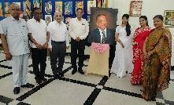  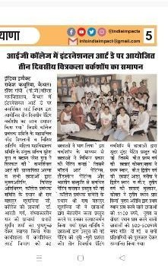

Prize by Mr.
Narende r Miglani) Muskan
/Komal
B.A IInd
 |  | On the Spot Painting | Division Level Legal Literacy Cell competiti ons organize d at P. Chiranjila l Sharma Govt.  College Karnal 18/04/23 | Save Girl Child | 02 | Gend er | Ist Prize (Certific ate+Rs.5 100/-  Cash) Priya B.A  IInd12119 6200206  8  IIndPrize (Certific ate+Rs.3 100/-)  Ravina  B.A 1st 12219620 02406 | 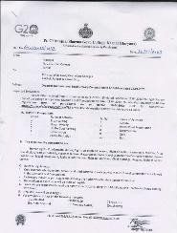
 |  | Slogan Writing | Division Level Legal Literacy Cell competiti ons organize d at P. Chiranjila l Sharma Govt.  College Karnal  18/04/23 | Save Girl Child | 01 | Gend er | IstPrize (Certific ate+Rs.5 100/-)  Komal  B.A 1st 12219630 02010

 |  | Rangoli Competitio n | State Level Competit ion organize d by I.B(PG)  College , Panipat under Legal Literacy Cell and Women Cell  26-04-202  3 | Legal Rights of Women in India | 02 | Gend er | Ravina/B  .A 1st (1211962  002406)-  Participa ted Seema/B  .A 1st (1211962  002357)-  Participa ted | 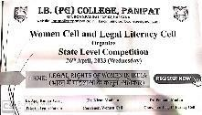
 |  | Poster Making Competitio n | State Level Competit ion organize d by I.B(PG)  College , Panipat under Legal Literacy Cell and Women Cell  26-04-202  3 | Legal Rights of Women in India | 02 | Gend er | Priya  /B.A IInd(1211 9620020  68)-Parti cipated Komal/B. A 1st (1221963  002010)-  Participa ted
 |  | Best Out of Waste | Arya PG College, Panipat organize d State Level Annual Inter College Academic  & | Wall Clock | 02 | Profe ssion al Ethic s | First Prize got Certifica te+Rs.21 00/-  cash prize Nikita  B.A 3rd  1201960  02343 | 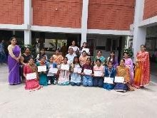  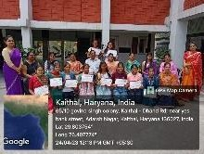

 |  |  | Cultural Fest.  21/04/202  3 |  |  |  | Niharika  B.A 3rd 1201960 02311
 |  | Collage Making Competition | State Level Inter college competiti ons organize d at S.A Jain (PG) College by Commerc e Associati on.  21/04/202  3 | Atmanirbh ar Bharat / Made in India | 02 | Profe ssion al Ethic s | Ist Prize Komal  B.A 1st 12219630 02010  Participa ted Geeta  B.A 1st 12219620 02086 | 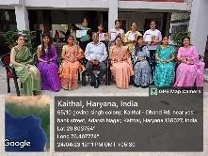  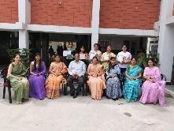
 |  | Poster Making Competitio n | State Level Online Poster Making Competit ion organize d by AHIR  College, Rewari to celebrate World Earth Day 22/04/202  3 | World Earth Day | 02 | Envir onme nt and Susta inabil ity | Ist Position Ravina  B.A 1st 12119620 02406  IIIrd Position Priya  B.A IInd 12119620 02068 | 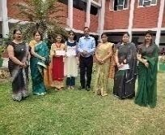

 |  | Poster Making Competitio n | KAV D.A.V  College for Women, Karnal organize d Online State Level Poster Making , Declamat ion & Essay Writing competiti on 24/04/202  3 | Human Rights, Fundamen tal Duties, Drug  D-addictio n, Rights to Informatio n | 02 | Hum an Value s | Participa ted Komal  B.A 1st 12219630 02010  Participa ted Ravina  B.A 1st 12119620 02406 | 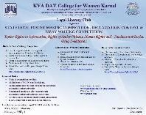
 |  | Poster Making Competitio n | National Level Poster Making & Slogan Writing Competit ion organize d by IGMMV  Kaithal under Women Cell 25/04/202  3 | Stand up for women | 01 | Gend er | IInd Position (Rs.  300/-  Cash prize ) Priya B.A  IInd12119 6200206  8 | 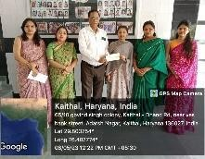  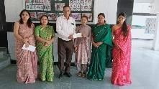

 |  | WildLife Photograp hy | National Level Wild Life Photogra phy Competit ion organize d by Biology & Prakriti Associati on of Dyal Singh College , Karnal on the occasion of Earth Day .  26-04-202  3  Result  -01-06-20  23 | WildLife | 01 | Envir onme nt & Susta inabil ity | IInd Prize Nikita  B.A 3rd 1201960 02343 | 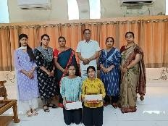  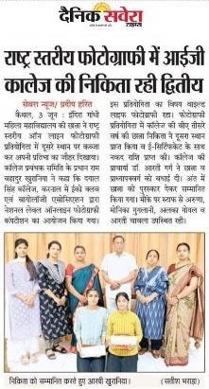
 |  | Slogan Writing Competitio n | State Level Online Slogan Writing & Poster Making Competit ion organize d by Departme nt of Economi cs, English, Pol.  Science &  NCC with | Source Sustainabil ity for Drinking Water | 02 | Envir onme nt & Susta inabil ity | IInd Prize Komal  B.A 1st 12219630 02010

the collabora tion of the Ministry of Jal Shakti, Govt. of India, Ministry of Educatio n & Departme nt of Babu Anant Ram Janta College, Kaul.
29-04-202
3

 |  |  |  |  |  |  |  | 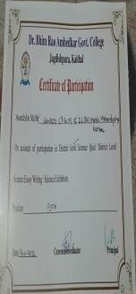
3 | Bota | Quiz | BR | Science | 6 | Professiona | 3rd Position
 | ny | competitio | Ambedkar |  |  | l Ethics | Manju(1201960
 |  | n | College |  |  |  | 15022),
 |  |  | Kaithal |  |  |  | Tanisha(120196
 |  |  |  |  |  |  | 030003),
 |  |  |  |  |  |  | Garima(120196
 |  |  |  |  |  |  | 015023),
 |  |  |  |  |  |  | 5th Position
 |  |  |  |  |  |  | Samriti(120196
 |  |  |  |  |  |  | 015019),
 |  |  |  |  |  |  | Neha(12019601
 |  |  |  |  |  |  | 5064), Deepika
 |  |  |  |  |  |  | (120196030040
 |  |  |  |  |  |  | )Selected for
 |  |  |  | Science | 6 |  | Zonal Level | 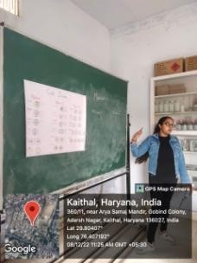
 | Botany | the Topics | Kaithal |  |  | Ethics | Mafi(12119630
 |  | according |  |  |  |  | 15015),
 |  | to the |  |  |  |  | Neha(12119630
 |  | syllabus |  |  |  |  | 3003),
 |  | (16.11.202
 |  | 2) to |  |  |  |  | Kajal(12119630
 |  | (16.12.202 |  |  |  |  | 15006)
 |  | 2)

 | Bota ny | Chart Making on the topic Pollution control and awareness (02.12.202  2) | I.G.M.M.V  Kaithal | Pollution control and awareness | 25 | Environme nt & Sustainabili ty | B.Sc Final Students | 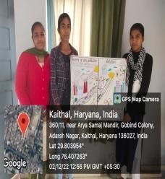
 | Bota | National | I.G.M.M.V | Science | 20 | Environme | 1st Position | 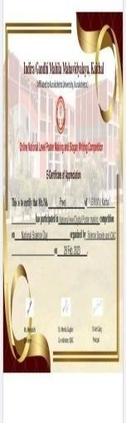
 | ny | Science | Kaithal | Saves |  | nt & | Preeti(1221963
 |  | Day Poster |  | Lives and |  | Sustainabili | 030008) in
 |  | and Slogan |  | future |  | ty | Poster Making
 |  | Writing on |  | Vision
 |  | Science |  | towards
 |  | Saves |  | Science
 |  | Lives and
 |  | future
 |  | Vision
 |  | towards
 |  | Science
 |  | (27.02.202
 |  | 3)
 | Bota | Sugar Mill | The Kaithal | Sugar Mill | 40 | Professiona | B.Sc Medical | 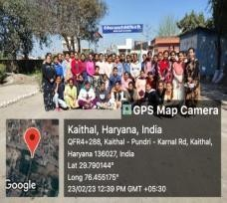
 | ny | Industrial | Sehkari | Industrial |  | l Ethics | Students
 |  | Visit | Sugar Mill | Visit
 |  | (23.02.202 | Karnal Road
 |  | 3)
 | Bota | National | Science | Science | 2 | Professiona | Participation | 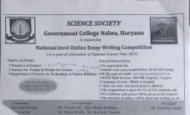
 | ny | Science | Society | for People |  | l Ethics | Ritika(1211963
 |  | Day Essay | Govt. | and |  |  | 030001),
 |  | Writing | College | People for |  |  | Nancy(1201960
 |  | (27.02.202 | Nalwa | Science |  |  | 15039)
 |  | 3)
 | Bota | National | Mahila | Wonders | 2 | Professiona | Participation | 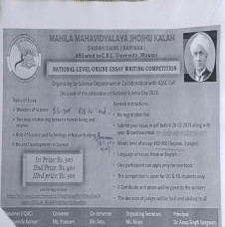
 | ny | Science | Mahavidiyal | of Science |  | l Ethics | Ritika(1211960
 |  | Day Essay | a Jhojhu |  |  |  | 30001),
 |  | Writing | Kalan |  |  |  | Tammana(1201
 |  | (27.02.202 | Charkhi |  |  |  | 96015046)
 |  | 3) | Dardi

 | Bota ny | National Science Day Essay Writing (27.02.202  3) | Mukhtiar Singh Memorial PG College Behbal apur Fathabad | Role of Green Energy on Environm ent Conservati on | 2 | Environme nt & Sustainabili ty | Participation Neha(12019601 5072),  Sakshi(1201960 15047) | 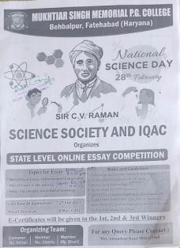
 | Bota ny | Science Quiz and Poster (25.02.202  3) | KUK | Energy Transmissi on Digital Economy | 3 | Professiona l Ethics | Participation Ritu(122196301 5057),  Tammana (122196301504  9)in Science Quiz, Chitra(1221963 015073) in  Poster Making | 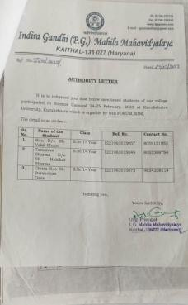
 | Bota ny | Career Guidance Seminar by Ms.  Chitralekha (28.02.202  3) | I.G.M.M.V  Kaithal | Career Guidance Seminar | 70 | Professiona l Ethics | All B.Sc Students | 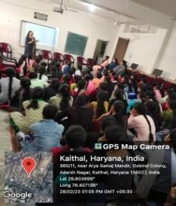
 | Bota ny | Chattbir Zoo Trip (12.03.202  3) | I.G.M.M.V  Kaithal | Chattbir Zoo Trip | 47 | Environme nt & Sustainabili ty | B.Sc Medical Students | 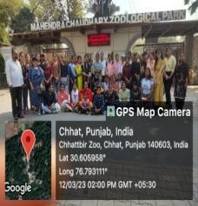
 | Bota | Zonal | Govt. Post | Science | 6 | Professiona | 3rd Position | 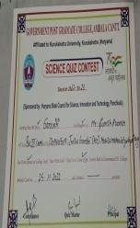
 | ny | Level Quiz | Graduate |  |  | l Ethics | Manju(1201960
 |  | Competitio | College |  |  |  | 15022),
 |  | n | Ambala |  |  |  | Tanisha(120196
 |  | (25.11.202 | Cantt. |  |  |  | 030003),
 |  | 2) |  |  |  |  | Garima
 |  |  |  |  |  |  | (120196015023
 |  |  |  |  |  |  | ),
 |  |  |  |  |  |  | 5th Position
 |  |  |  |  |  |  | Samriti(120196
 |  |  |  |  |  |  | 015019),
 |  |  |  |  |  |  | Neha(12019601
 |  |  |  |  |  |  | 5064),

Deepika(12019 6030040)
Selected for Zonal Level
 | Bota ny | Gardening Workshop (05.04.202  3) | I.G.M.M.V.  Kaithal | Gardening Workshop | 60 | Environme nt & Sustainabili ty | All B.sc Medical Students  Participated | 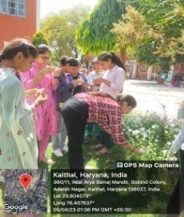
 | Bota ny | Science Model Exhibition (19.04.202  3 to  20.04.2023  ) | I.G.M.M.V.  Kaithal | Satellite Communi cation Sugar Mill | 75 | Professiona l Ethics | All B.sc Students Participated | 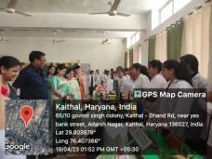
4. | Che | District | BR | Physics, | 6 | Professiona | 3rd Position | 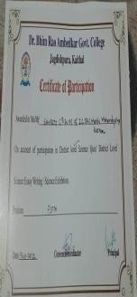
 | mist | Level Quiz | Ambedkar | Chemistry, |  | l Ethics | Manju(1201960
 | ry | competitio | College | Maths, |  |  | 15022),
 |  | n | Kaithal | Biology |  |  | Tanisha(120196
 |  | (19.10.202 |  |  |  |  | 030003),
 |  | 2) |  |  |  |  | Garima
 |  |  |  |  |  |  | (120196015023
 |  |  |  |  |  |  | ),
 |  |  |  |  |  |  | 5th Position
 |  |  |  |  |  |  | Samriti(120196
 |  |  |  |  |  |  | 015019),
 |  |  |  |  |  |  | Neha(12019601
 |  |  |  |  |  |  | 5064),
 |  |  |  |  |  |  | Deepika(12019
 |  |  |  |  |  |  | 6030040)
 |  |  |  |  |  |  | Selected for
 |  |  |  |  |  |  | Zonal Level
 | Che | Zonal | Govt. Post | Physics, | 6 | Professiona | Participation | 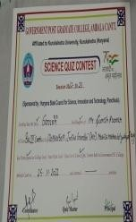
 | mist | Level Quiz | Graduate | Chemistry, |  | l Ethics | Manju(1201960
 | ry | Competitio | College | Maths, |  |  | 15022)
 |  | n | Ambala | Biology |  |  | ,
 |  | (25.11.202 | Cantt. |  |  |  | Tanisha((12019
 |  | 2) |  |  |  |  | 6030003),
 |  |  |  |  |  |  | Garima(120196
 |  |  |  |  |  |  | 015023),

 |  |  |  |  |  |  | Samriti(120196
 |  |  |  |  |  |  | 015019),
 |  |  |  |  |  |  | Neha(12019601
 |  |  |  |  |  |  | 5064),
 |  |  |  |  |  |  | Deepika(12019
 |  |  |  |  |  |  | 6030040)
 | Che mist ry | Seminar on the Topic Thermodyn amic and  d-blocks (16.11.202  2) | I.G.M.M.V  Kaithal | Thermody namic and d-blocks | 13 | Professiona l Ethics | Participation Mafi(12119630 15015), Neha(12119630 3003),  Kajal(12119630 15006) B.Sc 2nd | 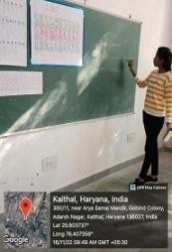
 | Che | Chart | I.G.M.M.V | Chemistry | 30 | Professiona | Participation | 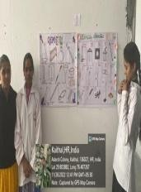
 | mist | Making on | Kaithal | in |  | l Ethics | Preeti(1211963
 | ry | the topic |  | Everyday |  |  | 03012),
 |  | Related to |  | Life |  |  | Prerna(1221963
 |  | Chemistry |  |  |  |  | 030010),
 |  | in |  |  |  |  | Muskan(122196
 |  | Everyday |  |  |  |  | 3015003)
 |  | Life
 |  | (26.11.202
 |  | 2)
 | Che | National | I.G.M.M.V | Science | 20 | Professiona | 1st Position | 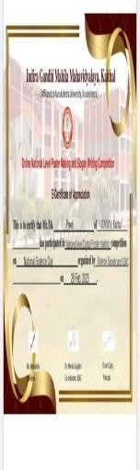
 | mist | Science | Kaithal | Saves |  | l Ethics | Preeti(1211963
 | ry | Day Poster |  | Lives and |  |  | 03012) in
 |  | and Slogan |  | future |  |  | Poster Making
 |  | Writing on |  | Vision
 |  | Science |  | towards
 |  | Saves |  | Science
 |  | Lives and
 |  | future
 |  | Vision
 |  | towards
 |  | Science
 |  | (27.02.202
 |  | 3)
 | Che | National | R.K.S.D. | Food | 3 | Environme | Participation | 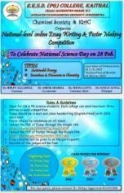
 | mist | Science | PG College | Adulterati |  | nt & | Ankita(1221963
 | ry | Day Poster | Kaithal | on, |  | Sustainabili | 015047),
 |  | and Essay |  | Importanc |  | ty | Akshita(122196
 |  | Writing |  | e of Water |  |  | 3015005) in
 |  |  |  | for Good |  |  | Poster Making

 |  | (28.02.202  3) |  | Health, Distillatio n of Water |  |  | and Sanita(1201963 0018) in Essay  Writing
 | Che mist ry | National Science Day Essay Writing (27.02.202  3) | Science Society Govt.  College Nalwa | Science for People and People for Science | 2 | Environme nt & Sustainabili ty | Participation Ritika(1211963 030001),  Nancy(1201960 15039) | 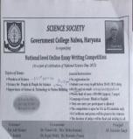
 | Che mist ry | National Science Day Essay Writing (27.02.202  3) | Mahila Mahavidiyal a Jhojhu Kalan Charkhi Dardi | Wonders of Science | 2 | Professiona l Ethics | Participation Ritika(1211963 030001,  Tammana(1201 96015046) | 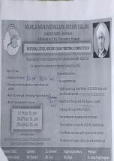
 | Che  mist ry | National  Science Day Essay Writing (27.02.202  3) | Mukhtiar  Singh Memorial PG College Behbal apur Fathabad | Role of  Green Energy on Environm ent Conservati on | 2 | Environme  nt & Sustainabili ty | Participation  Neha(12019601 5072),  Sakshi(1201960 15047) | 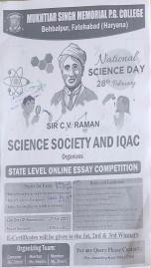
 | Che  mist ry | Science  Quiz and Poster (25.02.202  3) | KUK  University | Science | 3 | Professiona  l Ethics | Participation  Ritu(122196301 5057),  Tammana(1221 963015049) in  Science Quiz, Chitra(1221963 015073) in  Poster Making | 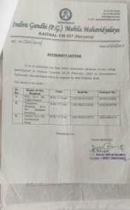
 | Che mist ry | Seminar on the Basic Concept Of Chemistry (13.03.202  3 to  27.03.23) | I.G.M.M.V  Kaithal | Basic Concept Of Chemistry | 20 | Professiona l Ethics | Participation Tannu(1211963 015013) Mafi(12119630 15015) Kajal(12119630  15006) | 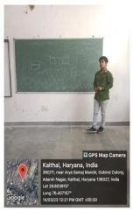
 | Che mist ry | Seminar on the topic solutions (16.03.202  3 to  20.03.23) | I.G.M.M.V  Kaithal | Solutions | 15 | Professiona l Ethics | Participation Tammana(1221 963015073)  Deepika(12019 6030040) | 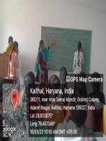

 | Che mist ry | Power point presentatio n on the topic s block, Vanderwaa l forces(  27.03.23) | I.G.M.M.V  Kaithal | S block, Vanderwa al forces | 20 | Professiona l Ethics | Participation Shiwani(12313 55048) | 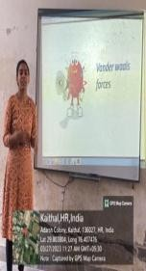
 | Che mist ry | Model Exhibition on the topics Food Adulteratio n and distillation of water (19.4.23  and 20.03.23) | I.G.M.M.V  Kaithal | Food Adulterati on and distillation of water | 75 | Environme nt & Sustainabili ty | Participation Karamjeet(1221 963015015),  Preeti(1221963 030008),  Akshita(122196 3015005), | 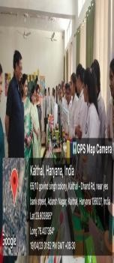
5 | Co mpu ter Scie nce | PPT  Competitio n Topic on Artificial Intelligenc e, Internet of Things, 5G,  Wireless Technolog y (31.10.202  2) | I.G.M.M.V.  Kaithal | Artificial Intelligenc e, Internet of Things, 5G,  Wireless Technolog y | 10 | Professiona l Ethics | 1st Position Muskan(121196 2011019) BCA II,  2nd Position  Komal BCA I,  3rd Position Tamnna (121963015036  )  BSc. I | 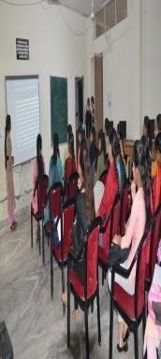
 | Co mpu ter Scie nce | District Level PPT Competitio n topic on “Protection of Women against Domestic Violence (06.02.202  3) | Dr. B.R.  Ambedkar College Kaithal | Protection of Women against Domestic Violence | 2 | Professiona l Ethics | 1^{s} ^{t} Position Anju(12119620 11003),  Muskan(121196 2011019)  BCA II | 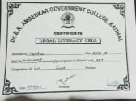

 | Co mpu ter Scie nce | Logos Recognitio n Competitio n (17.03.202  3) | I.G.M.M.V.  Kaithal | Technical Logos | 30 | Professiona l Ethics | - | 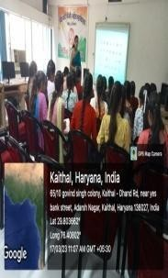
 | Co mpu ter Scie nce | PPT  Competitio n (21.03.202  3) | I.G.M.M.V.  Kaithal | 5G  Technolog y, AI,  Cyber Security | 15 | Professiona l Ethics | 1st Position Muskan(121196 2011019) BCA II,  2nd Position  Shalu BCA I,  3rd Position Simran BA II | 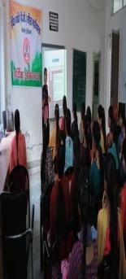
 | Co mpu ter Scie nce | Online National Level Poster Making Competitio n Topic on “Addiction of Mobile Phone” (28.03.202  3) | G.V.M.  Girls College, Sonipat | Addiction of Mobile Phone | 2 | Professiona l Ethics | 2nd Position Bhawna, 3rd Position  Bhawna M.Sc Final | 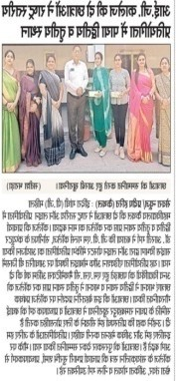
 | Co mpu ter Scie nce | State Level Cultural Fest (08.04.202  3) | Dayanand Mahila Mahavidyal aya, Kurukshetra | Cyber Attacks | 1 | Professiona l Ethics | Participation, Muskan(121196 2011019)  BCA II | 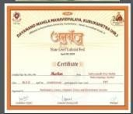
 | Co mpu ter Scie nce | Division Level Competitio n (18.04.202  3) | Pt. Chiranji Lal Sharma Govt.  College, Karnal | Domestic Violence Against Women | 2 | Gender | 3rd Position Muskan(121196 2011019),  Anju(12119620 11003) BCA II | 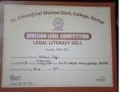
 | Co mpu ter Scie  nce | State Level Business Plan Competitio  n | S.A. JAIN(PG)  College, Ambala | Plastic Roads | 4 | Professiona l Ethics | Consolation, Anju Rani(12119620 11003), BCA II | 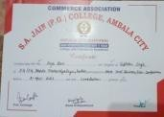

(21.04.202
3)
 | Co mpu ter Scie nce | State Level Legal Literacy Competitio n (25.04.202  3) | Shri Mata Mansa Devi Govt.  Sanskrit Mahavidyal aya, Panchkula | Domestic Violence Against Women | 1 | Gender | 3rd Position Muskan(121196 2011019)  BCA II | 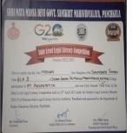
 | Co  mpu ter Scie nce | State Level  Business Plan Competitio n (26.04.202  3) | Maharaj  Agrasen Mahavidyal aya, Jagadhri | Plastic  Roads | 1 | Professiona  l Ethics | (Participation)  Muskan BCA II | 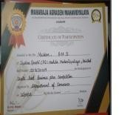
 | Co mpu ter Scie nce | State Level Business Plan Competitio n (26.04.202  3) | Maharaj Agrasen Mahavidyal aya, Jagadhri | Plastic Roads | 2 | Professiona l Ethics | Participation,  Simran BA II | 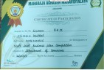
 | Co mpu ter Scie nce | Online National Level Poster Making Competitio n Topic on “Internatio nal Labour Day” (27.04.202  3 –  02.05.2023  ) | M.D.S.D  College, Ambala | Internatio nal Labour Day | 1 | Professiona l Ethics | 1st Position  Muskan BCA II | 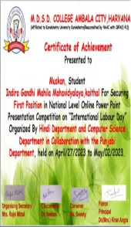
6 | Zo olo gy | Quiz Competiti on (19.10.20  22) | B.R.  Ambedka r College Kaithal | Science | 6 | Professiona l Ethics | 3rd Position Manju(120196 015022),  Tanishq(12019 6030003)  Garima(12019 6015023),  5th Samriti(12019

6015019), Neha(1201960 15064),
Deepika(1201 96030040)
 | Zo  olo gy | Natio  nal Level Digita l Poster  Making and Slogan Writin g Compe tition  (28.02.20  23) | I.G.M.M.V  .  Kaithal | Science  Saves Life | 2 | Environm  ent & Sustainabi lity | 1st Position  Preeti (12219630300  08)
 | Zo olo gy | Sugar Mill Kaithal Trip (23.02.20  23) | I.G.M.M.V  .  Kaithal | Sugar Mill Kaithal Trip | 4  1 | Professiona l Ethics | Participation Preeti(122196 30300008),  Deepika(1201 96030040),  Tammna, (12019601504  6)
 | Zool ogy | Career Guidance Seminar by Ms.  Chitralek ha  Deptt. of Science (27.02.20  23) | I.G.M.M.V  .  Kaithal | Career Guidanc e Seminar | 6  6 | Professiona l Ethics | Participation Loveleen(122 1963030014),  Kajal(1211963 015006),  Lovelesh(1221 963015068), Tanu(1211963 015013)
 | Zo olo gy | Educati onal Trip Chhatbir Zoolog ical  Park | I.G.M.M.V  .  Kaithal | Educati onal Trip Chhatbi r  Zoolo gical | 5  0 | Professiona l Ethics | Participation Preeti(122196 3030008),  Loveleen(122 1963030014),  Simran(121196

 |  | (12.03.  2023) |  | Park |  |  | 303016), Neha(12119630  3003)
 | Zool ogy | Science Exhibitio n ( 19.04.23-  20.04.202  3) | I.G.M.M.  V. Kait hal | Satellit e Comm unicati on Sugar Mill | 1  2 | Professiona l Ethics | Participation Preeti(122196 63030008),  Kajal(1211963 015006),  Loveleen(122 1963030014),  Prerna(122196 3030010),  Deepika((1201 96030040),
 | Eco no mic s De part me nt | Field visit SARVA HARYANA GRAMIN BANK,  Huda sector 20  (21.10.2022  ) | I.G.M.M.V.  Kaithal | SARVA HARYAN A GRAMIN BANK, | M. A  and B. A  Ec ono mic s stu den ts | Professional Ethics | Participation | 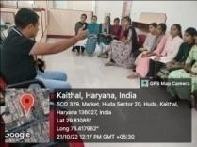
7 | Eco  no mic s De part me nt | Qualified  NTA Net examinatio n  (13,  03.2023) | I.G.M.M.V.  Kaithal | Qualified  NTA Net examinati on | Bh  aw na M  uw al | Professional  Ethics | - | 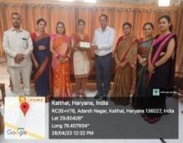
 | Eco  no mic s De part me nt | Power  Point Presentatio n  (21.03.  2023) | I.G.M.M.V.  Kaithal | Banking,  Poverty, Inflation, Budget 2023-24 | M.  A  and B. A  Ec ono mic s stu den ts | Professional  Ethics | Participation | 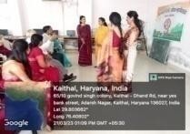

 | Eco no mic s De part me nt | Collage making competitio n  (08-04-202  3) | Commerce and Economics society of DayanandM ahilaMahavi dyalaya | Industries of India | ko ma l of B A  Fir st (E  co no mi cs  ) | Professional Ethics | Participation | 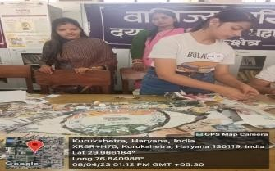
 | Eco no mic s De part me nt | National Level Online Quiz Completio n  (17. 04.  2023) | Commerce and Economics of Hindu Kanya Mahavidyal aya , JiArya nd | Commerc e and Economic s | M. A  and B. A  Ec ono mic s stu den ts | Professional Ethics | Participation | 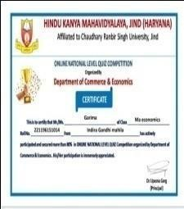
 | Eco  no mic s De part me nt | Declamation  Competition in  Dishayen-2 023  (21  .04.2023) | Arya P.G.  College , Panipat | Women  Empowerm ent | M  A  Ec ono mic s stu den t An nu Sha rm a | Professional  Ethics, Gender | Participation | 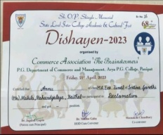

8 | Mat hs | Online PowerPoint Competitio ns on Mathemati cs is the mother of all sciences and Contributio n of Indian Mathemati cs in Contempor ary Mathemati cs (22.12.202  2) | Department of Mathematic s, KKR.  University | Mathemati cs is the mother of all sciences and Contributi on of Indian Mathemati cs in Contempo rary Mathemati cs | 2 | Professiona l Ethics | Khushboo MSc I , Pooja MSc I, Khushboo MSc I got selected from District Kaithal for further face to face participation in the PPT competition to be held on at KKR  University) | 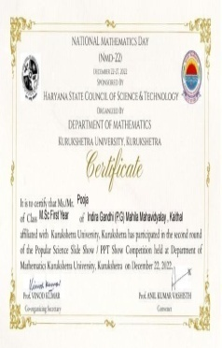
 | Mat hs | National Level Online Quiz Competitio n to Commemo rate 135th Birth Anniversar y of Legendary Mathemati cian Srinivasa Ramanuja m (22.12.202  2) | Saraswati Mahila Mahavidyal aya, Palwal | To Commem orate 135th Birth Anniversa ry of Legendary Mathemati cian Srinivasa Ramanuja m | 3 | Human Values | 2nd Position  Kajal Mittal  B.A II 1211962002053 | 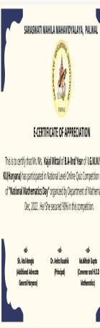
 | Mat hs | Power Point Competitio n on Mathemati cs is the mother of all sciences  (27.12.202  2) | Department of Mathematic s, KKR.  University | Mathemati cs is the mother of all sciences | 1 | Professiona l Ethics | Khushboo M.Sc I 222196175004 | 
 | Mat hs | Extension Lecture on Importance of Metric Space by Dr. Indu Gaba from Dr. B.R.A.  Govt. College Kaithal (24.02.202  3) | I.G.M.M.V  Kaithal | Importanc e of Metric Space | 20  0 | Professiona l Ethics | M.Sc, B.Sc,  B.A. Maths | 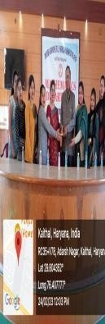
 | Mat hs | Power Point Presentatio n on Mathemati cs in Everyday Life, Contributio n of Indian Mathemati cians in contempor ary mathematic s (24.02.202  3) | I.G.M.M.V  Kaithal | Mathemati cs in Everyday Life, Contributi on of Indian Mathemati cians in contempor ary mathemati cs | 30 | Professiona l Ethics | M.Sc III Math 1st Position Kajal , 2nd Position Komalpreet,3rd Position Menka | 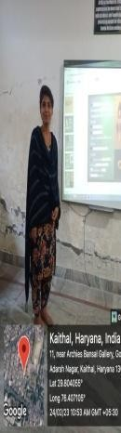
 | Mat hs | National Level Online Poster Making Competitio n on ‘Innovation and Technolog y for gender equality’  (08.03.202  3) | M.D.S.D.  College Ambala City | ‘Innovatio n and Technolog y for gender equality’ | 3 | Gender | 1st Position  Usha M.sc P  Participation Bhavna M.sc Final Khushboo M.sc P | 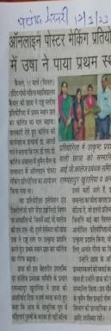
 | Mat hs | National Level Online Essay Writing Competitio n on ‘Shaping the World Better for Women’ (08.03.202  3) | Shah Satnam Ji Girls College Sirsa | Shaping the World Better for Women | 4 | Gender | 2nd Position  Akshita B.sc I  3rd Position Kajal M.sc Final,  Participation Usha M.sc P, Menka M.sc Final | 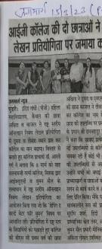

 | Mat hs | National Level Online Poster Making Competitio n on ‘Innovation and Technolog y for gender equality’ (08.03.202  3) | Mukand Lal National College Yamuna Nagar | Innovation and Technolog y for gender equality | 2 | Gender | 1st Position Bhavna M.sc Final,  Participation Khushboo M.sc P | 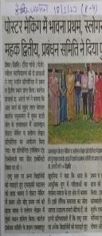
 | Mat hs | National Level Online Slogan Writing Competitio n on ‘Innovation and Technolog y for gender equality’ (08.03.202  3) | Mukand Lal National College Yamuna Nagar | Innovation and Technolog y for gender equality | 1 | Gender | Participation Khushboo M.sc P 222196175004 | 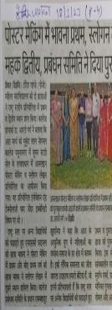

 | Mat hs | Inter National Level Online Essay Writing Competitio n on Role of Modern Women In drug Eradication from the society (10.03.202  3) | Ch. Ishwar Singh Kanya Mahavidyal aya Dhand DadwanaKa ithal | Role of Modern Women In drug Eradicatio n from the society | 2 | Gender | 1st Position Bhavna M.sc Final,  Participation Khushboo M.sc P | 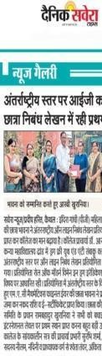
 | Mat hs | National Level Online Poster Making Competitio n on Gender Equality (13.03.202  3) | Mata Sundri Khalsa Girls College Nissing Karnal | Gender Equality | 1 | Gender | Participation Bhavna M.sc Final 221196175009 | 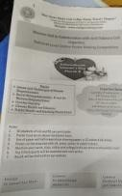
 | Mat hs | National Level Online Poster Making Competitio n on Mathemati cs is the Mother of Science (16.03.202  3) | I.G.M.M.V.  Kaithal | Mathemati cs is the Mother of Science | 32 | Professiona l Ethics | Participation Akshita Bharti B.Sc I 1221963015005 | 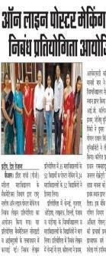

 | Mat hs | National Level Online Essay Writing Competitio n on Mathemati cs is the Mother of Science (16.03.202  3) | I.G.M.M.V.  Kaithal | Mathemati cs is the Mother of Science | 50 | Professiona l Ethics | 1st Position Bhavna M.Sc Final,  Participation Khushboo M.sc P | 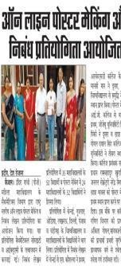
 | Mat hs | Online National Level Quiz Competitio n on Human Rights (25.03.202  3) to (26.03.202 3) | Babu Anant Ram Janta College Kaul Kaithal | Human Rights | 1 | Human Values | Bhavna M.sc Final 221196175009  got 100/100 | 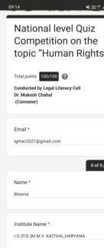
 | Mat  hs | Online  National Level Poster Making Competitio n on Addiction of Mobile Phone (28.03.202  3) | G.V.M.  Girls College Sonipat | Addiction  of Mobile Phone | 3 | Human  Values | 2nd Position  Bhavna M.sc Final,  3rd Position Bhawana M.sc Final | 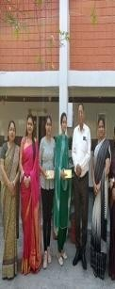
 | Mat hs | Online State Level Essay Writing Competitio n on “The Effects of Raggingan d Sexual  Abuse” | I.G.M.M.V.  Kaithal | The Effects of Ragging and Sexual Abuse | 2 | Gender | 2nd Position Bhavna M.sc Final,  Usha M.sc P | 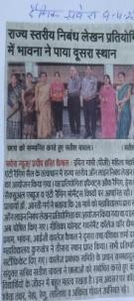

(28.03.202
3)
 | Mat hs | Online National Level Quiz Contest on the theme “Laws and Rights (India)” (28.03.202  3) | Mukand Lal National College Yamuna Nagar | Laws and Rights (India) | 23 | Human Values | M.sc Final Students 1st position Bhawna | 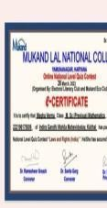
 | Mat hs | Mathemati cs Model Exhibition on General Mathemati cs (05.04.202  3) | I.G.M.M.V.  Kaithal | General Mathemati cs | 40 | Human Values | Participation Usha Msc Previous(22219 61175008)  2nd Position Bhawna(Msc Final) (221196175009  ) | 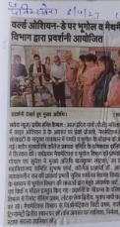
 | Mat hs | Online National Level Article Writing Competitio n on Public Health and Economic Developme nt (07.04.202  3) | I.B. (PG) College Panipat | Public Health and Economic Developm ent | 1 | Professiona l Ethics | Participation Bhavna M.sc Final (221196175009  ) | 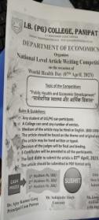
 | Mat hs | State Level Power Point Presentatio n Competitio n on Role of Mathemati cs for  Make Up India | Dayanand Mahila Mahavidyal aya Kurukshetra | Role of Mathemati cs for Make Up India | 1 | Professiona l Ethics | Consolation Akshita B.sc 1st (122196301500  5) | 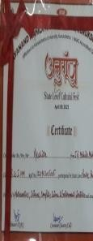

(08.04.202
3)
 | Mat hs | State Level Sanskrit Song Competitio n (08.04.202  3) | Dayanand Mahila Mahavidyal aya Kurukshetra | Song | 1 | Professiona l Ethics | Poonam M.sc Final (221196175019  ) | 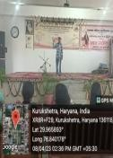
 | Mat hs | Online National Level Creative Ad-Designi ng and Making Competitio n (12.04.202  3) | Vaish Mahila Mahavidyal aya,Rohtak | Creative Ad-Desig ning and Making Competiti on | 1 | Professiona l Ethics | 1st Position Akshita B.Sc. 1st  (122196301500  5) | 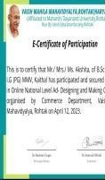
 | Mat hs | State Level Inter College Debate Competitio n on topic Artificial Intelligenc e:Boon or Bane (21.04.202  3) | S.A. Jain(P.G.) College, Ambala City | Artificial Intelligenc e:Boon or Bane | 1 | Professiona l Ethics | 3rd Position Payal B.Sc. 1st (122196301501  1) | 
 | Mat hs | State Level Inter College Declamatio n Competitio n on topic Atmanirbh ar Bharat (21.04.202  3) | S.A. Jain(P.G.) College, Ambala City | Atmanirbh ar Bharat | 1 | Professiona l Ethics | 3rd Position Karmjeet B.Sc. 1st (122196301501  5) | 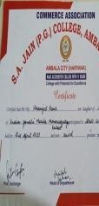

 | Mat hs | State Level Inter College Business Plan Competitio n on topic Plastic Roads (21.04.202  3) | S.A. Jain(P.G.) College, Ambala City | Plastic Roads | 2 | Professiona l Ethics | Consolation  Muskan, (121196201101 9)Anju B.C.A.  2nd (121196201100  3) | 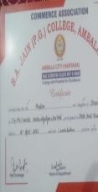
 | Mat hs | State Level Annual Inter College Declamatio n Contest (21.04.202  3) | Arya(P.G.)C  ollege,Panip at | Absence of a Student in Student | 1 | Human Values | Participation Akshita B.Sc. 1st (122196301500  5) | 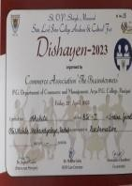
 | Mat hs | State Level Annual Inter College Best Out Of Waste Competitio n (21.04.202  3) | Arya(P.G.)C  ollege,Panip at | Best Out Of Waste | 1 | Professiona l Ethics | 1st Position Nikita B.A. 3rd Mathematics (120196002343  ) | 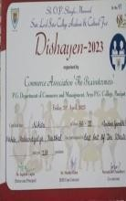
 | Mat hs | Online National Level Essay Writing Competitio n on topic Ground Water-Mak ing the Invisible,V isible (22.04.202  3) | I.G.M.M.V.  Kaithal | Ground Water-Ma king the Invisible, Visible | 1 | Environme nt & Sustainabili ty | 2nd Position  Akshita B.Sc. 1st  (122196301500  5) | 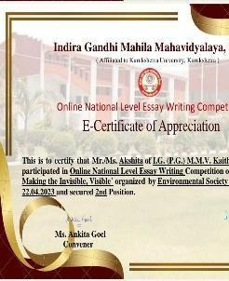

 | Mat hs | State Level Online Mathemati cs Quiz Competitio n (24.04.202  3) | Guru Nanak Khalsa College,Ya munanagar | Mathemati cs | 16 | Professiona l Ethics | 1st Position  Poonam B.A. 2nd  (121196200225  6)  Payal B.Sc. 1st 3rd Position (122196301501  1) | 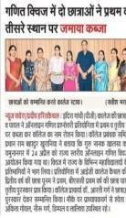
 | Mat hs | Online National Level Video Resume Competitio n (25.04.202  3) | R.K.S.D.  College Kaithal,Har yana | Video Resume | 1 | Professiona l Ethics | Participation Akshita B.Sc. 1st (122196301500  5) | 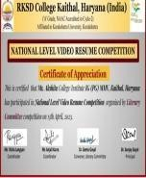
 | Mat hs | Online National Level Tagline Writing Competitio n on the product related to FMCG  sector. (25.04.202  3) | Guru Nanak Girls College,Ya munanagar | FMCG | 1 | Professiona l Ethics | Participation Akshita B.Sc. 1st (122196301500  5) | 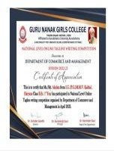
 | Mat hs | Online National Level Essay Writing Competitio n on the topic Green Computing in India: Approache | Dyal Singh College,Kar nal | Green Computin g in India: Approach es and Challenge s | 1 | Environme nt & Sustainabili ty | 1st Position Akshita B.Sc. 1st (122196301500  5) | 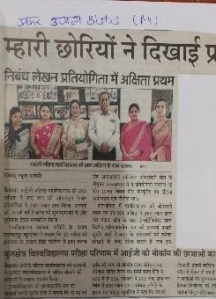

s and Challenges (25.04.202
3)
 | Mat hs | Online National Level Poster Making Competitio n on the theme Stand Up for Women (25.04.202  3) | I.G.M.M.V.  Kaithal | Stand Up for Women | 1 | Gender | Participation Bhavna M.Sc. Final (221196175009  )
 | Mat hs | Online State Level Essay Writing Competitio n on the topic Rights of Senior Citizens (25.04.202  3) | I.G.M.M.V.  Kaithal | Rights of Senior Citizens | 1 | Human Rights | Participation Akshita B.Sc. 1st (122196301500  5) | 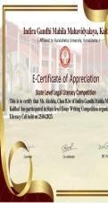
 | Mat hs | Online National Level Mathemati cs Quiz Competitio n (25.04.202  3) | I.B.(P.G.)  College,Pan ipat | Mathemati cs | 12 | Professiona l Ethics | B.Sc. 1st Students | 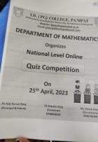
 | Mat hs | State Level Declamatio n Competitio n on the topic Legal Rights of Women in India | I.B.(P.G.)  College,Pan ipat | Legal Rights of Women in India | 1 | Gender | Participation Akshita B.Sc. 1st (122196301500  5) | 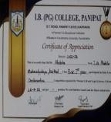

(26.04.202
3)
 | Mat hs | Online state Level Quiz Contest on the topic General Knowledge  ,Basic Mathemati cs and Reasoning (27.04.202  3) | Jyotiba Phule Govt. College Radaur,Yam unanagar | General Knowledg e,Basic Mathemati cs and Reasoning | 1 | Professiona l Ethics | 3rd position Preeti B.Com 1st  (1221963003022) | 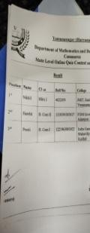
 | Mat hs | National Level Online powerpoint presentatio n Competitio n on Mathemati cs in everyday life (29.04.202  3) | I.B.(P.G.)  College,Pan ipat | Competiti on on Mathemati cs in everyday life | 2 | Professiona l Ethics | Participation Akshita B.Sc. 1st (122196301500  5)  Komalpreet M.Sc. Final (221196175008  ) | 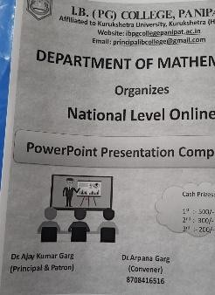
 | Mat hs | Online State Level Slogan Writing,Es say Writing and Poster Making Competitio n on the theme Source Sustainabil ity for | Babu Anant Ram Janta College,Kau l(Kaithal) | Source Sustainabi lity for Drinking Water | 1 | Environme nt & Sustainabil uity | Participation Akshita B.Sc. 1st (122196301500  5) | 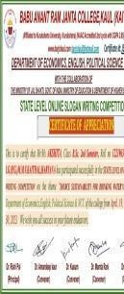

Drinking Water (30.04.202
3)
 | Mat hs | Online National Level Webinar on the topic Real Life Applicatio ns of Mathemati cs (02.05.202  3) | M.D.S.D.  College,Am bala City | Real Life Applicatio ns of Mathemati cs | 32 | Professiona l Ethics | Participation  M.Sc.  Mathematics 4th semester and B.Sc. 2nd semester students | 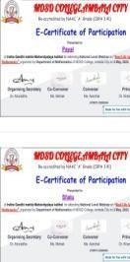
 | Mat hs | National Level Online power point presentatio n Competitio n on the theme related to labour day (27.04.202  3 to  02.05.2023  ) | M.D.S.D.  College,Am bala City | The theme related to labour day | 3 | Human Values | 2nd Position Karmjeet B.Sc. 1st 1221963015015  Participation Akshita, 1221963015005  Payal 1221963015011  B.Sc. 1st | 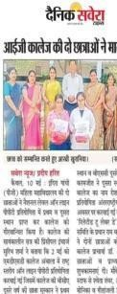
 | Mat hs | Online National Level Slogan Writing Competitio n on the topic Humanity (08.05.202  3) | Dayanand Mahila Mahavidyal aya,Kuruksh etra | Humanity | 1 | Human Values | Akshita B.Sc. 1st  2nd Position  1221963015005 | 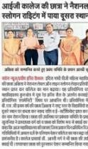

 | Mat hs | Online National Level Poster Making Competitio n on the topic Humanity to Peace (08.05.202  3) | Vaish Mahila Mahavidyal aya,Rohtak | Humanity to Peace | 1 | Human Values | Akshita B.Sc. 1st  1st Position  1221963015005 | 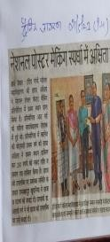
 | Mat hs | Online National Level Slogan Writing Competitio n on the topic Selfless Service and Humanity (08.05.202  3) | I.B.(P.G.)  College,Pan ipat | Selfless Service and Humanity | 1 | Human Values | Participation Akshita B.Sc. 1st 1221963015005 | 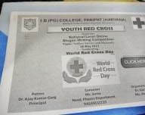
 | Mat hs | Online National Level Slogan Writing Competitio n on the topic Blood Donation (08.05.202  3) | Vaish College,Roh tak | Blood Donation | 1 | Human Values | Paricipation Akshita B.Sc. 1st 1221963015005 | 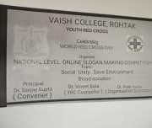
 | Mat hs | Online National Level Nature Photograph y Competitio n on the | Govt. College Mohna,Fari dabad,Harya na | Environm ental Sustainabi lity | 1 | Environme ntal & Sustainabili ty | ParticipationAk shita B.Sc. 1st 1221963015005 | 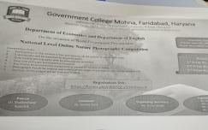

theme environme ntal sustainabili ty (10.05.202
3)
 | Mat hs | Online National Level Slogan Writing Competitio n on the topic Unity (08.05.202  3) | D.a.v. College for girls,Yamun anagar | Unity | 1 | Human Values | Participation Akshita B.Sc. 1st 1221963015005 | 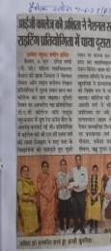
9 | Phy sics | Quiz Competitio n (19.10.202  2) | Dr. B.R.  Ambedkar Govt.  College Kaithal | Science | 6 | Professiona l Ethics | 3rd Position Manju(1201960 15022),  Tanisha(120196 030003),  Garima(120196 015023)  5th Position Samriti(120196 015019), Neha(12019601 5064),  Deepika(12019 6030040) | 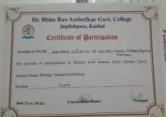
 | Phy sics | Chart Making Competitio n  ( | I.G.M.M.V.  Kaithal | Electronic Devices | 60 | Professiona l Ethics | Participated | 
 | Phy sics | Career Guidance Seminar by Ms.  Chitralekha (28.02.202  3) | I.G.M.M.V  Kaithal | Career Guidance Seminar | 70 | Professiona l Ethics | All B.Sc Students | 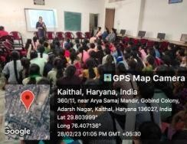

 | Phy sics | Zonal Level Quiz Competitio n (25.11.202  2) | Govt. Post Graduate College Ambala Cantt. | Science | 6 | Professiona l Ethics | ParticipationMa nju(120196015 022),  Tanisha(120196 030003),  Garima(120196 015023)  5th Position Samriti(120196 015019), Neha(12019601 5064),  Deepika(12019 6030040) | 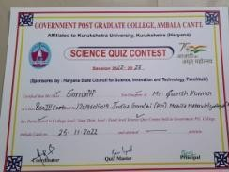
 | Phy sics | National Science Day Poster and Slogan Writing on Science Saves Lives and future Vision towards Science (27.02.202  3) | I.G.M.M.V  Kaithal | Science Saves Lives and future Vision towards Science | 20 | Environme nt & Sustainabili ty | 1st Position Preeti(1201960 15005) in  Poster Making | 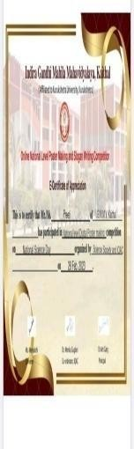
 | Phy sics | National Science Day Poster and Essay Writing (28.02.202  3) | R.K.S.D.  PG College Kaithal | Sustainabl e Energy | 3 | Environme nt & Sustainabili ty | ParticipationAn kita(122196301 5047),  Akshita(122196 3015005) in  Poster Making and Sanita(1201960 30018)  in Essay Writing | 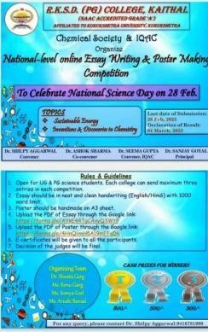
 | Phy sics | National Science Day Essay Writing (27.02.202  3) | Science Society Govt.  College Nalwa | Science for People and People for Science | 2 | Professiona l Ethics | ParticipationRit ika(1211963030 001),  Nancy(1201960 15039) | 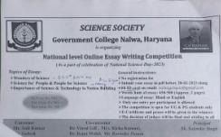

 | Phy sics | National Science Day Essay Writing (27.02.202  3) | Mahila Mahavidiyal a Jhojhu Kalan Charkhi  Dardi | Wonders of Science | 2 | Professiona l Ethics | ParticipationRit ika(1211963030 001),  Tammana(1201 96015046) | 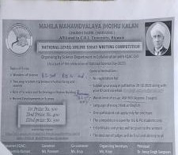
 | Phy sics | National Science Day Essay Writing (27.02.202  3) | Mukhtiar Singh Memorial PG College Behbal apur Fathabad | Role of Green Energy on Environm ent Conservati on | 2 | Environme nt & Sustainabili ty | Participation Neha(12019601 5072),  Sakshi(1201960 15047) | 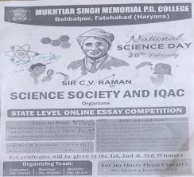
 | Phy sics | Science Quiz and Poster (25.02.202  3) | KUK  University | Energy Transmissi on Digital Economy | 3 | Professiona l Ethics | ParticipationRit u(12219630150 57),  Tammana(1221 963015049) in  Science Quiz,  Chitra(1221963 015073) in  Poster Making | 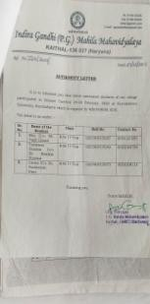
 | Phy sics | Power Point Presentatio n Topic:- Fortran, Solid State Physics (18.03.202  3) | I.G.M.M.V  Kaithal | Fortran, Solid State Physics | 65 | Professiona l Ethics | All B.sc Final Students Participated | 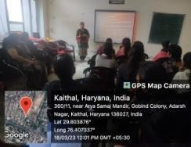
 | Phy sics | Chart Making Competitio n (16.03.202  3) | I.G.M.M.V  Kaithal | Electric Choices | 60 | Professiona l Ethics | All B.sc 1st Year Students Participated | 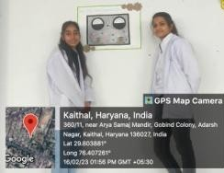
 | Phy sics | Model exhibition (19.04.202  3-20.04.20  23) | I. G. M. M. V  Kaithal | Satellite Communi cation Sugar Mill | 75 | Professiona l Ethics | B. Sc. Ist, IInd and IIIrd year students participated | 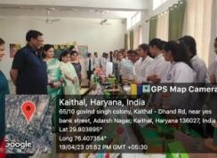

10 | Psyc holo gy | World Mental Health Day (11.10.202  2) | I.G.M.M.V.  Kaithal | Mental Health Awareness | 40 | Human Values | Participated | 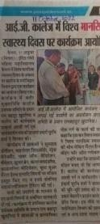
 | Psyc holo gy | HIV Aids (World AIDS Day) (02.12.202  2) | I.G.M.M.V.  Kaithal | HIV AIDS | 14 | Human Values | Participation Preet, Pavani, Nitu, Palak | 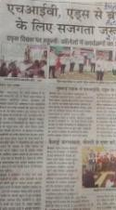
 | Psyc holo gy | Meditation skill (a relaxation therapy) (12.04.23) | I.G.M.M.V.  Kaithal | Meditatio n skill | All ps yc hol og y stu de nts | Human Values | - | 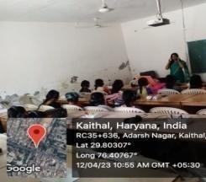  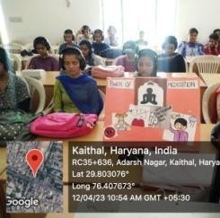
 | Psyc holo gy | Team building Under organizatio n--al psychology (12.4.23) | I.G.M.M.V.  Kaithal | Team building Under organizati on--al psycholog y | Fin al ye ar stu de nts | Human Values | - | 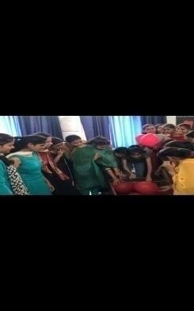  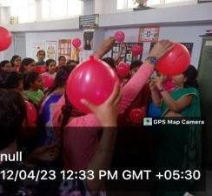
11 | Dep t of Heal th and | Training Camp of Yoga- 15 days | IGMMV,  Kaithal | Yoga | All Le ctu rer | Human Values | - | 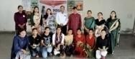

 | Phy sical Edu cati on | (17.05.202  2-1.06.202  2) |  |  | s & 35  0  Stu de nts |  |  | 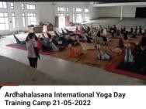
 | Dep  t of Heal th and Phy sical Edu cati on | Celebration  of National Sport Day(21.06. 2022) | IGMMV,  Kaithal | Celebratio  n of National Sport Day | 12  0 | Professiona  l Ethics | - | 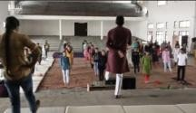  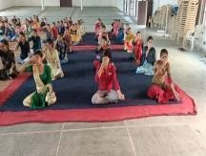  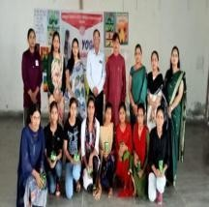
 | Dep t of Heal th and Phy sical Edu cati on | 1)Inter College Champions hip Judo (07.12.202  2) | KKR  University | Judo | 2 | Professiona l Ethics | 2nd position Sonali  B.A III Roll  no.=120196000 2413  3rd position Manisha  B.A III Roll  No.=120196000 2378 |   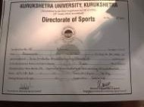  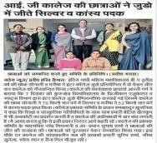
 | Dep t of Heal th and Phy sical Edu | Art of Living(Me ditation) (24.02.202  3) | IGMMV,  Kaithal | Art of Living | All Le ctu rer s & Stu de nts | Human Values | - | 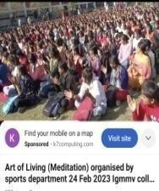

cati
on
 | Dep t of Heal th and Phy sical Edu cati on | State Level Competitio n Handball(1 0.03.2023-  11.03.2023  ) | Era Public School,Dum khra  (Jind) | Handball | 1 | Professiona l Ethics | 2nd position Tanisha BAMC I  Roll no.=122196300 9042
 | Dep t of Heal th and Phy sical Edu cati on | Poster & Model Exhibition Competitio n (07.04.202  3) | IGMMV,  Kaithal | Health & Physical Education | 25  0 | Professiona l Ethics | All Students | 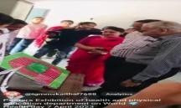  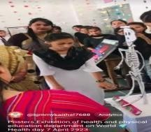
 | Dep t of Heal th and Phy sical Edu cati  on | National Sports Day (28.09.202  3) | IGMMV,  Kaithal | National Sports Day | 17  5 | Professiona l Ethics | All Students | 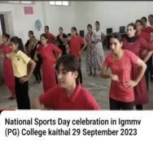
 | Dep t of Heal th and Phy sical Edu  cati on | Health & Physical Awareness Camp(28.0 9.2023-29.  09.2023) | IGMMV,  Kaithal | Health & Physical Awareness Camp | All Le ctu rer s & Stu de nts | Human Values | - | 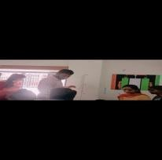  

 |  |  |  |  |  |  |  | 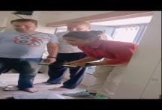
12 | Engl ish | Extension Lecture by Dr. Suruchi Sharma (Associate Professor of English, RKSD  College Kaithal) (02.12.202  2) | I.G.M.M.V.  Kaithal | Overview of Grammati cal Concepts | 15  0 | Professiona l Ethics | All BA and MA Students Participated | 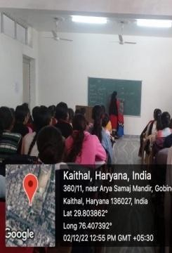
 | Engl ish | Talent Show Declamatio n Competitio n (01.10.202  2) | I.G.M.M.V.  Kaithal | 1)Social Media: Pros and Cons  2)  E-learning | 7 | Human Values | 1st position Sachleen Preet Kaur  37 B.M.C.,  2nd position Renu 259 B.A. I | 
 | Engl ish | Talent Show Poem Recitation (01.10.202  2) | I.G.M.M.V.  Kaithal | 1)Gender Equality 2)Social Media | 5 | Gender | 1st position  Juhi 336  B.A. III  2nd position  Mehak 208  B.A. I | 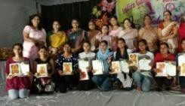
 | Engl ish Dep t. | State Level Essay Writing Competitio n  06.02.2023 | Dr. Bhim Rao Ambedkar College, Kaithal | Dowry System | 12 | Gender | 3rd Position Sachleen-12119 63009057(BMC  2nd Year) | 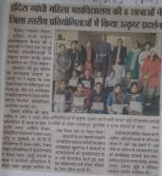
 | Engl ish | Extension Lecture Seminar Speaker Dr. Suruchi Sharma (Associate Prof.  RKSD | I.G.M.M.V.  Kaithal | Characteri stics of Research | 70 | Professiona l Ethics | All Staff Members and PG Students | 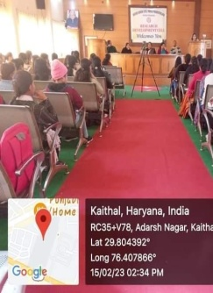

College Kaithal ) (16.02.202
3)
 | Engl ish | State Level Cultural Fest Declamatio n Contest (25.03.202  3) | I.G.M.M.V.  Kaithal | Women Empower ment : A Political Pretence  Changing Scenario of Indian Culture | 1 | Gender, Human Values | Participation  Simran Preet  B.M.C. II | 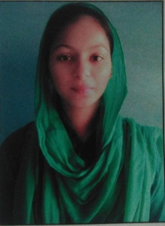
 | Engl ish & Mas s  Co mm unic atio n | Workshop on Paper Reading (05.04.202  3) | I.G.M.M.V.  Kaithal | Paper Reading | 40 | Professiona l Ethics | Students of BAMC | 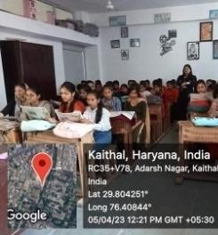
 | Engl ish | Power Point Presentatio n Session (06.04.202  3) | I.G.M.M.V.  Kaithal | Session on various literary topics for M.A.  English | 50 | Professiona l Ethics | Students of  M.A. English (2nd and 4th sem) | 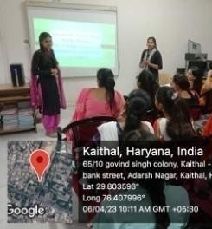
 | Engl ish | National Level Online Quiz Competitio n (10.04.202  3) | I.G.M.M.V.  Kaithal | On the occasion of 53rd Inception Day | 80 | Professiona l Ethics | Students from 25 colleges and universities | 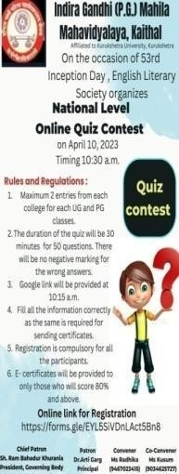

 | Engl ish | Chart Making Activity on Topics of English Grammar (29.04.202  3) | I.G.M.M.V.  Kaithal | Topics of English Grammar | 30 | Professiona l Ethics | Students of  B.A. II | 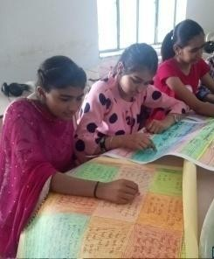
 | Engl ish | Movie Show on the novel Gulliver’s Travels (29.04.202  3) | I.G.M.M.V.  Kaithal | Gulliver’s Travels |  | Human Values | Students of  B.A. I | 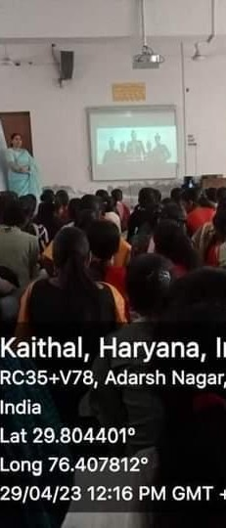
 | Engl ish, Eco nom ics, Polit ical Scie nce and NC C | State Level Online Slogan Writing and Poster Making Competitio n (29.04.202  3) | Babu Anant Ram Janta College, Kaul | Source Sustainabi lity for Drinking Water | 1 | Environme ntal & Sustainabili ty | 2nd position  Komal B.A. I | 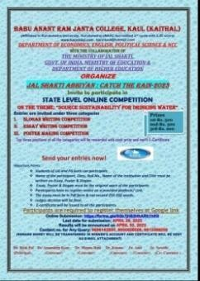
 | Engl  ish & Eco nom ics | National  Level Online Nature Photograph y Competitio n (05.05.202  3 -  14.05.2023  ) | Govt.  College, Mohna | Environm  ental Sustainabi lity | 11  4 | Environme  ntal & Sustainabili ty | Neeru (1st  position) and Kajal Nain (3rd position) | 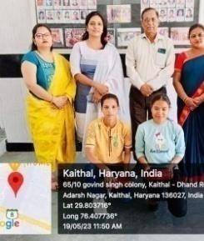
 | Engl ish | National Level Online Competitio n on Shakespear  ean | I.B. College, Panipat | Shakespea rean Soliloquie s | 1 | Professiona l Ethics | Participation Prachi Sharma 22196152012  M.A. Eng (Prev.) | 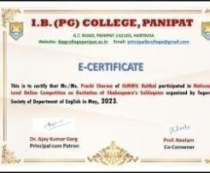

Soliloquies (08.05.202
3)
 | Engl ish Lite rary Soci ety und er Dep artm ent of Engl  ish | A National Level Quiz on Shakespear e | R.K.S.D. (PG)  College, Kaithal | Shakespea re | 3 | Professiona l Ethics | Participation Anjali 22196152016  M.A. Eng (Prev.) PrachiSharma 22196152012  M.A. Eng (Prev.) Shashi 22196152006  M.A. Eng (Prev.) | 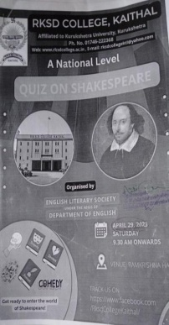
13 | Hin di Dep t. | Speech Activity (Agrassen Jayanti)  26.09.22 | IGMMV  Kaithal | Life Achievem ents of Maharaja  Agrasen | 6 | Human Values | Participation | 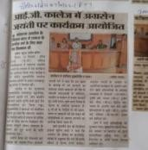
 | Hin di Dep t. | Talent Hunt Speech & Poem Activity 01.10.2022 | IGMMV  Kaithal | Speech 1)Social Media: Pros and Cons  2)  E-learning Poem 1)Gender Equality 2)Social Media | 8 | Human Values, Gender | 1st Position Karamjeet-1221 963015015(Spe  ech), 1st  Payal-12019600  235(Poem) | 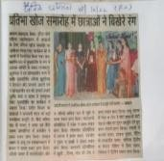
 | Hin di Dep t. | State Level Essay Writing Competitio  n(02.10.20 23) | Dayanand Mahila Mahavidyal aya,  Kururkshetr a | Hindi Sahitya mein Nari ka Chitran | 2 | Gender | 2nd Position Sheetal B.A. III Participation Pooja B.A. III | 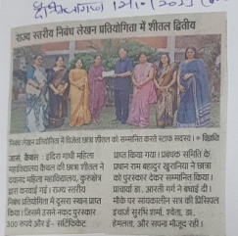

 | Hin di Dep t. | State Level Essay Writing Competitio n(30.10.20 23) | RDS Girls College | Vaishvikar an ke Dor me Hindi Bhasha ka Mahatva | 2 | Human Values | 3rd Position Pooja B.A. III(Certificate + Cash Prize) Participation Simran B.A. III | 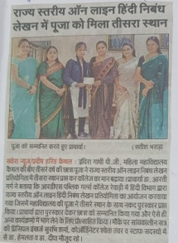
 | Hin di Dep t. | Gurunanak Jayanti Activity Speech & Poem Activity 08.11.2022 | IGMMV  Kaithal | Veerta ki Mahima | 5 | Human Values | Participation | 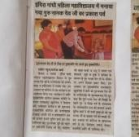
 | Hin di Dep t. | Vigilance awareness Campaign Under Power Grid Corporatio n  Speech & Poem Activity 09.11.2022 | IGMMV  Kaithal | Vigilance awareness Campaign Under Power Grid Corporatio n | 8 | Human Values | 1st Position Sachleen-12219 63002058(BMC  2nd Year) 2nd Position  SimranPreet-12 0196009014(B  AMC Final) 3rd Position Shiwani-12219 63002058(BA  1ST Year) | 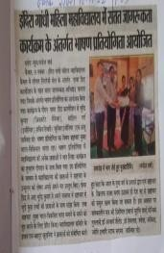
 | Hin di Dep t. | Guru Gobind Singh Parkash Purb 29.12.2022 | IGMMV  Kaithal | Life Achievem ents of Guru Gobind Singh | 7 | Human Values | Participation | 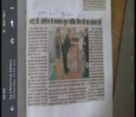
 | Hin di Dep t. | Swami Vivekanan d Jayanti 12.01.2023 | IGMMV  Kaithal | Life Achievem ents of Swami Vivekanan  da | 7 | Human Values | Participation | 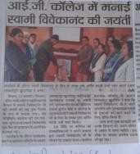
14 | Ho me Scie nce | Rangoli Making on 01st October 2022 | IGMMV | Rangoli Making | 26 | Professiona l Ethics | 1st Position- Kajal- (BA 2nd)(163)  2nd Position– Sanjana (25)(BA 2nd) | 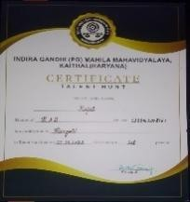

 | Ho me Scie nce | Flower Arrangeme nt on 01st October 2022 | IGMMV | Flower Arrangem ent | 11 | Professiona l Ethics | 1st Position- Ritu (23)(BA  1st)  2nd Position– Nisha(318) (BA 3rd) | 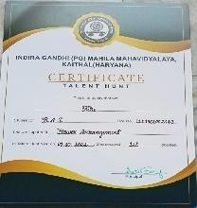
 | Ho  me Scie nce | Mehandi  Competitio n on 11th October 2022 | IGMMV | Karwa  Chauth | 38 | Professiona  l Ethics | 1^{s} Position  Tanisha(123) (BA 3rd)  2nd Position – Sonia (361)(BA 2nd)  3rd Position – Anju(192) (BA  1st) | 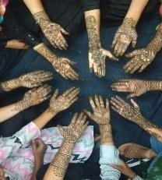
 | Ho me Scie nce | Pot Decoration on 25th March 2023 | IGMMV | Pot Decoratio n | 22 | Professiona l Ethics | 1st- position Tannu (Ishwar singh college, Dhand))  2nd Position – Preeti (Arya P G College)  3rd Position – Bharti(24) (IGMMV,  Kaithal) | 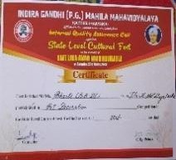
15 | Geo grap hy | State Level Quiz Competitio n (22.04.202  3) | Dyal Singh College Karnal | Only One Earth | 3 | Environme nt & Sustainabili ty | 3rd Position Manju-1201960 02092 (BA III)  3rd Position Komal- 120196002037 (BA III),  3rd Position Ritika-1201960 02043 (BA III) | 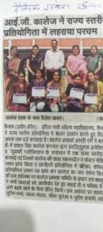

 | Geo grap hy | College Level Competitio n Exhibition( Working Model-Re mote Sensing) | IGMMV  College, Kaithal | Working Model-Re mote Sensing | 3 | Professiona l Ethics | 1st Position Ritika-120196 002403,  Ritu-1201960 02093,  Manju-12019 6002092 | 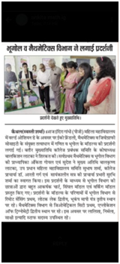
 | Geo grap hy | College Level Competitio n Exhibition( Working Model- Lotak Lake) | IGMMV  College, Kaithal | Working Model- Lotak Lake | 3 | Professiona l Ethics | 2nd Position Manjeet-12019 6002043,  Anju-12019600 2112,  Amandeep- 1221962002101 | 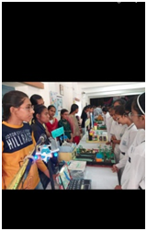
 | Geo grap hy | College Level Competitio n Exhibition( Working Model- Seismogra ph Instrument) | IGMMV  College, Kaithal | Working Model- Seismogra ph Instrument | 3 | Professiona l Ethics | 3rd Position Pooja-122196 2002158,  Neeru-122196 2002130,  12219620022  24,  Anjali-122196 2002224 | 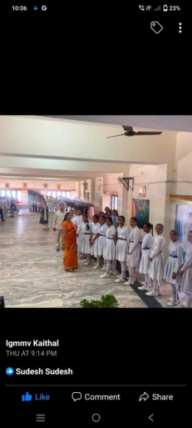
 | Geo grap hy | College Level Two Day Workshop under guidance of Ms.  Sudesh  (20-03-202  3 to | IGMMV  College, Kaithal | Work shop | 20 | Professiona l Ethics | Participation | 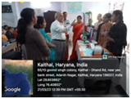

21-03-2023
)
16 | Sans krit | Departmen t Activity Session Opening Ceremony Hawan  (22.08.2022) | IGMMV,  Kaithal | Session Opening Ceremony | 30  0 | Human Values | All Staff Members and Management Members | 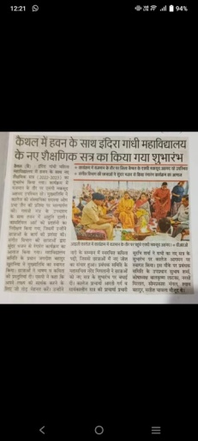
 | Sans krit | Talent Show Sanskrit Shlok Uchchara n, Sanskrit Speech (01.10.20  22) | I.G.M.M.V.  Kaithal | Shlok Uchcharan Sanskrit Declamati on | 12 | Human Values | Participation | 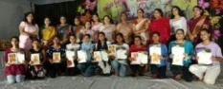
 | Sans krit | Sanskrit Shlok Uchcharan (20.09.2022  ) | Maharishi Valmiki University Mundri | Sanskrit Shlok Uchcharan | 2 | Human Values | Participated Neetu B.A 2nd 1211962002150  , Tanu | 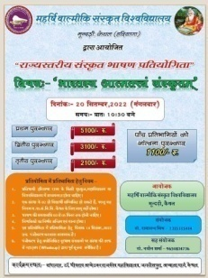
 | Sans krit | 45th Zonal Youth Festival Sanskrit Declamatio n (16.10.202  2) | Babu Anant Ram Janta College Kaul Kaithal | Sanskrit Bhasha ka Mahatva | 1 | Human Values | 3rd Neetu B.A. II 1211962002150 | 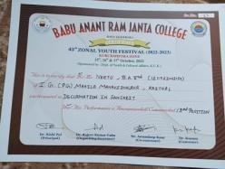
 | Sans krit | Depart ment Activit y Found ers Day Hawan | I.G.M.M.V.  Kaithal | Foun ders Day Hawa n | 25  0 | Human Values | All Staff Members and Management Members | 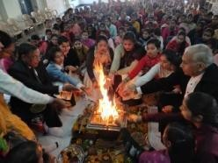

(06-02-202
3)
 | Sans krit | State Level Cultural Fest Sanskrit Song, Shlokochc haran (08.04.202  3) | Dayanand Mahila Mahavidyala ya Kurukeshetra | Sanskrit Song | 2 | Human Values | Participation | 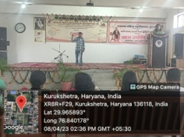
 | Sans krit | Online One day International Webinar Topic भगवदगीता : सां4ययोग  (30.04.2023  ) | Dept. of Sanskrit IGMMV  Kaithal | भगवदगीता  : सां4ययोग | 12  0 | Human Values | Organized by Sanskrit Department | 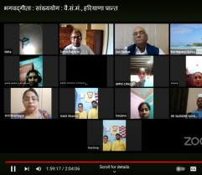
17 | Co mm erce Dep t. | Talent hunt 10 -10-  2022  Singing  Competiti on | IG(PG)MM V  Date- 10.10.2023 | Music | 3 | Professiona l Ethics | Singing  Competition:  - Tamanna 1st position BCom II  1211963003125  - Navjot 2nd position BCom I  1221963003046  - Shefali Participated MCom II 221196168042 | 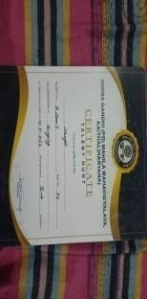

 |  | Group Dance  Competiti on | IG(PG)MM V  Date- 10.10.2023 | Group Dance | 4 | Professiona l Ethics | Group Dance Competition: 1.Nitti  1st position BCom II 1211963003039  - Shweta 1st position BComII  1211963003066  - Priya  1st position BCom II 1211963003099  - Shefali 2nd position MCom II  221196168042 | 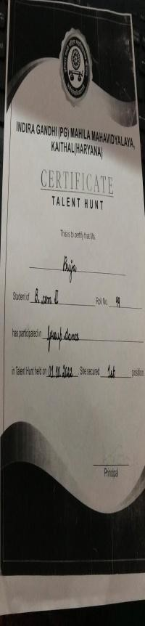
 |  | Quiz  Competiti on | IG(PG)MM V  Date- 10.10.2023 | General Knowledg e | 2 | Professiona l Ethics | Quiz  Competition:  - Khushi 1st position BCom III  120196003086  - Meera 1st position BCom II  1211963003008 | 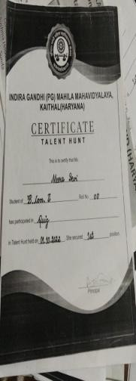
 |  | 45th ‘Zonal Youth Festival’ at Babu Anant Ram Janta College, Kaul  Date- 15th October 2022 to | Dept. of Youth and Culture Affairs , K.U.K | Patriotism | 2 | Professiona l Ethics | Group Song General:  - Tamanna 3rd position BCom II  1211963003125  - Navjot 3rd position BCom I  1221963003046 | 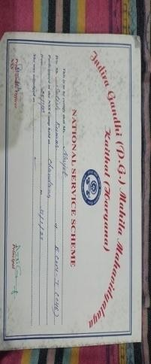

17th October20 22
Group Song General:
 |  | Folksong General: | Dept. of Youth and Culture Affairs , K.U.K | Folk Song | 1 | Professiona l Ethics | 1. Navjot 3rd position BCom I  1221963003046 | 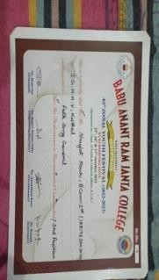
 |  | Group Song Haryanvi: | Dept. of Youth and Culture Affairs , K.U.K | Haryanvi Culture | 1 | Professiona l Ethics | 1. Tamanna 3rd position BCom II  1211963003125 | 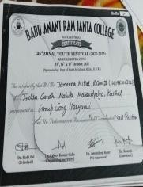
 | Co mm erce Dep t. | Industrial Trip to The Kaithal  Cooperati ve Sugar Mill  Date-  17-11-2022  ( Students got educational information regarding various subjects like production process, accounting, management  , business and marketing) | Commerce Department | Industrial Trip | 39 | Professiona l Ethics |  | 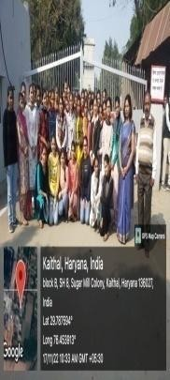

 | Co mm erce Dep artm ent | Written Quiz Competitio n:  Date-  22 -11-  2022 | Commerce Department | Indian Financial System, Security Market Operation s, Business Statistics, Financial Managem ent, Advertise ment | 53 | Professiona l Ethics | Khushi  1st position BCom III 120196003086  Rubi  2nd position BCom III 120196003040  Nisha  3rd position MCom II 221196168003  Diksha  3rd position  MCom II 221196168009 | 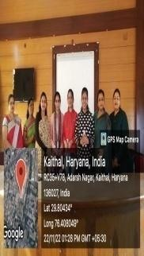
 | Co mm erce Dep artm ent | Model Exhibition: Topics: Security Market, Advertisin g, Finance, Banking and Accounting etc  Date-  30-11-2022 | Commerce Department | Security Market, Advertisin g, Finance, Banking and Accountin g etc | 45 | Professiona l Ethics |  | 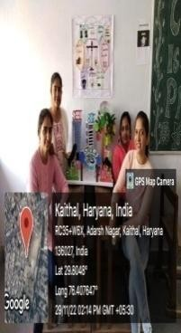
 | Co mm erce Dep artm ent | Flyer Making Competitio n:  Date-  10 -03-  2023 | Commerce Department | Consumen Day Celebratio n | 30 | Professiona l Ethics | Ritu  1st position MCom II 221196168024  Kavita  2nd position MCom II 221196168061  Anshu  3rd position MCom II 221196168033 | 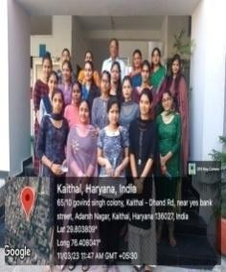

 | Co mm erce Dep artm ent | State Level Online Essay Writing and Power Point Presentatio n Competitio n in observance of ‘World Consumer Right Day’ Date-  15-03-2023 | Commerce Department and Career Guidance Cell | Know Your Rights | 19 | Human Values | Rubi  2nd position BCom III 120196003040 | 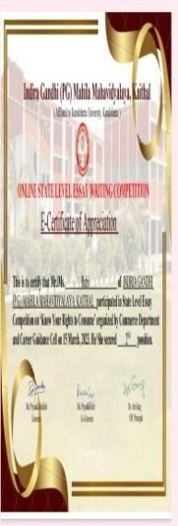
 | Co mm erce Dep artm ent | State Level Cultural Fest  Date- 25-03-  2023  Folk Song General (Solo)  1. | IQAC Cell of college | Music | 1 | Professiona l Ethics | Folk Song General (Solo) Navjot  1st position BCom I 1221963003046 | 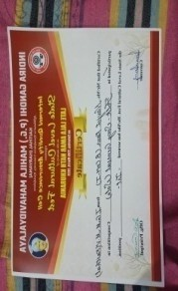
 | Co mm erce Dep artm ent | Debate on Cause of Failure of Silicon Valley Bank  Date-  05-04-2023 | Commerce Department | Cause of Failure of Silicon Valley Bank | 6 | Professiona l Ethics | Participation | 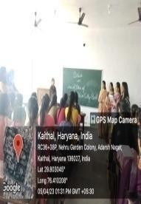

Research work activities of IGMMV faculty members (2022-2023)

Sr.  NO. | Name of the Teacher | Seminar/Conference/FDP/  Orientation Program | Organised by | Date | Participation/Presentation | Topic | Paper Title
1 | Surbhi Sharma | One day rNational Seminar  (Online) | MDSD College Ambala  City, Haryana | 25-Mar-23 | Presentation | representing mythology in comntemporay literature | myths and trends in literrature
 |  | One day National Seminar  (Online | internal quality  assurance cell | 27-Mar-23 | Presentation | roles and responsibilities in higher education instutions in implimentation of NEP 2020 | critical role of NEP 2020 in Transforming English Literature
 |  | One day National  Seminar(Online) | khun khun ji Girl PG College Chowk Lukhnow and mumtaz PG College Lukhnow | 14-Apr-23 | Presentation | vartaman pariprkshya mein Dr Bhimrao Ambedkar ki vaichariki | The idea of economic justice as embaded in english literature
 |  | National Conference NCGSPIFP-23 | department of english and women cell . Aggarwal college Ballabgarh | 04-May-23 | Presentation | Gender studies past issues and future posibilities | Changing gender roles and empowering of women through digital revolution
 |  | National Conference | SD Pg College Panipat | 18-19 mar. 2023 | Presentation | Contemporay trends in humanities and social science | objectification of women through media and literature
2 | Bhawna | One day National seminar | Shri Jain Post graduate College,Bikaner | 12-Feb-23 | Presentation | Contemporay Trends in Humanities and Social science | A theoretical framework of digital payment
 |  | One day National seminar | Bhagwan Parshu Ram College,Kurukshetra | 20-Mar-23 | Presentation | Women Empowerment"Post Covid Challenger and hurdles | A Comparision Study Of women Job and Satisfaction in private and public sector
 |  | Multidisciplinary National conference | SD PG College  Panipat | 18-19March2023 | Presentation | Contemporay trends in humanities and social science | Factor affecting Rural enterpreneurship
 |  | one day virtual international Conference | Dyal Singh College,Karnal | 21-Apr-23 | Presentation | Digitalization move towards economic growth | Social Media Marketing and rural enterprenurship
3 | Radhika | One day National Seminar | Guru Nanak Khalsa College For Women | 04-Feb-23 | Presentation | Towars Gender Inclusivity"Emerging contemporary issues around gender | Women Empowerment @75 years of Indepenence
 |  | Multidisciplinary National conference | SD PG College  Panipat | 12-Feb-23 | Presentation | Contemporay Trends in Humanities and Social science | Migretion and Diaspara : Diasparic Perspectives and identity guest in Rudyardkipiling'skim
4 | Monika Garg | Interational conference | Shri Bala ji college Engineering & technology, Jaipur | Jun-22 | Presentation | Engineering, Social Science and Management | Impact of startsup on Indian Economy
 |  | Professional Development Program | Indira Gandhi National Open University New Delhi | 12 to 20June2023 | Participation | UGC approved short term professional development program | Professional Development Program on implementation of NEP2020 for University and College teachers
 |  | one week Faculty Development program | Guru Nanak Khalsa Institute of Technology and Management Technical Campus,Yamunanagar | 27Feb-3March2023 | Participation | Changing Landscape in Banking and Finance:Inovation And regulation
5. | Seema Suneja | One day national seminar | Pt.Chiranji Lal Sharma govt. college karnal | 25/02/2023 | Presentation | Indian Media Political And Socio Cultural Dimensions | Citizen Journalism

