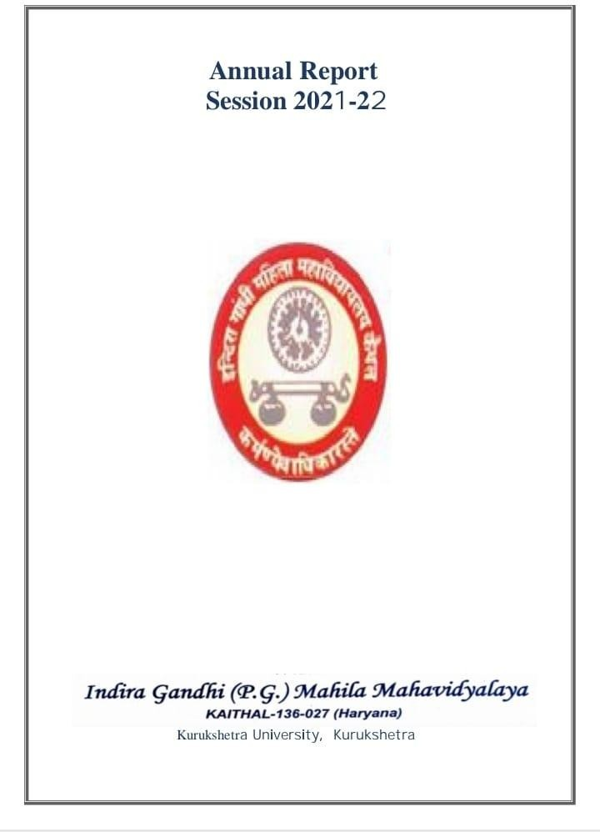
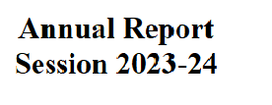
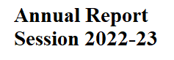
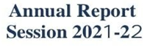
NAAC Accrediation Certificate of Cycle-1
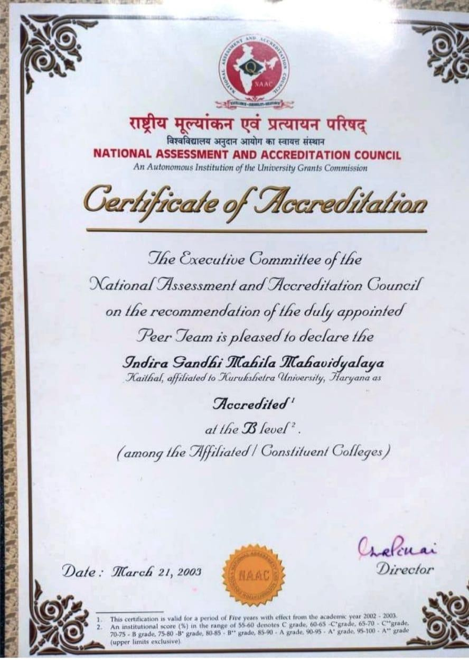

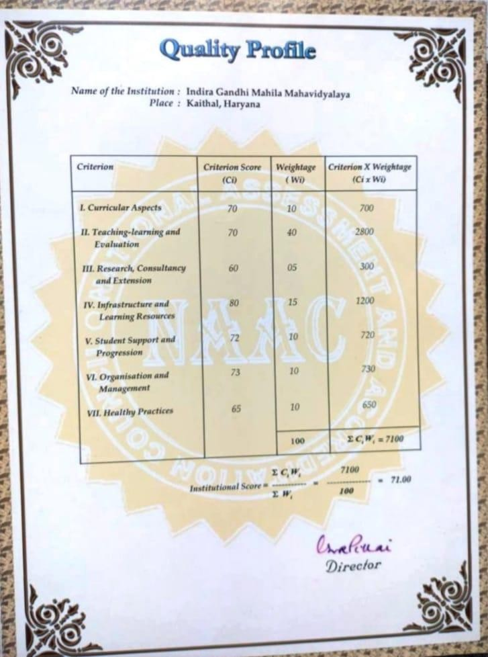

3

NAAC Accrediation Certificate of Cycle 2

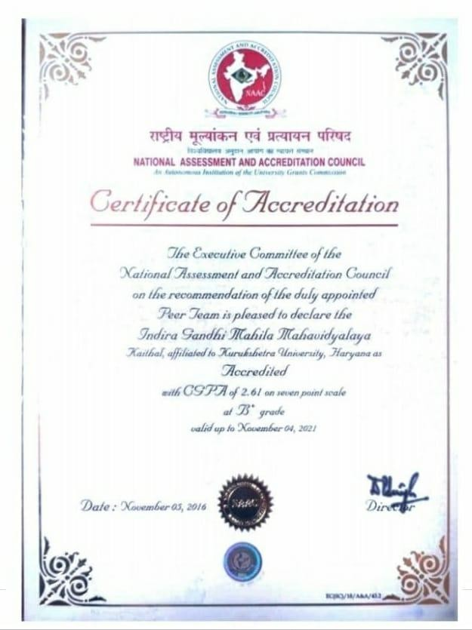

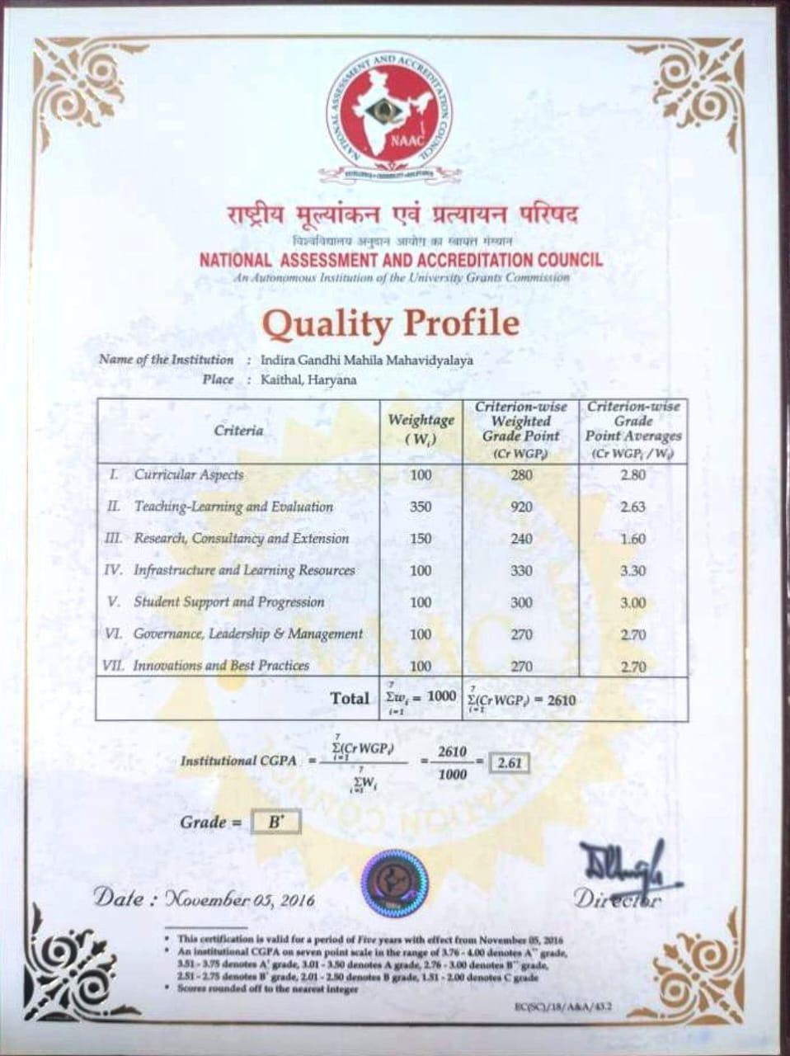

Smt. Indira Gandhi(Prime Minister of India) has rightly said:
“Education is a liberating force and in our age it is also a democratizing force, cutting across the barriers of caste and class, smoothing but inequalities imposed by birth and other circumstances”
Indira Gandhi P.G Mahila Mahavidyalaya, a pioneer institute proving its excellence still without flinching by providing quality education for the last 52 years. Named after the name of a rare personality, Mrs. Indira Gandhi and established in 1970 by a great social activist and the then finance minister, Late (Smt.) Om Prabha Jain. In this challenging venture, she was supported by worthy members of Bal Shiksha Samiti MahashaiBrijlal, Sh. Ram Gopal Latka, Sh. Bhagwan Dass and Sh. Mohan Bahadur Khurania, advocate and liberal donor Seth Durga Prasad and others.The foundation stone of the college was laid by sSh.Bansi Lal, the then Chief Minister on 10th April, 1970.
In the very first year of its inception 200 girls were enrolled which was an encouraging start by our college. In the beginning it was affiliated to Panjab University, Chandigarh. Pre- University and B.A-1 and 2nd were immediately introduced and highly qualified staff was appointed. Three storied building of the college is designed by Sh. B.P Mathur, senior Architect of Panjab University, Chandigarh. In 1973 College Day was celebrated and synchronized with the birthday of our Prime Minister Smt. Indira Gandhi. This event was enlightened by the then Union Minister for Tourism and Civil Aviation Dr. Sarojni Mahishi.
In these five progressive decades of progression, our College possesses a group of well-equipped buildings: Administrative Block with software networking, Pt. ChiranjilalSharmaScienceBlock,New constructed Block,Computerized Library, Smt, Om Prabha Jain Commercial Art block, Lala Amarnath Khurania Commerce Block, Multipurpose Block, Evening Block, Sport Room, NSS Room, Auditorium, Play ground, New Post graduate Block, O.P Jindal Memorial Gym, Dr. Shanno Devi Seminar Hall, Rajiv Arora Memorial fitness Hall, well equipped functional English Lab, Three AC Computer Lab with internet facility, Four AC staff rooms, reading room, fully equipped Medical/Non-Medical Science labs, Canteen etc.
Evening college has been introduced with the sincere efforts of our benevolent Management and dedicated Principal. Our college contributes to transform young girls to be women with all the qualities so that they can radiate in the cultural and socialhorizons.A holistic environment is provided here to all the girls and

approximately 2818 students are enrolled in the morning and evening. Different streams at U.G level (B.A, B.sc(Med,Non-med,Computer science),B.com.B.C.A) have been introduced . Our college got P.G status by opening regular MA English, Economics, M.Com, M.sc, Math and P.G.D.C.A.The beginning of B.Sc Medical/Non-Medical computer has a boon for the girls of nearby villages. Top positions in the university are the proofs that Management, Principal and staff have performed with excellence to achieve desired goal in the world of cut throat competition. In alignment with the National Education Policy (NEP) 2020, our college embarked on its transformative journey in the academic session 2023-24. Affiliated with Kurukshetra University, Kurukshetra, a prestigious institution renowned for its academic excellence and heritage, we are dedicated to fostering holistic education and multidisciplinary learning.
Our governing body is working very efficiently for the welfare of the college under the guidance of our unopposed President, Sh. Ram Bahadur Khurania. The day since Sh. Jagdish Bahadur Khurania has taken the charge of MahilaMahavidyalaya Samiti, as an elected President of Samiti, the college has been adding new dimensions of achievement and progress. From the time of Smt. Om Prabha Jain, Sh. Mohan Bahadur Khurania has been a source of inspiration for all. Our college is nurturing the girls students by focusing on slogan ‘Beti Bachao,Beti Padhao’.
Our College is awarded with B+ grade CGPA 2.61 by NAAC team in September, 2016. To maintain effective student learning our faculty combined their efforts with new strategies, administered the curriculum and proved their excellence in each & every way. Students also responded in a very disciplined manner. These efforts became fruitful as a result of the instructions as well as resources provided by the Governing body.We aim to lead these girls students in their pursuit of excellence and create an institution that fulfills educational and professional demands of the evolving world.
The college is affiliated with Kurukshetra University, Kurukshetra, and adheres strictly to the curriculum prescribed by the university. Starting from the 2023-24 academic session, the university implemented the National Education Policy (NEP) 2020 across all affiliated colleges. The university provided a selection of courses for affiliated colleges to choose and implement. Our college has adopted the following courses:

1.1 Number of courses offered by the Institution across all programs during the year
Number of courses offered by the Institution in 1st Semester during the year 57
Program Code | Program Name | Course code | Course Name | Smester/Annual | Year of introduction
 | B.Com | (B23-COM-101) | Financial Accounting | Semester-1 | NEP 2020 Imlemented in 2023-24 Session
 | B.Com | (B23-COM-102) | Business Laws | Semester-1 | NEP 2020 Imlemented in 2023-24 Session
 | B.Com | (B23-COM-103) | Business Management | Semester-1 | NEP 2020 Imlemented in 2023-24 Session
 | B.Com | (B23-COM-104) | Business Mathematics-I | Semester-1 | NEP 2020 Imlemented in 2023-24 Session
 | BCA | (B23-CAP-101) | Problem Solving Through C | Semester-1 | NEP 2020 Imlemented in 2023-24 Session
 | BCA | (B23-CAP-102) | Foundations of Computer Science | Semester-1 | NEP 2020 Imlemented in 2023-24 Session
 | BCA | (B23-CAP-103) | Logical Organization of Computer | Semester-1 | NEP 2020 Imlemented in 2023-24 Session
 | BCA | (B23-CAP-104) | Mathematical Foundations for Computer Science-I | Semester-1 | NEP 2020 Imlemented in 2023-24 Session
 | BAMC | (B23-JMC-101) | Introduction to Communication | Semester-1 | NEP 2020 Imlemented in 2023-24 Session
 | BAMC | (B23-JMC-102) | Introduction to Journalism | Semester-1 | NEP 2020 Imlemented in 2023-24 Session
 | BAMC | (B23-JMC-103) | History of Media | Semester-1 | NEP 2020 Imlemented in 2023-24 Session
 | BAMC | (B23-JMC-104) | Computer Applications | Semester-1 | NEP 2020 Imlemented in 2023-24 Session
 | BSC Physical Science | (B23-CHE-101) | Chemistry-I | Semester-1 | NEP 2020 Imlemented in 2023-24 Session
 | BSC Physical Science | (B23-CSE-101) | Problem Solving Through C | Semester-1 | NEP 2020 Imlemented in 2023-24 Session
 | BSC Physical Science | (B23-MAT-101) | Calculus | Semester-1 | NEP 2020 Imlemented in 2023-24 Session
 | BSC Physical Science | (B23-PHY-101) | Mechanics | Semester-1 | NEP 2020 Imlemented in 2023-24 Session
 | BSC Physical Science | (B23-CHE-103) | Minor Chemistry-I | Semester-1 | NEP 2020 Imlemented in 2023-24 Session
 | BSC Physical Science | (B23-CSE-103) | Basics of Computer Science | Semester-1 | NEP 2020 Imlemented in 2023-24 Session
 | BSC Physical Science | (B23-MAT-103) | Basic Calculus | Semester-1 | NEP 2020 Imlemented in 2023-24 Session
 | BSC Physical Science | (B23-PHY-103) | Elementary Mechanics | Semester-1 | NEP 2020 Imlemented in 2023-24 Session
 | BSC Life Science | (B23-ZOO-101) | Animal Diversity of Non-Chordates | Semester-1 | NEP 2020 Imlemented in 2023-24 Session
 | BSC Life Science | (B23-BOT-101) | Diversity of Microbes, Algae, Fungi and Archegoniates | Semester-1 | NEP 2020 Imlemented in 2023-24 Session
 | BSC Life Science | (B23-CHE-101) | Chemistry-I | Semester-1 | NEP 2020 Imlemented in 2023-24 Session
 | BSC Life Science | (B23-CSE-103) | Basics of Computer Science | Semester-1 | NEP 2020 Imlemented in 2023-24 Session
 | BSC Life Science | (B23-PHY-103) | Elementary Mechanics | Semester-1 | NEP 2020 Imlemented in 2023-24 Session
 | BA | (B23-POL-101) | Principles of Political Science -I | Semester-1 | NEP 2020 Imlemented in 2023-24 Session
 | BA | (B23-PSY-101) | Foundations of Psychology | Semester-1 | NEP 2020 Imlemented in 2023-24 Session
 | BA | (B23-ECO-101) | Micro Economics-I | Semester-1 | NEP 2020 Imlemented in 2023-24 Session
 | BA | (B23-ENG-101) | Introduction to Short Story and Basic Grammar | Semester-1 | NEP 2020 Imlemented in 2023-24 Session
 | BA | (B23-GEO-101) | Physical Geography | Semester-1 | NEP 2020 Imlemented in 2023-24 Session
 | BA | (B23-PED-101) | History and Foundation of Physical Education | Semester-1 | NEP 2020 Imlemented in 2023-24 Session
 | BA | (B23-MAT-101) | Calculus | Semester-1 | NEP 2020 Imlemented in 2023-24 Session
 | BA | (B23-SKT-101) | Nitisahityam Vyakaranm Ch | Semester-1 | NEP 2020 Imlemented in 2023-24 Session
 | BA | (B23-SOC-101) | Introduction to Sociology | Semester-1 | NEP 2020 Imlemented in 2023-24 Session
 | BA | (B23-HIN-101) | Hindi Bhasha Evam Adhunik Kavita | Semester-1 | NEP 2020 Imlemented in 2023-24 Session
 | BA | (B23-BMV-101) | Musicology | Semester-1 | NEP 2020 Imlemented in 2023-24 Session
 | BA | (B23-POL-103) | Fundamentals of Political Science-I | Semester-1 | NEP 2020 Imlemented in 2023-24 Session
 | BA | (B23-ENG-103) | Literature and Language I | Semester-1 | NEP 2020 Imlemented in 2023-24 Session
 | BA | (B23-MAT-103) | Basic Calculus | Semester-1 | NEP 2020 Imlemented in 2023-24 Session
 | BA | (B23-HIN-103) | Hindi ka Vyvaharik Vyakaran | Semester-1 | NEP 2020 Imlemented in 2023-24 Session
 | BA | (B23-HIS-103) | Indian History & Culture | Semester-1 | NEP 2020 Imlemented in 2023-24 Session
 | BA | (B23-HIS-101) | Idea of Bharat | Semester-1 | NEP 2020 Imlemented in 2023-24 Session
 | BA | (B23-COA-101) | Fundamental of Arts | Semester-1 | NEP 2020 Imlemented in 2023-24 Session
 | BA | (B23-HSE-101) | Home and Interior Decor | Semester-1 | NEP 2020 Imlemented in 2023-24 Session
 | AEC for All Stream | (B23-AEC-E111) | English Language and Communication: Level-1 | Semester-1 | NEP 2020 Imlemented in 2023-24 Session
 | AEC for All Stream | (B23-AEC-H121) | Hindi Bhasha Aur Vyakaran | Semester-1 | NEP 2020 Imlemented in 2023-24 Session
 | AEC for All Stream | (B23-AEC-S131) | Sanskrit Bhasha Evm Sampreshan-I | Semester-1 | NEP 2020 Imlemented in 2023-24 Session
 | MDC | (B23-JMC-105) | Public Speaking and Art of Anchoring | Semester-1 | NEP 2020 Imlemented in 2023-24 Session
 | MDC | (B23-COM-105) | Personal Finance | Semester-1 | NEP 2020 Imlemented in 2023-24 Session
 | MDC | (B23-PED-104) | Fundamentals of Physical Education | Semester-1 | NEP 2020 Imlemented in 2023-24 Session
 | MDC | (B23-CSE-104) | Fundamentals of Computer Science | Semester-1 | NEP 2020 Imlemented in 2023-24 Session
 | MDC | (B23-BMV-102) | Introduction of Indian Music | Semester-1 | NEP 2020 Imlemented in 2023-24 Session
 | MDC | (B23-HSE-103) | Basics of Home Science I | Semester-1 | NEP 2020 Imlemented in 2023-24 Session
 | MDC | (B23-COA-104) | Basics of Fine Arts-1 | Semester-1 | NEP 2020 Imlemented in 2023-24 Session
 | SEC | (B23-SEC-101) | Office and Spreadsheet Tools Learning | Semester-1 | NEP 2020 Imlemented in 2023-24 Session
 | VAC | (B23-VAC-101) | Human Values and Ethics | Semester-1 | NEP 2020 Imlemented in 2023-24 Session
 | VAC | (B23-VAC-201) | Environmental Studies | Semester-1 | NEP 2020 Imlemented in 2023-24 Session

List of Committee & Cells

 | CELL | INCHARGE
  SNo.
1. | Women Cell | Dr. Monika Rani  Ms. Radhika  Ms. Kusum
2. | Legal Literacy Cell | Ms. Alka Goel  Ms. Sapna  Ms. Aruna
3. | Sexual Harassment And Grievance Cell | Ms. Nirmal  Ms. Sakshi  Ms. Monika Bhardwaj
4. | Red Ribbon And Red Cross | Ms. Priyanka Bindlish  Ms. Ritu Gupta
5 | NSS Advisory | Dr. Deepa  Ms. Renu Bala
6. | Alumni | Ms. Seema Suneja  Ms. Kusum  Ms. Aruna  CALL SUPPORT  01746-222336
7. | Road Safety Club | Dr Hemlata  Ms. Geetanjali
8. | Anti Ragging | Ms. Lalisha  Ms. Monika Bhardwaj
9. | Employment/Placement Cell | Ms. Priyanka Bindlish  Ms. Priyanka Goel
10. | Electoral Club | Ms. Seema Goel
11. | IQAC | Dr. Silender  Dr. Monika  Dr. Arti Mendiratta  Ms. Ankita Goel  Dr. Shweta Gupta  Ms. Nandita
12. | ICCASH | Dr. Arti Mendiratta  Ms. Annu  Dr. Mamta  Ms. Deepshikha
13. | Swami Vivekananda Youth Cell | Ms. Monika Mittal  Ms. Nandita
14. | Grievance Redressal And Committee Or Redressal Of Complaints Of Female Employee Cell | Dr. Monika Guglani  Ms. Seema Suneja
15. | Research Cell | Dr. Silender  Dr. Shweta Gupta
16. | Tobacco Free Educational Institutional | Ms. Bhawna  Ms. Ashu  Ms. Chetna
17. | Green, Energy and Environment Audit | Ms. Priyanka Goel  Ms. Pooja(Chem.)  Ms. Pooja(H.Sc.)  Ms. Monika (H.Sc.)
18. | Code of Conduct Committee | Ms. Ankita Goel (Superviser)  Ms. Priyanka Bindlish  Mr. Amarnath Goel  Ms. Monika Mittal  Ms. Kusum  Ms. Nirmala  Ms. Ishika
19. | Psychological Services/Counselling Services | Ms. Neeru Garg  Ms. Shweta Tanwar
20. | Yoga Club | Ms. Reena  Dr. Deepa  Ms. Renu Bala  Dr. Hemlata
21. | Gender Sensitization Committee | Dr. Monika Guglani  Ms. Renu Bala  Dr. Deepa  Dr. Arti Chawla
22. | EDP(Entrepreneurship Development Programme) Cell | Ms. Seema Suneja  Ms. Priyanka Bindlish  Ms. Ritu Gupta
23. | Parent-Teacher Association | Ms. Priyanka Bindlish  Dr. Monika Guglani
24. | Reception | Dr. Monika Guglani  Ms. Priyanka Bindlish  Ms. Alka Goel
25. | Discipline | Ms. Reena  Ms. Renu Bala  Mr. Suresh
26. | Daily Report | Ms. Seema Suneja  Ms. Navneet
27. | Photography | Ms. Seema Suneja  Ms. Srishti  Ms. Navneet
28. | Library Advisory | Ms. Seema Goel  Ms. Priyanka Bindlish
29. | General Function | Dr. Monika Guglani  Ms. Seema Suneja  Ms. Renu Sharma  Ms. Priyanka Bindlish
30. | Magazine | Ms. Radhika  Ms. Kusum
31. | Annual Report | Dr. Monika Guglani  Ms. PrikankaBindlish  Ms. Seema Suneja  Ms. Lalisha
32. | Sports | Ms. Reena
33. | Beautification And General Cleanliness | Ms. Pooja  Ms. Monika (Home Science)  Ms. Aruna
34. | Website Upgradation | Ms. Srishti  Ms. Monika Bhardwaj  Ms. Geetanjali  Ms. Ritika  Ms. Manisha
35. | UGC | Mr. Amaranth
36. | Cultural Affairs | Mr. Dhramveer  Ms. Aruna
37. | Examination
38. | Feedback Analysis | Ms. Monika Mittal  Ms. Nandita
39. | Hospitality | Ms. Seema Goel  Ms. Pooja (H.Sc.)  Ms. Monika (H.Sc.)
40. | Canteen | Mr. Amaranth  Mr. Anil
41. | Cycle Stand | Mr. Dinesh
42. | Sanitation/Cleanliness | Ms. Sudesh  Ms. Deepa
43. | Press And Publicity | Ms. Seema Suneja  Ms. Navneet
44. | Tour Committee | Dr. Monika Guglani  Ms. Priyanka Bindlish
45. | Scrap | Ms. Seema Goel  Mr. Rajender Saini
46. | Sound | Mr. Dharmveer
47. | Building | Mr. Anil
48. | University Work | Dr. Silender
49. | SC/BC Cell | Mr. Dhramveer  Dr. Silender  Mr. Lalit  Mr. Suresh  Ms. Pooja (Chem.)
50. | Purchasing Cell | Ms. Seema Goel  Ms. Priyanka Bindlish
51. | NEP Committee | Dr. Silender  Dr. Shweta Gupta
52. | Time Table | Ms. Priyanka Bindlish  Ms. Ankita Goel  Dr. Monika Guglani  Ms. Lalisha
53. | Results | Ms. Sudesh  Ms. Lalisha  Ms. Priyanka Bindlish  Ms. Pooja
54. | Exam Duty | Dr. Monika Guglani  Ms. Priyanka Bindlish  Ms. Pooja
55. | Admission & Concession Comittee | Ms. Ankita Goel  Ms. Renu Sharma  Ms. Radhika

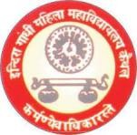
(University Toppers 2023-2024)
BA 3rd Sem

Students Name | Father’s Name | Class | Class Roll No. | Marks  % | Position | Mobile  No. | Picture
Anjali Devi | Sh. Rampratap | BA 3rd sem | 1221962002224 | 333/370 90% | 1st | 9468072231 | 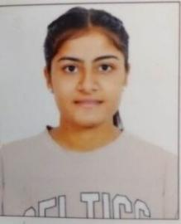
Muskan Devi | Sh. Shishpal | BA 3rd sem | 1221962002134 | 356/400 89% | 3rd | 9518669795 | 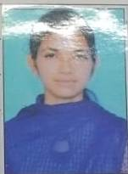
Muskan | Sh. Rajesh Kumar | BA 3rd sem | 1221962002357 | 329/370 88.91% | 4th | 9992038616 | 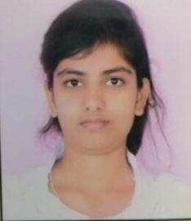
Upasna | Sh. Ashok Kumar | BA 3rd sem | 1221962002035 | 302/345 87.5% | 7th | 9416292058 | 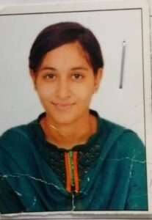
Komal Rani | Sh. Krishan Kumar | BA 3rd sem | 1221962002030 | 347/400 86.7% | 9th | 9728215097 | 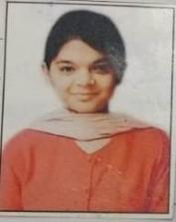
Priya Devi | Sh. Balwan | BA 3rd sem | 1221962002075 | 320/370 86.4% | 10th | 9992342722 | 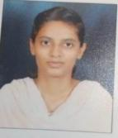
Kajal Devi | Sh. Lila Singh | BA 3rd sem | 1221962002367 | 319/370 86.2% | 12th | 7419041944

BA 4th Sem
Students Name | Father’s Name | Class | Class Roll No. | Marks  % | Position | Mobile  No. | Picture
Ravina | Vijay Kumar | BA 4th sem | 1221962002122 | 351/400 87.75% | 3rd | 9053293145 | 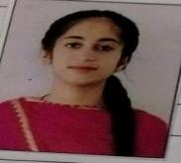
Muskan Rani | Mohan Singh | BA 4th sem | 1221962002045 | 377/430 87.67% | 4th | 8901957010 | 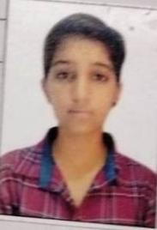
 | Shishpal | BA 4th sem | 1221962002134 | 350/400  87.5% | 5th | 9518669795
  Muskan Devi
Seema Devi | Satyanarayan | BA 4th sem | 1221962002343 | 452/520  86.92% | 6th | 8570862465 | 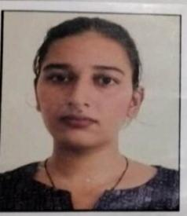
Neha | Sataywan | BA 4th sem | 1221962002028 | 345/400  86.25% | 10th | 9671973392 | 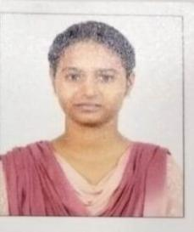

BA 5th Sem
Students Name | Father’s Name | Class | Class Roll No. | Marks  % | Position | Mobile  No. | Picture
Sushmita | Sanjay Kumar | BA 5th sem | 1211962002082 | 351/400 87.7% | 1st | 9466270243 | 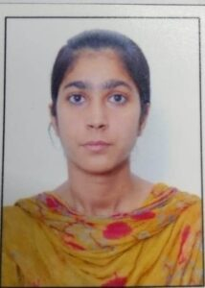
Manju | Sanjay Kumar | BA 5th sem | 1211962002081 | 333/400 83.2% | 10th | 9991344617 | 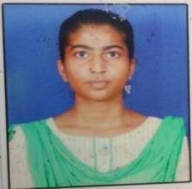

BA 6th Sem
Students Name | Father’s Name | Class | Class Roll No. | Marks  % | Position | Mobile  No. | Picture
Salone | Sh. Jai Bhagwan | BA 6th Sem | 1211962002016 | 414/450 | 1st |  | 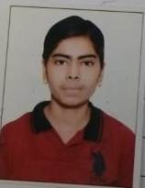
Muskan | Sh. Jaidev | BA 6th Sem | 1211962002002 | 363/400 | 2nd |  | 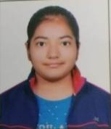
Manju | Sh. Sanjay Kumar | BA 6th Sem | 1211962002081 | 362/400 | 3rd |  | 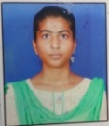
Kajal | Sh. Pawan Kumar | BA 6th Sem | 1211962002053 | 359/400 | 4th |  | 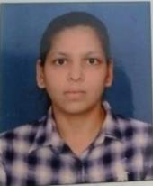
Parveen | Sh. Naresh Kumar | BA 6th Sem | 1211962002360 | 404/455 | 8th |  | 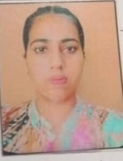
Sushmita | Sh. Sanjay Kumar | BA 6th Sem | 1211962002082 | 353/400 | 9th
Ritu | Sh. Suresh Kumar | BA 6th Sem | 1211962002080 | 353/400 | 9th |  | 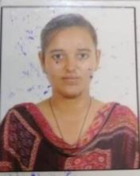

BAMC 3rd Sem
Students Name | Father’s Name | Class | Class Roll No. | Marks  % | Position | Mobile  No. | Picture
Rashmi | Mr. Shripal | BAMC 3rdsem | 1221963009005 | 378 | 6th | 8950672016 | 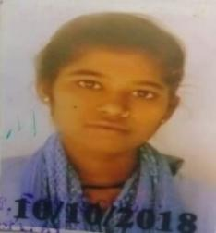

BAMC 5th Sem
Students Name | Father’s Name | Class | Class Roll No. | Marks  % | Position | Mobile  No. | Picture
Sachleen  preet Kaur | Punjab  Singh | BAMC 5th Sem | 1211963009037 | 411  82.2% | 1st | 7082641763 | 
Aarti | Raghubir | BAMC 5th Sem | 1211963009024 | 405  81% | 2nd | 8683870651 | 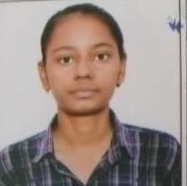
Gurpreet | Karam Singh | BAMC 5th Sem | 1211963009034 | 389  77.8% | 5th | 9996487476 | 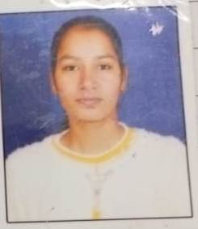
Radhika | Rajesh Kumar | BAMC 5th Sem | 1211963009029 | 372  74.4% | 11th | 7717329214 | 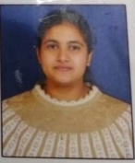
Ritu | Hawa Singh | BAMC 5th Sem | 1211963009039 | 372  74.4% | 11th | 7988392096 | 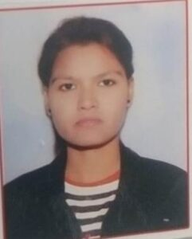
Asha | Ramsawroop | BAMC 5th Sem | 1211963009038 | 368  73.6% | 13th | 7056197741 | 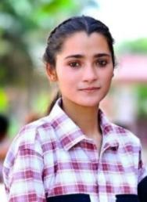
BAMC 6th Sem
Students Name | Father’s Name | Class | Class Roll No. | Marks  % | Position | Mobile  No. | Picture
Sachleen  preet Kaur | Punjab Singh | BAMC 6th sem | 1211963009037 | 423  84.6% | 1st | 7082641763
Aarti | Raghubir | BAMC 6th sem | 1211963009024 | 420  84% | 2nd | 8683870651
Gurpreet | Karam Singh | BAMC 6th sem | 1211963009034 | 413  82.6% | 3rd | 9996487476
Radhika | Rajesh Kumar | BAMC 6th sem | 1211963009029 | 404  80.8% | 7th | 7717329214 | 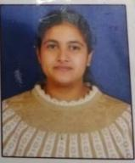
Ritu | Hawa Singh | BAMC 6th sem | 1211963009039 | 395  79% | 12th | 7988392096

B.Com 3rd Sem.

Students Name | Father’s Name | Class | Class Roll No. | Marks  % | Position | Mobile  No. | Picture
Saloni | Sh. Neeraj Gupta | B.com 3rd Sem | 1221963003006 | 511/600 | 1st | 9416384945 | 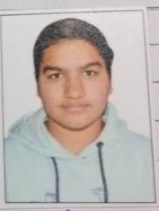

B.Com 4th Sem.

Students Name | Father’s Name | Class | Class Roll No. | Marks  % | Position | Mobile  No. | Picture
Saloni | Sh. Neeraj Gupta | B.com 4th Sem | 1221963003006 | 511/600 | 4th | 9416384945

B.Com 5th Sem.

Students Name | Father’s Name | Class | Class Roll No. | Marks  % | Position | Mobile  No. | Picture
Sohaniya | Sh. Balinder | B.com 5th Sem | 1211963003005 | 498/600 | 7th | 9878755715 | 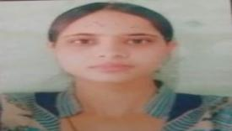

B.Com 6th Sem.

Students Name | Father’s Name | Class | Class Roll No. | Marks  % | Position | Mobile  No. | Picture
Khushi Garg | Yashpal Garg | B.com 6th Sem | 1221963003112 | 2996/3600  83.22% | 1st | 7015313149 | 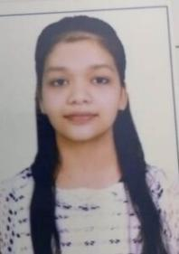

B.Sc 3rd Sem.
B.Sc
Students Name | Father’s Name | Class | Class Roll No. | Marks  % | Position | Mobile  No. | Picture
Khushboo | Sukhdev | B.sc 3rd Sem (C.S) | 1221963015039 | 346/400  86.5% | 1st | 7496810910 | 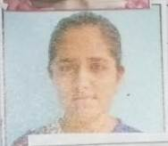
Muskan | Naresh Kumar | B.sc 3rd Sem (N.M) | 1221963015003 | 362/420 86.19% | 2nd | 7015553995 | 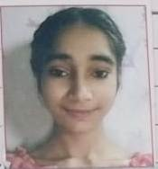
Muskan | Rajinder Singh | B.sc 3rd Sem (N.M) | 1221963015012 | 349/420 83.10% | 6th | 9416308548 | 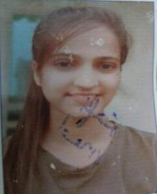
Kafi | Rohtash | B.sc 3rd Sem (Med) | 1221963030023 | 320/370 86.49% | 3rd | 8572830278 | 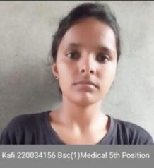
Preeti | Suresh Kumar | B.sc 3rd Sem (Med) | 1221963030008 | 309/370 83.5% | 7th | 9992889779 | 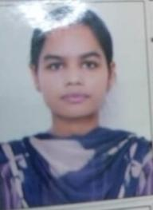
Kajal | Krishan | B.sc 3rd Sem (Med) | 1221963030011 | 309/370 83.5% | 7th | 9996181891 | 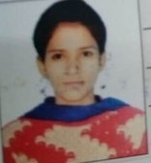

B.Sc. 4th Sem
Students Name | Father’s Name | Class | Class Roll No. | Marks  % | Position | Mobile  No. | Picture
Khushboo | Sukhdev | B.sc 4th Sem (C.S) | 1221963015039 | 538/600  89.6% | 2nd | 7496810910
Kashish | Rajesh Kuamr | B.sc 4th Sem (C.S) | 1221963015032 | 531/600 88.5% | 3rd | 9253422503 | 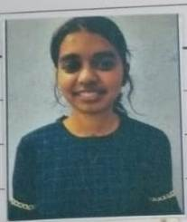
Muskan | Naresh Kumar | B.sc 4th Sem | 1221963015003 | 536/580 92.4 % | 1st | 7015553995
Muskan | Rajinder Singh | B.sc 4th Sem (N.M) | 1221963015012 | 531/580 89.5% | 4th | 9416308548 | 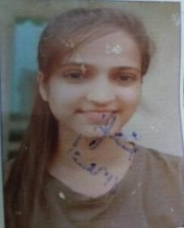
Loveleen | Kashmir Singh | B.sc 4th Sem (Med) | 1221963030014 | 565/630  89.6 % | 1st | 9053135318
Kajal | Krishan | B.sc 4th Sem (Med) | 1221963030011 | 557/630  88.4 % | 3rd | 9996181891 | 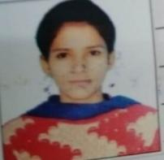
Prerna | Ramparsad | B.sc 4th Sem (Med) | 1221963030010 | 554/630  87.9 % | 5th | 8708000167 | 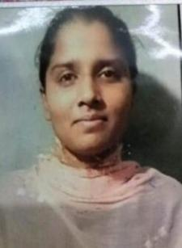
Preeti | Suresh Kumar | B.sc 4th Sem (Med) | 1221963030008 | 552/630 87.61% | 6th | 9992889779 | 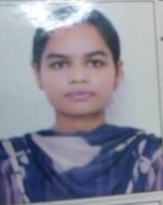
Kafi | Rohtash | B.sc 4th Sem (Med) | 1221963030023 | 551/630 87.4% | 7th | 8572830278 | 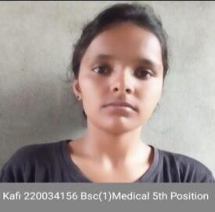

B.Sc 5th Sem.
Students Name | Father’s Name | Class | Class Roll No. | Marks  % | Position | Mobile  No. | Picture
Ritika | Yashpal | B.sc 5th Sem (C.S) | 1211963015050 | 298/350  85.14% | 2nd | 9812640916 | 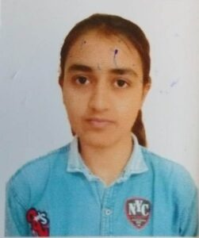
Simran | Ravi Kumar | B.sc 5th Sem (Med) | 1211963030016 | 276/320 | 7th | 7404192004 | 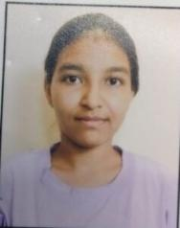

B.Sc6th Sem
Students Name | Father’s Name | Class | Class Roll No. | Marks  % | Position | Mobile  No. | Picture
Ritika | Yasphal | B.sc 6th Sem (C.S) | 1211963015050 | 2623/2900 90.44% | 1st | 7082180296
M.A. Eco 1st Sem.
Students Name | Father’s Name | Class | Class Roll No. | Marks  % | Position | Mobile  No. | Picture
Sheetal Rani | Jogi Rana | MA Eco 1st Sem | 2231925006 | 402/500 80.4% | 2nd | 8950707020 | 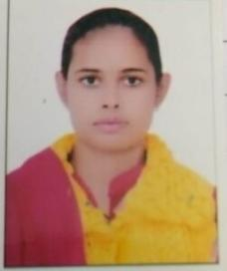
Priya | Pawan | MA Eco 1st Sem | 2231925010 | 373/500 74.6% | 5th | 9817124959 | 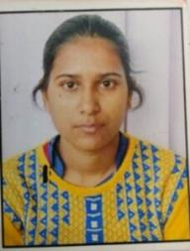
Sonali | Jai Parkash | MA Eco 1st Sem | 2231925018 | 361/500 72.2% | 8th | 8295861476 | 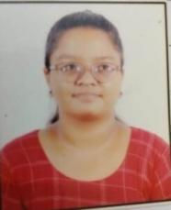

M.A. Eco 4th Sem.
Students Name | Father’s Name | Class | Class Roll No. | Marks  % | Position | Mobile  No. | Picture
Ritu Goyal | Durga Das | MA Eco 4th Sem | 222196151015 | 1475/2000  73.75 % | 9th | 7495008661 | 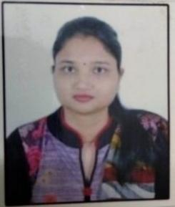
Kajal | Mahabir | MA Eco 4th Sem | 22219615115 | 1432/2000  71.6 % | 11th | 8813985174

M.A. Eng 1st Sem.
Students Name | Father’s Name | Class | Class Roll No. | Marks  % | Position | Mobile  No. | Picture
Deepika Choudhary | Jay Kumar | MA English 1st Sem | 2231926039 | 378/500 75.6% | 3rd | 7015434564 | 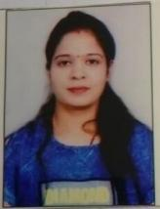
Monika | Vishpal | MA English 1st Sem | 2231926004 | 374/500 74.8% | 4th | 8950860566 | 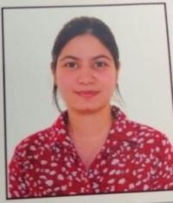

M.A. Eng 3rd Sem.
Students Name | Father’s Name | Class | Class Roll No. | Marks  % | Position | Mobile  No. | Picture
Shivangi | Ram Nath | MA English 3rd Sem | 222196152039 | 389/500 77.8% | 4th | 9817028030 | 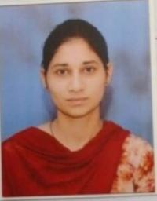
Ritu Rani | Shishpal | MA English 3rd Sem | 222196152017 | 383/500 76.6% | 6th | 7082677908 | 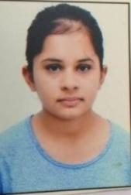
Prachi Sharma | Ramesh Sharma | MA English 3rd Sem | 222196152012 | 380/500 76% | 8th | 7494885907 | 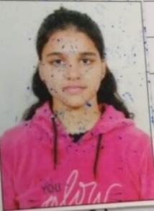

M.A. Eng. 4th Sem.
Students Name | Father’s Name | Class | Class Roll No. | Marks  % | Position | Mobile  No. | Picture
Shashi | Rajesh | MA English 4th Sem | 222196152006 | 1449/2000 72.45% | 10th | 7988313896 | 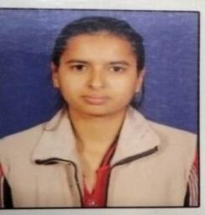
Prachi Sharma | Ramesh Sharma | MA English 4th Sem | 222196152012 | 1481/2000 74.05% | 4th | 7494885907

M.Sc Mathematics 1st Sem
Students Name | Father’s Name | Class | Class Roll No. | Marks  % | Position | Mobile  No. | Picture
Anu | Dilbag | M.Sc Math 1st Sem | 2231928007 | 465/600 77.5% | 1st | 7206838103 | 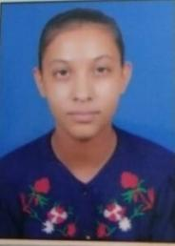
Anju | Rajesh | M.Sc Math 1st Sem | 2231928013 | 411/600 68.5% | 7th | 7206273182 | 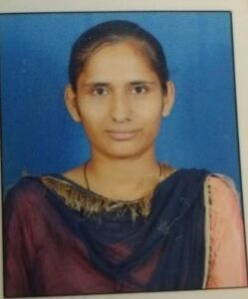

M.Sc Mathematics 2nd Sem
Students Name | Father’s Name | Class | Class Roll No. | Marks  % | Position | Mobile  No. | Picture
Anu | Dilbag | M.Sc Math 2nd Sem | 2231928007 | 465/600 77.5% | 6th | 7206838103 | 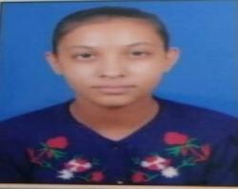
Anju | Rajesh |  | 2231928013 | 411/600 68.5% | 5th | 7206273182
Astha | Ranbir Singh |  | 2231928006 | 502/600  83.66 % | 2nd | 8930358144 | 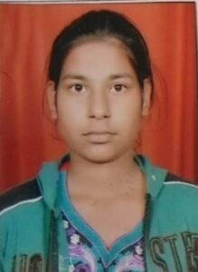
Muskaan | Ram Kumar |  | 2231928008 | 477/600  79.5 % | 7th | 7027053885 | 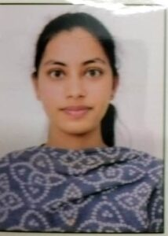

M.Sc Mathematics 3rd Sem
Students Name | Father’s Name | Class | Class Roll No. | Marks  % | Position | Mobile  No. | Picture
Pooja | Suresh | M.Sc Math 3rd Sem | 222196175012 | 512/600 85.33% | 3rd | 9817961304 | 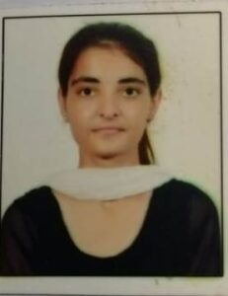
Megha Verma | Sanjay Kumar | M.Sc Math 3rd Sem | 222196175006 | 503/600 83.83 % | 6th | 8053180380 | 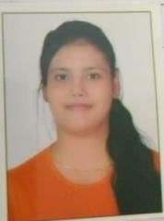

M.Sc Mathematics 4thSem
Students Name | Father’s Name | Class | Class Roll No. | Marks  % | Position | Mobile  No. | Picture
Pooja | Suresh | M.Sc Math 4th Sem | 222196175012 | 515/600 85.33% | 6th | 9817961304
Megha Verma | Sanjay Kumar | M.Sc Math 4th Sem | 222196175006 | 509/600 83.83 % | 9th | 8053180380

M.Com 1st Sem
Students Name | Father’s Name | Class | Class Roll No. | Marks  % | Position | Mobile  No. | Picture
Payal | Mukesh Kumar | M.Com 1st Sem | 2231927021 | 466/600 77.67% | 10th | 9350530880 | 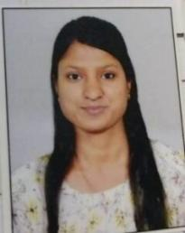

M.Com 2nd Sem
Students Name | Father’s Name | Class | Class Roll No. | Marks  % | Position | Mobile  No. | Picture
Shobha | Subhash | 2nd Sem | 2231927024 | 530/650 81.54% | 3rd | 7027962310 | 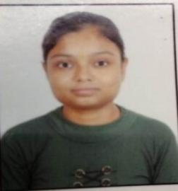

IGMMV focus on learner -centric education approach which uses different types of techniques that shift the role of teachers from contributors of information to providing student learning through appropriate practices . IQAC always encouraged teachers to utilize ICT tools , practical approach , demonstrative techniques in classroom and laboratories. To facilitate the students IQAC suggested new innovative methods for making teaching learning process effective and interactive after suggestions from IQAC various departments arranged different online activities to increase the interest of studentsandto make thembetter understand the concept . Various cells in the college are also take some efforts to initiate various online and offlineactivities( competition , quiz , webinars, extension lecture etc) to improve skills in students so one of the main objective of our educational institution is to create institute of excellencecommitted to provide quality education along with moral values and leadership qualities all girl students without any kind of discrimination.
Pass percentage of students
Year | Program name |  | Number of students appeared in final year examination | No. of students Passed in final year Examination | Pass percentage
2023 -  2024 |  | B.A. | 385 | 292 | 75.844%
2023 -  2024 |  | B.Com. | 103 | 86 | 83.495%
2023 -  2024 |  | B.Sc. (Non Medical+Medical) | 51+24=75 | 50 | 66.66%
2023 -  2024 |  | B.A. Mass Comm. | 27 | 8 | 29.629%
2023 -  2024 |  | BCA | 16 | 8 | 50%
2023 -  2024 |  | M.A. (Eco.) | 13 | 9 | 69.23%
2023 -  2024 |  | M.A.(English) | 36 | 32 | 88.88%
2023 -  2024 |  | M.Com | 33 | 23 | 69.69%
2023 -  2024 |  | M.Sc (Mathematics) | 9 | 4 | 44.44%
2023 -  2024 |  | PGDCA | 0 | 0 | 0
2023 -  2024 |  | B.A. (Evening) | 185 | 42 | 22.70%
2023 -  2024 |  | Total | 882 | 554 | 62.812%

Cells and Departmental Activities2023-24
Sr.  No. | Sub/Dept./Cell | Competition/ Activity | OrganizedBy | Topics | No.ofPart. | Cross  -cutting Issues | Participants/  /PositionHolders | Relevant  Documents
1 | Sexual Harassment and Grievance Cell in collaboration with Computer Science Department | PowerPoint Presentation on ‘Sexual Harassment’  (7.10.2023) | I.G.M.M.V. KAITHAL | The Impact of Sexual Harassment on Victims | 4  (Shivani,  Vritika,  Komal,  Muskan) | Gender | Ist position  (Muskan) | 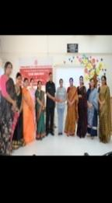
2 | Sexual Harassment and Grievance Cell in collaboration with ICCASH | Documentary on Posh Act 2013  (9.02.2024) | I.G.M.M.V. KAITHAL | The Legal Framework of the POSH Act | 100 Students | Gender | --- | 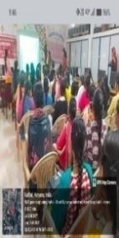
3. | Sexual Harassment and Grievance Cell in collaboration with Redressal Cell | Awareness Program about crimes against women  (12.04.2024) | I.G.M.M.V. KAITHAL | Sexual Harassment: Understanding the Laws and How to Speak Up | 250-350 Students | Gender | -- | 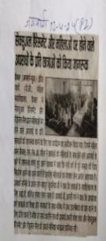
4. | Anti-Ragging Cell | Introduction /Orientation Programme  (12.08.2023) | I.G.M.M.V | “Fostering Respect: Building a Ragging –Free Campus” | 75 | Social Values |  | 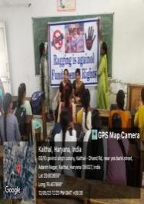
5. | Anti-Ragging Cell | Poster Making Competition  (13.08.2023) | I.G.M.M.V | Ragging is a Crime, Not a Tradition | 15 | Social Values | 1st Komal (B.A-2nd)  (Rollno. 10)(S.F)  2nd Priya  (B.A-3rd )  ( Rollno.68) | 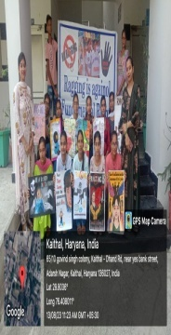
6. | Anti-Ragging Cell | Logo Designing Competition  (14.08.2023) | I.G.M.M.V | Zero Tolerance for Ragging :Act Now | 10 | Social Values | 1st Ravina (B.A-2nd )  (Rollno.406)  2nd Karamjeet kaur  (B.A-2nd )  (Rollno. 21(S.F) | 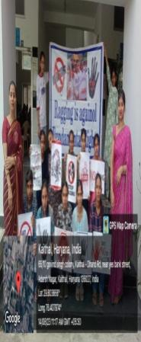
7. | Anti-Ragging Cell | Essay Writing Competition  (15.08.2023) | I.G.M.M.V | Sexual Abuse | 8 | Social Values | 1st Shiwani  (B.A-2nd )  Rollno. 58 (S.F)  2nd Kajal Mittal  (B.A-3rd)  (Rollno. 53) | 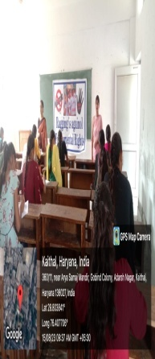
8. | Anti-Ragging Cell | Slogan Writing Competition  (16.08.2023) | I.G.M.M.V | A Friendly Welcome, Not a Fearful One | 12 | Social Values | 1st Bhumi (B.A-1st)  (Rollno. 322)  2nd Nisha  (B.A-3rd)  (Rollno.295) | 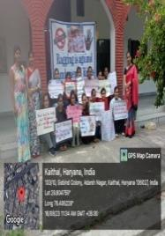
9. | Anti-Ragging Cell | Documentary /Short Movie on Ragging  (17.08.2023) | I.G.M.M.V | The Ragging (2016) | 100 | Social Values |  | 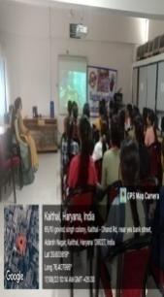
10. | Anti-Ragging Cell | Prize Distribution  (18.08.2023) | I.G.M.M.V |  |  | Social Values |  | 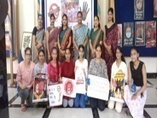
11. | Anti-Ragging Cell | Rally  (19.02.2024) | I.G.M.M.V | Stop Ragging , Start Repecting | 150 | Social Values |  | 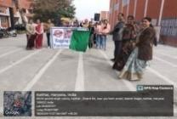
12. | Swami Vivekananda Youth cellwith collaboration of Career Guidance and Placement cell | An inspirational film '12th fail' was shown to the students  Date-  12 January 2024 | I.G.M.M.V.  Kaithal | Career guidance and inspiration not to quit in your life | 70 | Human value | 70 | 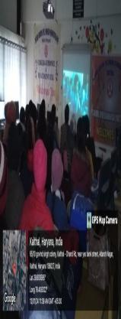
13. | Career Guidance and Placement cell | Lecture delivered  Date-  26 February 2024 | I.G.M.M.V.  Kaithal | Earn Digitally | 100 | Professionalism | 100 | 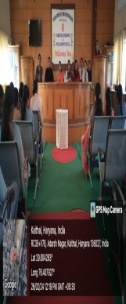
14. | Career Guidance and Placement cell | Lecture delivered by Dr.Rajiv Associate Professor in Department of Management Baddi University, Baddi  Date-  05 April 2024 | I.G.M.M.V.  Kaithal | Career opportunities available after graduation and post graduation | 100 | Professionalism | 100 | 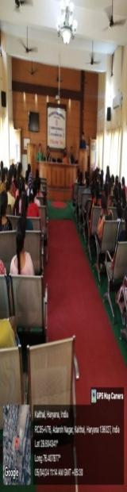
15. | Red Cross and Red Ribbon Cell | LECTURE DELIVERED  By Dr. Vinay Gupta  (Monitoring & Evaluation Officer) Civil, Hospital Kaithal  8-9-2023 | I.G.M.M.V.  Kaithal | Drug Addiction | 100 | Gender |  | 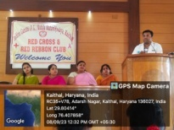
16. | Red Cross and Red Ribbon Cell | LECTURE DELIVERED  By Police Dept. , Kaithal  18-11-2023 | I.G.M.M.V.  Kaithal | AWARENESS PROGRAMME ON NASHA MUKT HARYANA | 700 | Gender | 700 | 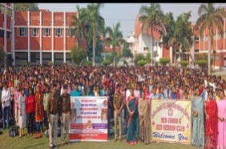
17. | Red Cross and Red Ribbon Cell | POSTER MAKING  1-12-2023 | I.G.M.M.V.  Kaithal | World AIDS Day | 17 | Gender | 17 | 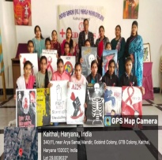
18. | Red Cross and Red Ribbon Cell | LECTURE DELIVERED  By Red Cross Society, Kaithal  15-12-2023 | I.G.M.M.V.  Kaithal | HIV AIDS, Tuberculosis, Cancer | 250 | Gender | 250 | 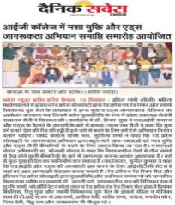
19. | Red Cross and Red Ribbon Cell | LECTURE DELIVERED  By Ms. Sonia , Counselor Civil Hospital, Kaithal  26-12-2023 | I.G.M.M.V.  Kaithal | HIV AIDS, Testing Of HIV AIDS | 50 | Gender | 50 | 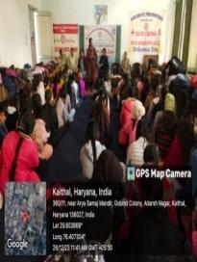
20. | Red Cross and Red Ribbon Cell | LECTURE DELIVERED  By Dr. Vijay Bansal,  Director  Department Of Cancer Surgery I V Y Hospital, Mohali  03-2-2024 | I.G.M.M.V.  Kaithal | Cancer | 70 | Gender | 70 | 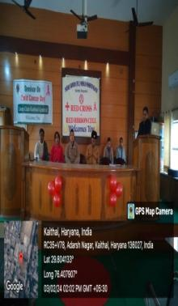
21. | Red Cross and Red Ribbon Cell | POSTER MAKING  17-02-2024 | I.G.M.M.V.  Kaithal | DWorming | 70 | Gender | 70 | 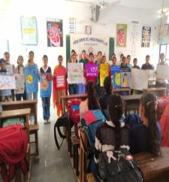
22. | Red Cross and Red Ribbon Cell | POSTER MAKING  08-05-2024 | I.G.M.M.V.  Kaithal | Red Cross Day | 50 | Gender | 50 | 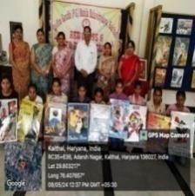
23. | Red Cross and Red Ribbon Cell | Slogan Writing  08-05-2024 | DFayanand Mahila Mahahvidyalya, Kurukshetra | World Red Cross Day | 1 | Gender | Ravina B.A.2nd year Roll no. 1221962002406 1st Position. | 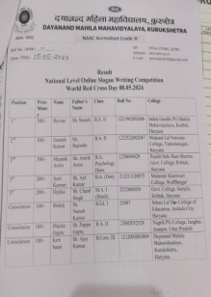
24 | Road Safety Club | Meeting(11.03.2023) | IGMMV,Kaithal | RoadSafety | 05 | Human Values | 5  Faculty members | 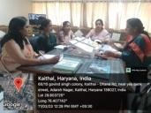
25 | Road Safety Club | Road,Safety Poem Competition(14.03.2023  ) | IGMMV,Kaithal | RoadSafety | 06 | Human Values | 1st Position  Saloni  B.A II66  2nd Position  Khushi  B.A II310  3rd Position  Monika  M.A II03 | 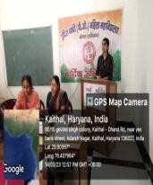
26 | Road Safety Club | State LevelMeetingatSectreate(13.09.2023  ) | PoliceDepartment | RoadSafetyQuizCompetition | 1 | Human Values | Dr.DeepaAtri | 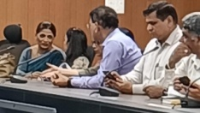
27 | Road Safety Club | Road Safety Quiz Competition13.10.2023 | IGMMV,K  aithal | RoadSafety | 130 | Human Values | 1st  PositionNehaB.Sc II1211963  015021  2nd  Position  Khushi  B.A I1231349383  3rd  Position  Muskan  B.A I1231349215 | 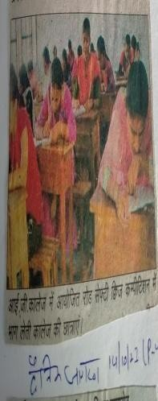
28 | Road Safety Club | Road Safety Quiz Competition  (14-10-202  3) | Police Officer transportation,kurukshetra | RoadSafety | 105 | Human Values | 1st  PositionNehaB.Sc II1211963  015021  2nd  Position  Khushi  B.A I1231349383  3rd  Position  Muskan  B.A I  1231349215 | 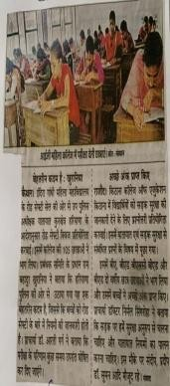
29 | Road Safety Club | Road Safety Quiz Competition  (30-10-202  3) | Police Officer transportation,kurukshetra | RoadSafety | 03 | HumanValues | 1stPositionNehaB.Sc II1211963015021  2nd Position  Khushi  B.A I1231349383  3rdPosition  Muskan  B.A  I1231349215 | 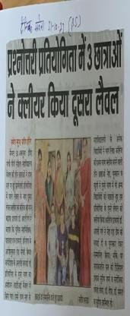
30 | Road Safety Club | District Level Inter School Road Safety Quiz Level-  (10-11-202  3) | Police Officer transportation, kurukshetra | RoadSafety | 03 | HumanValues | 2ndPosition in District level Neha  B.A III  108  Khushi  B.A I1231349383  Muskan  B.A I  1231349215 | 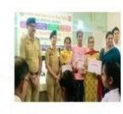
31 | Road Safety Club | Road Safety Quiz Competition  12/11/2024 | IGMMV,K  aithal | RoadSafety | 150 | Human Values | Komal B.Com II 049  Rimjhim BCA I  Sheetal BA I 313 | 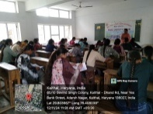
32 | Road Safety Club | District Level Inter School Road Safety Quiz  Level-  05/12/2024 | Police Officer transportation,kurukshetra | RoadSafety | 03 | Human Values | - | 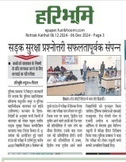
33 | Electoral literacy club | District level Drama Competition | I.G.M.M.V .Kaithal. | Nothing like voting, I vote for sure.” | 10 | Human Value | 3rd | 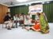
34 | Electoral literacy club | District level Mandhi Competition | I.G.M.M.V .Kaithal. | Nothing like voting, I vote for sure.” | 2 | Human Value | Ist | 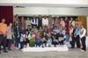
35 | Electoral literacy club | District level Rangoli Competition | I.G.M.M.V .Kaithal. | Nothing like voting, I vote for sure.” | 3 | Human Value | Ist
36 | Electoral literacy club | District level Speech Competition | R.K.S.D. College, Kaithal | Nothing like voting, I vote for sure.” | 1 | Human Value | Ist | 
37 | Electoral literacy club | District level Essay writing Competition | R.K.S.D. College, Kaithal | Nothing like voting, I vote for sure.” | 1 | Human Value | 2nd | 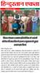
38 | ICCASH | Sexual harassment  (7 oct 2023) | IGMMV  College | About low of awareness,  Solving girls student problem | 30 | Gend er | Participants(30) | 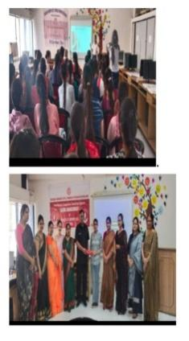
39 | ICCASH | Awareness  Activity  (9 feb 2024) | IGMMV  College | Sexual  Harassment ,Awareness among student | 60 | Gender | Participants(60) | 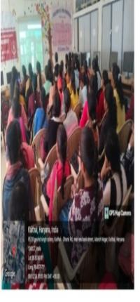
40 | ICCASH | Workshop  (7march 2024) | IGMMV  College | Gender  Sensitization | 3 | Gender | Participants(3) | 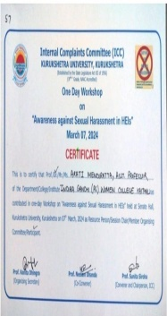
41 | Anti Tobacco cell | Awareness campaign | I.G.M.M.V.  Kaithal | Nasha mukthamara gaon Nasha mukthamara Shahar Nasha mukthamaraHaryana jahabdudhdahi ka khana | 700 | Drugs | NA | 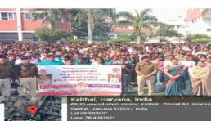
42 | Anti Tobacco cell | Pledge ceremony | I.G.M.M.V.  Kaithal | Pledge against smoking | 70 | Smoking | NA | 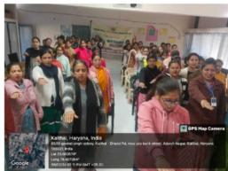
43 | Legal Literacy  Cell | On the spot Painting Competition  18/04/2024 | IG(PG) MMV, Kaithal | FemalFoeticide  Human Rights  Save Girl Child | 3 | Human Values | Ravina BA II R-406  First Position  Nidhi BA I R-320  2nd Position  Ankush  BA I R-065  3rd Position | 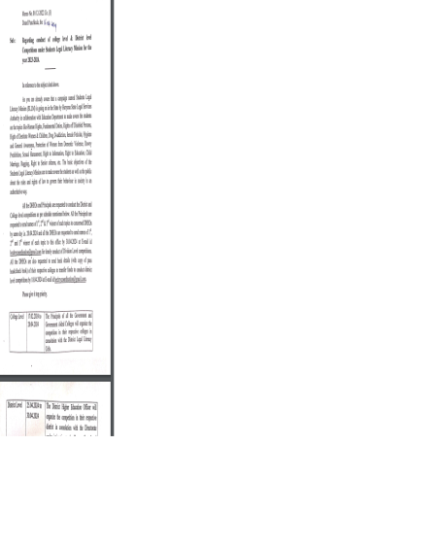
44 | Legal Literacy  Cell | Slogan Writing Competition  18/04/2024 | IG(PG) MMV, Kaithal | Save Girl Child  Women Empowerment  Human Rights | 3 | Human Values | Komal BA II R-10  1st Position  Mehak  BA II  R-200  3rd Position
45 | Legal Literacy  Cell | Quiz Competition  18/04/2024 | IG(PG) MMV, Kaithal | Human Rights  Fundamental Duties  Rights of Senior Citizen | 3 | Human Values | Pooja BA I R-109  Sonia BA I R-10  Tamanna BA I  R-14  1stPosition
46 | Legal Literacy  Cell | Declamation Competition  18/04/2024 | IG(PG) MMV, Kaithal | Fundamental Duties  Rights of Senior Citizen | 2 | Human Values | Monika BA I R-52(SF)  Honey BA I R-292
47 | Legal Literacy Cell | Power Grid Corporation of India Ltd. Vigilance Awareness (31.10.2022) to (6.11.2022) | IGMMV, Kaithal |  | 3 | Human Values | 1st Position Sachleen  Kaur BAMC II 1211963009037  2ndPosition SimranPreet Kaur  BAMC III  12096009014  3rd Position Shivani  B.A I  1221962002001 | 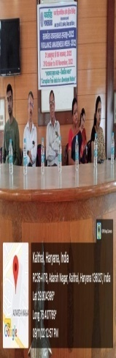
48 | Legal Literacy Cell | National Human Rights & Crime Petrol Beaureau  (24-01-2023) | IGMMV, Kaithal |  | 21 | Human Values | Participation | 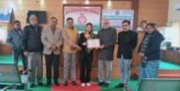
49 | Legal Literacy Cell | On The Spot Painting (04.02.2023) | Director Higher Education Haryana  Shiksha Sadan Sector-5 Panchkula |  | 3 | Human Values | 1st Position Priya  B.A 2nd  1211962002068  2ndPosition Ravina  B.A I  121962002406  3rd Position Nikita  50B.A III  12196002343 | 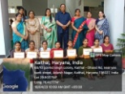
50 | Legal Literacy Cell | Slogan Writing  (04-02-2023) | Director Higher Education Haryana  Shiksha Sadan Sector-5 Panchkula |  | 3 | Human Values | 1st Position Komal  B.A I 1221963002010  2ndPosition Mehak, B.A II, 1221962002200  3rd Position Khushi, B.A II,1211962002020 | 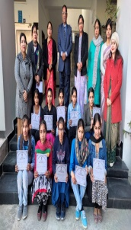
51 | Legal Literacy Cell | Essay Writing  (04-02-2023) | Director Higher Education Haryana  Shiksha Sadan Sector-5 Panchkula |  | 3 | Human Values | 1st Position Meena  M.Com,221196168021  2ndPositionSachleenKaur,BAMC II,1211963009037  3rd Position Seema, B.Com III, 120196003092 | 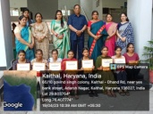
52 | Legal Literacy Cell | District level Competition on the spot Painting (06-02-2023) | B.R Ambedkar Govt.. College, Kaithal |  | 2 | Human Values | 1st Position Raveena B.A I,1221962002406  3rd Position Priya, BA II,1211962002068
53 | Legal Literacy Cell | District level Competition on the Slogan Writing (06-02-2023) | B.R Ambedkar Govt.. College, Kaithal |  | 1 | Human Values | 1st Position Komal  B.A I | 
54 | Legal Literacy Cell | District level Competition on the Essay Writing (06-02-2023) | B.R Ambedkar Govt.. College, Kaithal |  | 1 | Human Values | 3rd Position  SachleenKaur,BAMC II 1211963009037
55 | Legal Literacy Cell | District Level PPT Competition  (06-02-2023) | B.R Ambedkar Govt.. College, Kaithal |  | 2 | Human Values | 1st Position  Muskan BCA II (1211962011019)  1st Position  Anju BCA II  (1211962011003)
56 | Legal Literacy Cell | District Level Quiz Competition  (06-02-2023) | B.R Ambedkar Govt.. College, Kaithal |  | 3 | Human Values | 3rd Position Ashu B.AII 1211962002185  3rd Position Mansi B.A III 120196002387  3rd Position  Mehak B.A I 1221962002200
57 | Legal Literacy Cell | Poster Making Competition  (2-03-2023) | IGMMV, Kaithal |  | 3 | Human Values | 1st Position Komal  B.A I 1221963002010  2nd Position Sarbjeet, B.A II 120196002311  3rd Position Priya, BA II,1211962002068 | 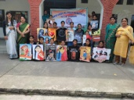
58 | Legal Literacy Cell | Quiz Competition  (04-04-2023) | IGMMV, Kaithal |  | 1 | Human Values | 1st Position Shivani  1st Position Sakshi  1stPosition Kajal | 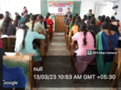
59 | Legal Literacy Cell | Declamation Competition  (31-03-2023) | IGMMV, Kaithal |  | 3 | Human Values | 1st Position Preeti  2ndPositionTamanna  3rd Position Ankita | 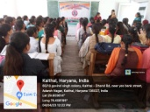
60 | Legal Literacy Cell | Online National Level Quiz Competition (25-03-2023 ) (02-26-2023) | Babu Anant Ram Janta College Kaul Kaithal |  | 19 | Human Values | Participation | 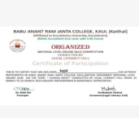
61 | Legal Literacy Cell | State Level Competition (25.04.2023) | Shri Mata Mansa Devi Govt.t. Sanskrit  Mahavidyalaya Panchkula |  | 2 | Human Values | 3rd Position  Priya BA2nd (1211962002068)  3rdPosition Muskan Bca2nd  (1211962011019) | 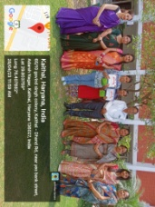
62 | Legal Literacy Cell | State Level Essay Writing Competition (25.04.2023 | IGMMV Kaithal |  | 2 | Human Values | 1st Position  Yogesh  ,B.Ed I 22079  2nd Position  Simranjeet,  B.A I 1221963002041 | 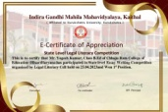
63 | Legal Literacy Cell | State Level Poster Making Competition (25.04.2023 | IGMMV Kaithal |  | 2 | Human Values | 1st Position  Komal B.A I ,1221963002010  2nd Position  Kusum B.A III,  120409002052 | 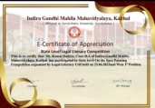
64 | Women Cell | National Level Essay Writing Competiton on the Occasion – International Girl Child Day  09.10.2024 | M.D.S.D College , Ambala City | Violence Against Girls  Child labour  Survival as the first challenge for girl  Status of girl child  Gender Inequality | 2 | Gender | SimranjeetKaur B.A IInd  1221963002041  sivikakaur@gmail.com  Ankita B.A IInd | 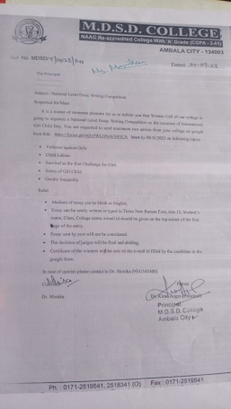
66 | Women Cell | State Level Essay Writing competition  International Girl Child Day | I.G.(PG)M.M.V , Kaithal | Save girl child  Stop Infanticide  Schemes of Haryana Govt for Girl child | 9 | Gender | Gracy B.com IIIrd  1212093039002  D.N College , Kurukshetra  Siimrajeetkaur B.A II 1221963002041 | 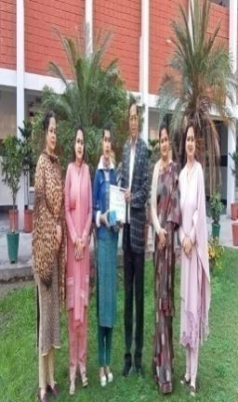
67 | Women Cell | National Level Online Essay Writing Competition  24.01.2024 | Women cell,  IG(PG)MMV,Kaithal | National Girl Child Day | 34 | Gender, Human Values | KamleshYaduvansh Degree College Mahendargarh in, Haryana  RS-500/-  IInd Prize - SachleenpreetKaur  IG(PG)MMV,Kaithal | 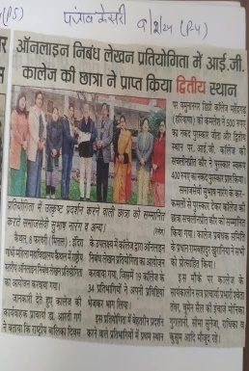
68 | Women Cell | National Level Online Quiz  24 Jan to26 Jan 2024 | R.K.S.D College, Kaithal | National Girl Child Day | Approx:50 | Gender | Participation of all students of M.A English | 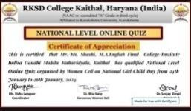
69 | Women Cell | Online National Level Poster Making Competition.  30.01.2024 | All India  Jat Heroes' Memorial College, Rohtak | National Cleanliness Day | 2 | Human Values & Environmental Consciousness | KaramjeetKaur  B.A.IInd 1221963002021  Poster making  Raveena (Rangoli)  BA IInd  121196 2002068 | 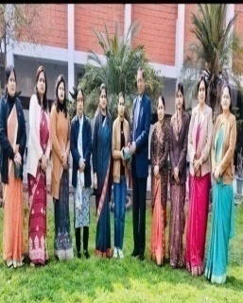
70 | Women Cell | National Level Observance of International Level of Women and Girl in sciences  10.02.2024 | Gita VidyaMandir Girl’s College, Sonipat | International Level Of Women and Girl in science | 2 | Human values & Gender | AkshitaB.Sc II – 3rd Position  KaramjeetB.Sc II – 3rd 1221963002021 | 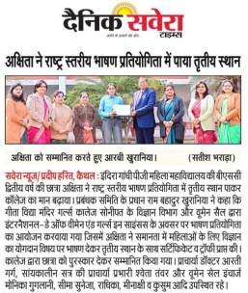
71 | Women Cell | National Level Speech Competition  29.02.2024 | Arya PG College, Panipat | Women Development Centre & Legal Literacy Cell |  | Human values | Navya – B.com II 1221963003008 ( certificate) | 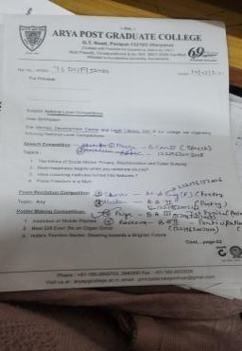
72 | Women Cell | National Level Poem Recitation competition :  29.02.2024 | Arya PG College, Panipat | Become Vegetatrian |  | Human values | Shashi – M.A Eng (final)  222196152006 ( certificate)  Muskan B.A II 1221962002160  ( certificate) | 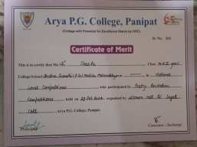
73 | Women Cell | National Level Poster Making Competition  29.02.2024 | Arya PG College, Panipat |  |  | Human values & Gender | Priya – B.AIII 1211962002068 Ist prize  Raveena B.A II 1221962002406 (Participation certificate) | 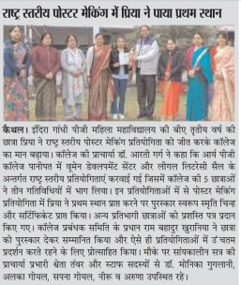
73 | Women Cell | National level Online Essay writing competition  29.2.2024 | Maharaja AgarsenMahavidyalay, Jagadhari | International Women’s Day2024 | 1 | Human values & Gender | Sachleenpreet BAMC 7082641763 | 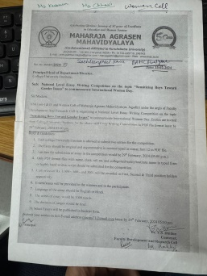
75 | Women Cell | Inter college online state Level  Poster Making  competition | D.A.V College, Lahore, Ambala City | Women’s inclusion ; A way to forge a better world | 2 | Human values & Gender | Komal B.A II 122196300210  (Consolation) | 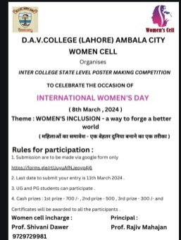
76 | Women Cell | Inter college Collage Making completion by Women Cell on Women’s day | Tika Ram College of Education,Sonipat | Wings of women |  | Human values & Gender | Komal B.A II 122196300210  Raveena B.A II 1221962002406  IIIrdposition (cash prize) rs.500 | 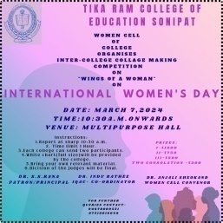
77 | Women Cell | State Level Slogan Writing Competition  08.03.2024 | I.G.M.M.V | Gender Sensitization and Mental Health of Women |  | Human values & Gender | No. of Total Participants 15  Muskan Sharma B.Ed II – 1ST position  Priya B.A II I.G.M.M.V  2nd position  Sakshi M.AII 3rd  Dyalsinghcollege ,Karnal | 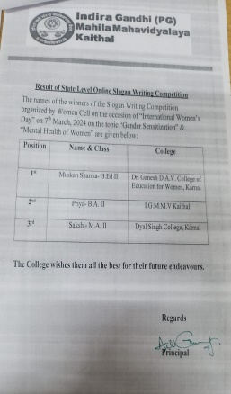
78 | Women Cell | International Women’s Day 09.03.2024 | S.A Jain College, Ambala | Veer Gatha ; A Declamation Contest |  | Human values & Gender | AkshitaB.Sc II 1st position  2ndevent ;  Komal&Muskan(BCA 2nd year )  2nd prize | 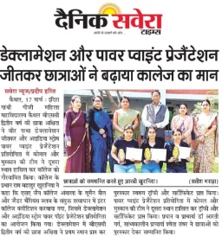
79 | Women Cell | Group Discussion  07.03.2024 | I.G (PG)M.M.V | Rights and duties of women  Women Empowerment  Gender Discrimination  Need of Education for Women | All M.A Economis  M.A English  M.com | Human values & Gender | M.A Economis  M.A English  M.com | 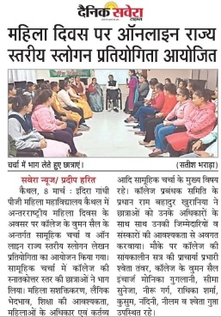
80 | N.S.S.  Cell | National Integration Camp  25-7-2023 to 31-07-2023 | Kurukshtera  University  Kurukshtera | 7Days camp | 100 | Social | 1  participants | 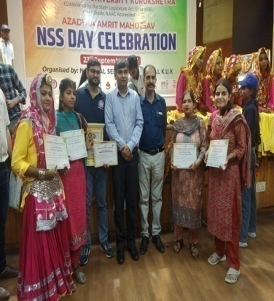
81 | N.S.S.  Cell | poster making competition was organized 4-9-2023 | Indira Gandhi Mahila Mahavidyalaya, Kaithal | anti-drug campaign | 30 | Social | 1st, 2nd, 3rd | 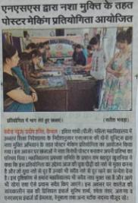
82 | N.S.S.  Cell | Painting pots and trees in the college campus.  8-10-2023 | Indira Gandhi Mahila Mahavidyalaya, Kaithal | donated labour | 80 | Social |  | 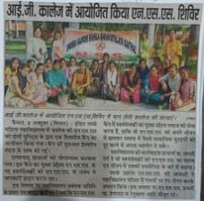
83 | N.S.S.  Cell | oath of national unity day  31-10-2023 | Indira Gandhi Mahila Mahavidyalaya, Kaithal | birth anniversary of Sardar Vallabhbhai Patel | 80 | Social |  | 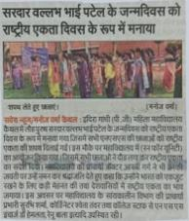
84 | N.S.S.  Cell | seven-day day and night NSS camp 22-12-2023 to 28-12-2023 | Indira Gandhi Mahila Mahavidyalaya, Kaithal | "Ban on stubble pollution" | 100 | Social | Isha B.Com 1st Year  Payal B.A 3rd m Year  Palak B.A 1st Year | 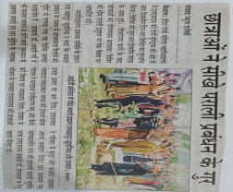
85 | N.S.S.  Cell | handmade garments, paintings, purses, jewelry, etc. 13-02 -2024 | Indira Gandhi Mahila Mahavidyalaya, Kaithal | Swavalambi Bharat Abhiyan | 30 | Social |  | 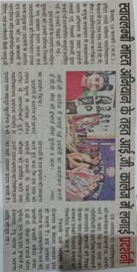
86 | N.S.S.  Cell | one-day camp  30-3-2024 | Indira Gandhi Mahila Mahavidyalaya, Kaithal | Awareness  all types of addiction, especially tobacco, oath | 90 | Social |  | 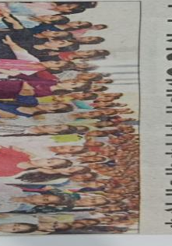
87 | Environment  Cell | Ozone Day Celebration  16-09-2023 | I.G.M.M.V.  Kaithal | Poster making and slogan writing competition | 15 |  | Ist–Muskan  (B.sc non med ist year)  2nd-Preti (B.sc med 2nd)  3rd–Shiwani  (Bsc Life science ist) | 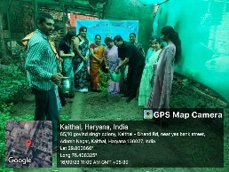
88 | Environment Cell | Hazardous effect of Peddy straw burning  7-11-2023 | I.G.M.M.V  Kaithal | Seminar by members of KrishiVigyan Kendra, kaithal | 60 |  | 60 participants | 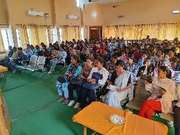
89 | Environment Cell | National level Slogan writing competition  30-1-2024 | M.S.D college, Ambala City | Slogan writing competition on cleanliness | 7 |  | 7 participants | 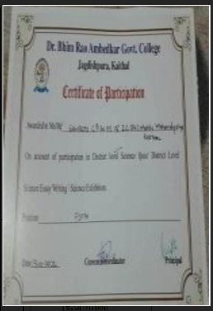
90 | EDP | Lectures  26-02-2024 | Career Guidance & Placement Cell , EDP( Enterprenure Development Program Cell in collaboration with Computer Science Department . | Freelancing and Tutorial Platforms, Online Services and Market Research Websites, Content Creation on YouTube or Blogging, Digital Marketing, E-commerce etc | 50 | Professionalism |  | 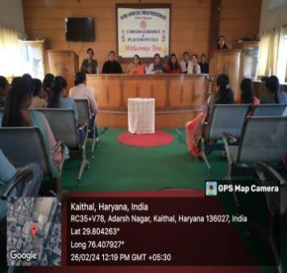  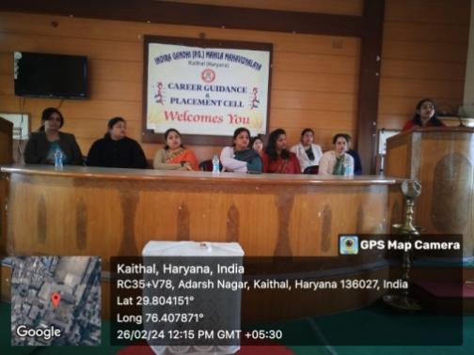
91 | EDP | Activity  4.03.2024 | an activity under "Waste Management" in context of 'World Sustainable Day' was organised by Commerce Department with collaboration of Entrepreneurship Development Programme Cell and Green Energy and Environment Audit Cell. In this activity students of Arts, Commerce, Science actively participated. Through these activities students gave message how the waste things can be reused in a creative way.  04-03-2024 | Best out of waste | 20 | Professionalism |  | 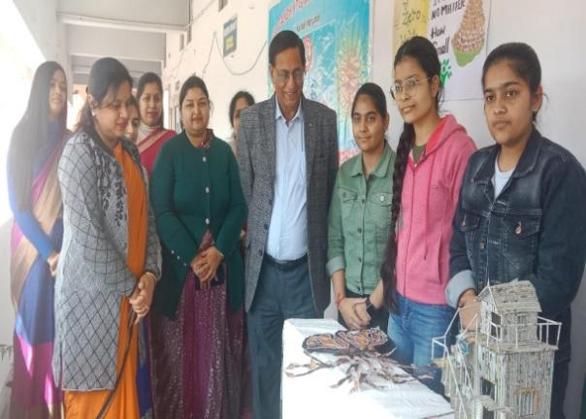  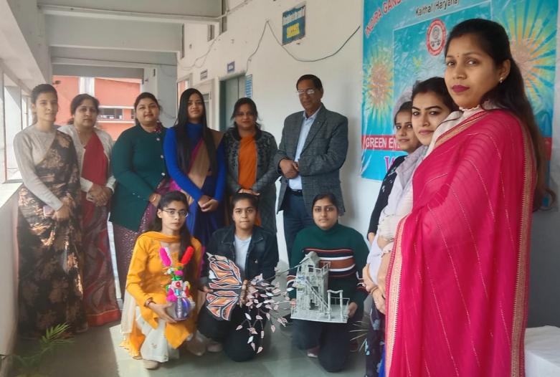
92. | Research Development Cell | Competition | Research Development Cell Collaborationwith Commerce Department | Service Model Competition and Speeches | 09 | Human | Arju & Team | 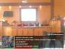

D

Departmental Activities 2023-24
Sr.  No. | Sub/Deptt./Cell | Competition/ Activity | OrganizedBy | Topics | No.of  Part. | Cross  -cutting  Issues | Participants/  /PositionHolders | RelevantDocuments
1 | Psychology dept. | Psychological testing camp. (Mental health day ) In village .Padlakaithal.  10.oct.2023 | I.G.M.M.V.  Kaithal | Psychological testing | 32 | Mental health | Psychology students | 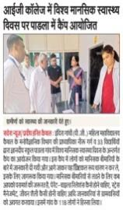
2 | Psychology | 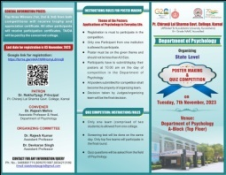 | Pt. Chiranji Lal Sharma Gov. college karnal | Psychological testing | 3 | Mental health | 2ND position  In poster making  jiya 2nd year | 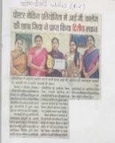
3 | Mathematics | State level Online PPT competition  (05.09.2023) | Importance of Mathematics in Our Daily Life | Sant Mohan Singh Khalsa Labana Girls College, Barara | 1 | Human Values | Akshita 1221963015005  1st position  B.Sc. 3rd Sem | 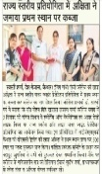
4 | Mathematics | National level Online Quiz competition  (11.09.2023) | General Mathematics | Sant Mohan Singh Khalsa Labana Girls College, Barara | 3 | General | Megha  222196175006 (3rd position),  Pooja  222196175012  Participation  Sanjana  222196175005  Participation  M.Sc. Final | 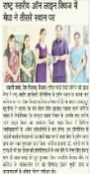
5 | Mathematics | State level Online Essay writing competition  (18.11.2023) | Use of Mathematics in Artificial Intelligence | Guru Nanak Khalsa College, Yamuna Nagar, Haryana | 1 | Human Values | Akshita  1221963015005  1st position  B.Sc. 3rd Sem | 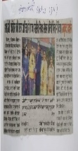
6 | Mathematics | Inter College Online Essay writing competition  (22.12.2023) | “Ramanujan’s Place in the World of Mathematics” | K.L. Mehta Dayanand College for Women, Faridabad | 2 | Human Values | Palak  1231355008  Participation  B.Sc. 1st Sem  Shweta  1231355038  Participation  B.Sc. 1st Sem | 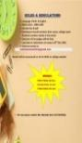
8 | Mathematics | District Level Science and Mathematics Exhibitions under Samagra Shiksha Kaithal  (29.12.2023) | General | GGSSS Jakhouli Adda Kaithal | 2 | General | Ms. Ankita Goel  Ms. Lalisha | 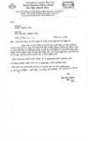
9 | Mathematics | Online National Level Essay Writing Competition  (4.1.2024) | - Life of Ramanujan  - Mathematics for Everyone  - Real Life Application of Mathematics | I.G.M.M.V.KAITHAL | 24 Students from different colleges including 2 students of our college | Human Value/ Social Value | Kajal Mittal  1211962002053  B.A. Final ParticipationMuskan Sharma  1211962002160  B.A. II  Participation |   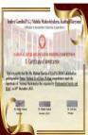
10 | Mathematics | National level Online Mathematics Quiz competition  (28.02.2024) | General | G.V.M. Girls College Sonipat in Collaboration with Vigyan Bharti, Haryana | 2 | General | Khushboo  222196175004  Participation  M.Sc. Final Astha  2231928006  Participation  M.Sc. Previous | 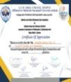  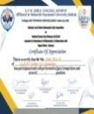
11 | Mathematics | Online National Level Collage Making Competition  (28.02.2024) | Mathematicians | I.B.(P.G.) College,Panipat | 2 |  | Manisha  1211962002322  1st position  B.A. Final  Nisha  1211962002295  B.A. Final  Participation | 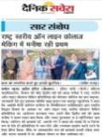  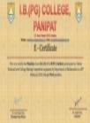
12 | Mathematics | Power point Presentation Competition on occasion of The International Day of Mathematics in Collaboration with C.I.S.K.M.V.  Dhand-Dadwana  (14.03.2024) | i) Origin and History of Pi  ii) Number Theory in Daily Life iii)ApplicationsofMathematics in Daily Life | I.G.M.M.V.KAITHAL | 8 students including 5 students of our College | Human value/ Social Value | Akshita 1221963015005  1st position  B.Sc. 3rd Sem | 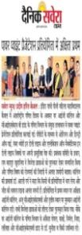
13 | Mathematics | State Level Online Poster Making Contest on occasion of The International Day of Mathematics  (14.03.2024) | i)Classical and Modern Mathematical Innovations  ii) Famous Mathematicians and their Contribution | S.U.S. Govt. College, Matak Majri,Karnal | 3 | Human Values | Manisha  1211962002322  1st position  B.A. Final  Priya  1211962002068  Participation  B.A. Final | 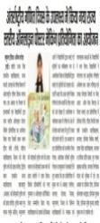
14 | Mathematics | Online National Level Quiz Competition  (14.03.2024) | General | I.B.(P.G.) College,Panipat | 10 | General | Nisha  222196175011  1st Position  M.sc. Final  Sanjana  222196175005  2nd Position  M.sc. Final  M.sc. Final and M.sc. Previous Students Participation | 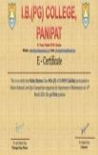  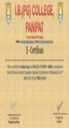
15 | Mathematics | State Level Online Quiz Competition  (14.03.2024) | Basic | Guru Nanak Girls College,  Yamunanagar | 5 | General | M.sc. Final Students  Participation |   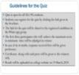
16 | Mathematics | National level Online PPT competition  (18.04.2024) | Role of Mathematics in Everyday Life | KVA DAV College for Women,Karnal | 1 | Human Values | Akshita 1221963015005 3rdposition  B.Sc. 4th Sem | 
17 | Commerce department | Presentation | Commerce department | Motivation , valid contract and branch account | 70 | Built confidence among students | _ | 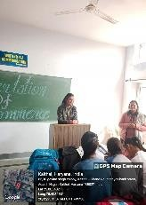
18 | Commerce department | State level online quiz competition (28 .02. 2024) | I.G.M.M.V, Kaithal | Financial management , insurance , income tax & corporate accounts | 100 | Enhancing knowledge of students | Saloni gupta  Roll no. 1221963003006  Position : 1st | 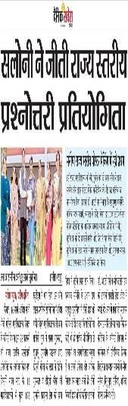
19 | Commerce department | One day research program (15.03.24) | I.G.M.M.V, Kaithal | Consumer awareness | 7 | Awaring the students regarding consumer rights | Aarzo & group  Class: M.com final  Roll no. 222196168020 | 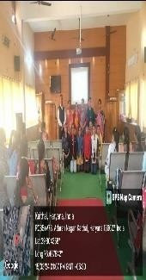
20 | Commerce department | Exhibition (4.03.2024) | I.G.M.M.V, Kaithal | Waste management | 20 | Educate students how to make best out of waste | - | 
21 | Commerce department | Industrial visit (16.03.2024) | I.G.M.M.V, Kaithal | Operation of a sugar mill | 106 | Educating girls about process of sugar mill | - | 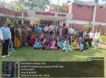
22 | Commerce department | Various literary and cultural event  (25.01.2024) | Election department | National voters day | 3 | Creating awareness among student regarding importance of vote | Pooja  Roll no .  1231352031  Clas : B.com 1st  Nancy  Roll no .  1231352091  Clas : B.com 1st  Tannu Gil  Roll no .  1231352134  Clas : B.com 1st | 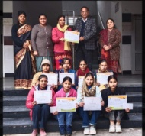
23 | Commerce  Deparment | Various competition were organized  (6.04.24) | R.K.S.D college , Kaithal | Manthan -2024 | 10 | Enhancing team spirit and confidence among students | Raveena  B.A 2nd year  Position : 1st  Event : Logo rangoli  Roll no. 1221962002406 | 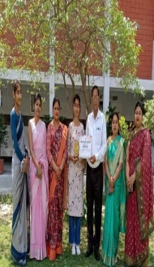
24 | Sports committee | Athletic meet  (2.03.24) | Physical education department | Different sports event wereorganised | 1 | Building physical & mental strength | Sneha  Class : b.com 1st  Position : 3rd  Event : 1500 m race  Roll no. 1231352055 | 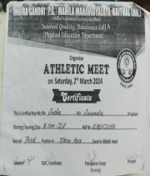
25 | Commerce department | Training camp  (14.05.2024 to 20 .05 .2024) | PNB Bank | Social security schemes , banking terms , various bank accounts &KYC etc, | 50 | Financial literacy | _ | 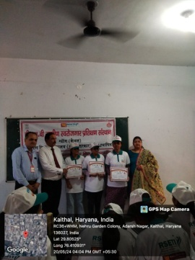
26 | Economics department | Model activity on economics ( 10 Nov, 2023) | Economics department | population, Insurance , G20 , Organic Farming , Public goods etc | 50 | awareness | Supply chain -  Komal ,mehak , Pooja , Tanisha (BA 2nd 1st position)  G20-Simran ,komal , shreejal , Tanya and group (BA 3^{rd,} 2nd position)  Journey of Indian economy-Kajal, Naveen and group (BA 3rd, 3rd position) | 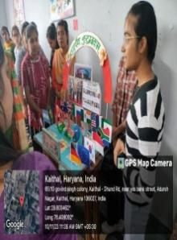  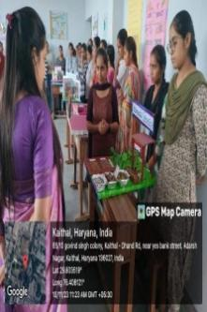
27 | Economics department | Essay writing (20thfeb 2024) | D.A.V college (Lahore), Ambala city | Viksit Bharat @2047 | 6 | Aware and motivate | participate | 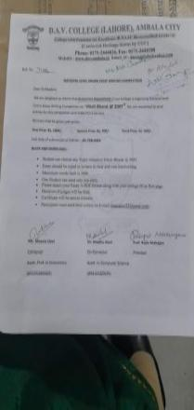
28 | Economics and computer science | Quiz competition (20thfeb 2024) | Government college Mohna, Faridabad | social justice | 15 | Aware about social jusrice | participate | 
29 | Economics and history department | Essay writing competition (29thfeb 2024) | IGMMV | G20 | 35 | aeareness | Muskan Devi (BA 2nd, 1st position)  Simran (BA 3rd , 2nd position)  Amrita (MA Eco (pre), 3rd position)  Sakshi (BA 3rd, 3rd position) | 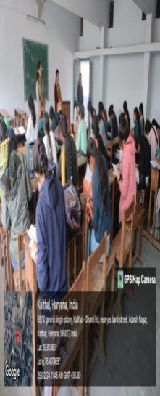
30 | Economics department | National level Online Quiz competition (27 march, 2024) | IGMMV | Indian economy | 30 college and 126 students | Aware about current topic | Janvi (IGMMV, B.com final, 500 cash prize)  Bhavaya (Guru nanakkhalsa college yamunanagar, PG, 400 cash prize)  Khushboo (IGMMV, M.sc math, 300 cash prize) | 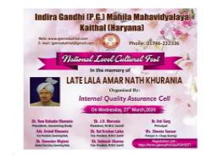
35 | Music | Hawan ceremony  24.07.2023 | IGMMV kaithal | Session opening | 6 | Indian culture | Kushi b.a 1st year  Komal b.a 3rd year  Navjyot b.com 2nd  Aarzoo b.a 2nd  Seema b.a 2nd  Pooja b.a 3rd | 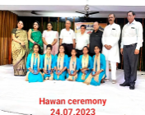
36 | Music | Independence day  15.08.2023 | IGMMV kaithal | Celebrate independence day | 8 | Patriotism | Navjyot b.com 2nd  Aarzoo b.a 2nd  Pooja b.a 3rd  Pavni b.a 3rd  Shabnam b.a 2nd  Annu b.a 3rd | 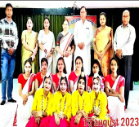
37 | Music | Talent hunt  29.08.2023 | IGMMV kaithal | Cultural event | 20 |  | 1 .Aarju Ba 2nd roll no 079 1st  Pooja Ba 3rd168 2nd  Simran M.com 028  3rd  .Navjotbcom 2nd 046 consolation  Instrument playing 5  .Simran M.com 1st | 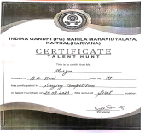  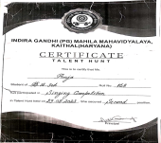  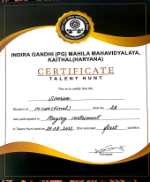  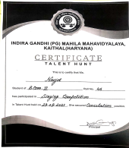
38 | Music | Teachers day | IGMMV Kaithal | Cultural event | 6 | Social | Navjyot b.com 2nd  Aarzoo b.a 2nd  Pooja b.a 3rd  Pooja b.a 1st  Shabnam b.a 2nd  Seema b.a 2nd
39 | Music | Hindi diwas | IGMMV Kaithal | Indian knowledge system | 5 | Indian culture | Navjyot b.com 2nd  Aarzoo b.a 2nd  Pooja b.a 3rd  Manisha b.a 1st  Muskan ba 2nd | 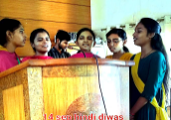
40 | music | N.S.S function | Kurukshetra University Kurukshetra | Awareness program | 2 | Social | Pavani b.a 3rd  Annu b.a 3rd | 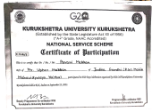
41 | Music | Convocation function | IGMMV Kaithal |  | 6 |  | Navjyot b.com 2nd  Aarzoo b.a 2nd  Pooja b.a 3rd  Pavani b.a 3rd  Annu b.a 3rd  Sneha b.a 2nd | 
42 | Music | 46th Zonal youth festival | Jat college kaithal | Haryanvi  Culture | 27 | Social values | Haryanvi group song -1st  Pooja ,pavani . annu ,navjot , aarju ,saloni  2.pop song – 1st  Aarju ,navjot (singer )  Saloni ,rashi , priya , komal , indrasunita , ritujyotipriyanka ,chetna (dancer )  3. Western solo – 1st  Navjot  4. gernal folk song – 2ndvanshika  5. Raagni solo –  Navjot  6. gernal group song –  Pooja ,pavani ,navjot ,aarju , saloni , vanshika | 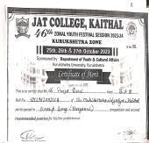  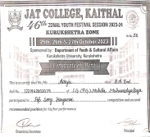  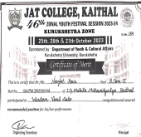  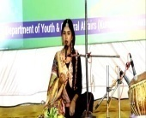  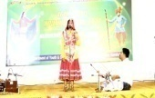  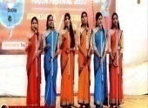
43 | Music | Ratnawali State level festival | Kurukshetra university kurukshetra | Haryanvi  Culture | 23 | Social values | 1.Duet raagni- 2nd Navjot , saloni (main singer )  Aarju ,pooja (course singer )  2. Raagni  Navjot 3. Group song Haryanvi  Navjot ,pavani , pooja , saloni , aarju , annu  4 .pop song  Aarju ,navjot (singer )  Saloni, rashi ,priya , komal , indra , sunita , ritu , jyoti , priyanka , chetna (dancer )  5. Bhajan  Navjot. | 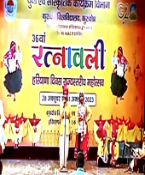
44 | Health and physical education | 68th junior national ball badminton championship  10-3-24 to 14-3-24 | Bihar Bal BandmintonAssociastion Patna | Sports Activity | 1 |  | Participation  Sunita B.A 1st year 1232464063 | 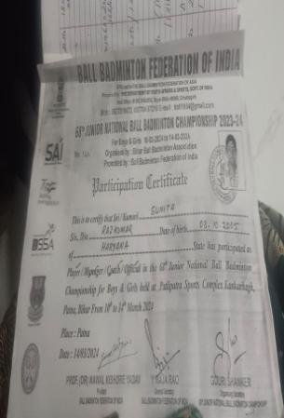
45 | Health and physical education | Khel Mahakhumbh  Handball  4-12-23 to 6-12-23 | Sports Department Government of Haryana Karnal | Sports Activity | 1 |  | Participation  Tanisha BMC 2ND Year | 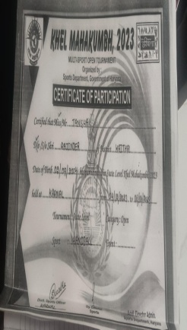
46 | Health and physical education | 3rd Haryana Senior State Handball Championship  9-3-23 to 10-3-2023 | ERA International School Dumerkhajind | Sports Activity | 1 |  | 3rd position  Tanisha BMC 2ND Year | 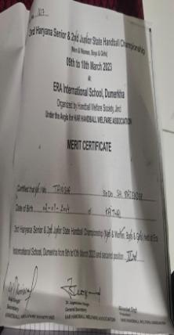
44 | Health and physical education | National sports  29.08.2923 | IGMMV Kaithal | Sports Activity | 200 |  |  | 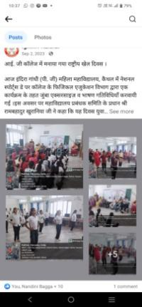
45 | Health and physical education | World cancer day  4.02.2024 | IGMMV Kaithal | Sports Activity | 400 |  |  | 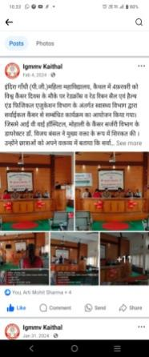
46 | Health and physical education | Athletic meet  13.03.2024 | IGMMV Kaithal | Sports Activity | 3200 |  | Appendix-1 | 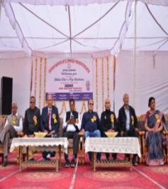  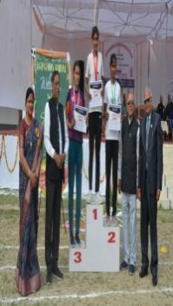
47 | Health and physical education | Model exhibition  16.04.2024 | IGMMV Kaithal | Sports Activity | 300 |  |  | 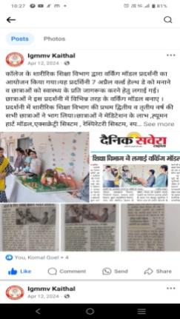
48 | Health and physical education | Health Checkup Camp 29 sep 2023-30 sep 2023 | IGMMV Kaithal | Sports Activity | All Lecturer and Student |  |  | 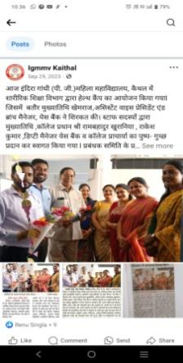
48 | Hindi Dept. | Hindi Diwas  14/09/  2023 | IGMMV Kaithal | Impotance of hindi | 3 | Indian knowledge system | Shivani B.A 2nd  SIMRANJEET KAUR B.A 2nd | 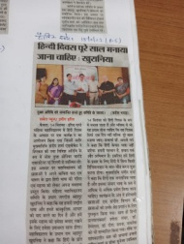
49 | Hindi Dept. | State level online Hindi Essay Writing Competition  11/10/2023 | Dayanand Mahila mahavidyalayakurkshetra | Essay Writing | 1 | Indian knowledge system | Sheetal  BA III  - NO. - 110  Second Position | 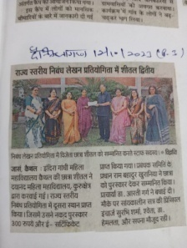
50 | Hindi Dept. | State level online Hindi essay competition 03/11/2023 | RDS Public Girls College Rewari | Essay Writing | 2 |  | Pooja BA III  Third Position | 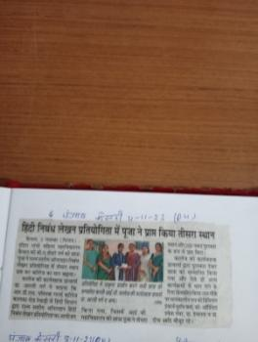
51 | Hindi Dept. | MatdankepratijagrukkarnekeliyejilaNivachan mandal dwaraaayojitpratiyogita  23/11/2023 | R.K.S.D College Kaithal | Matdankeliyejagrukta  (Essay Writing & Speech) | 2 | - | Sachleenpreet Kaur  BAMC - III  First Position  Muskan BA II  Second Position | 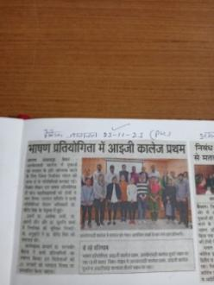
52 | Hindi Dept. | Bhartiya Bhasha Diwas  10/12/2023 | IG(PG)MMV College, Kaithal |  |  | Indian knowledge system |  | 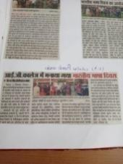
53 | Hindi Dept. | Rajya stariya Essay Writing Competition  29/12/2023 | RDS Public Girls College Rewari | Nibandh Lekhan Pratiyogita | 1 | - | Simran Jeet Kaur BA II  Second Position | 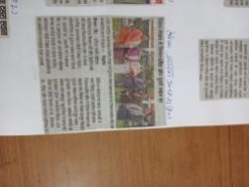
54 | Hindi Dept. | Vishv Hindi Divas  10/01/2024 | IG(PG)MMV College, Kaithal | Munshi premchand ki kahani - Idgah | 10 | Indian knowledge system |  | 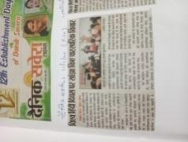
54 | English | District Level Debate Competition (11.08.2023) | B.R. Ambedkar Govt. P.G. College Jagdishpura |  | 2 |  | Students of MA English  Participation  PrachiSharma  22196152012  M.A. Eng (Prev.)  Shashi  22196152006  M.A. Eng (Prev.) | 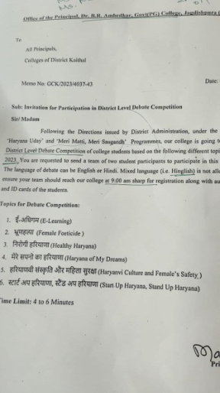
55 | English | P.G. Level Literary Quiz (30.10.2023) | B.R. Ambedkar Govt. P.G. College Jagdishpura  I.G.M.M.V. Kaithal |  | 20 |  | Students of MA English | 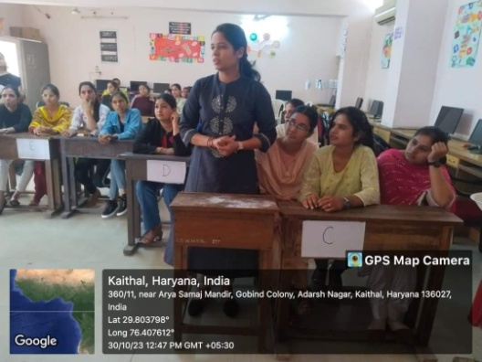
56 | English | Grammar Quiz  30.12.2023 | I.G.M.M.V. Kaithal |  | 3 |  | Mehak  (B.A Istsem)  Khushi  (B.A Istsem)  Komal(B.A Ist) | 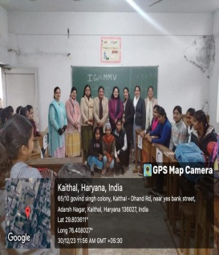
57 | English | Group Discussion  20.03.23 | I.G(PG).M.M.V. Kaithal |  | 40-50 |  | All the student of M.A (prev.) | 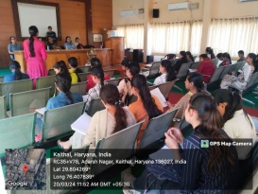
58 | English | English Declamation (Talent show) | IG(PG)MMV  KAITHAL |  | 6 |  | MuskanmB.a(IInd)  Roll no. 160  Akshita  B.Sc (IInd)  05  Renu B.A(IInd)  259  ArtiB.a(IInd)  Roll no. 81 SF  Rashi  B.a(Ist)  Roll no 290  Prachi Sharma M.A (final year) (eng) 12 | 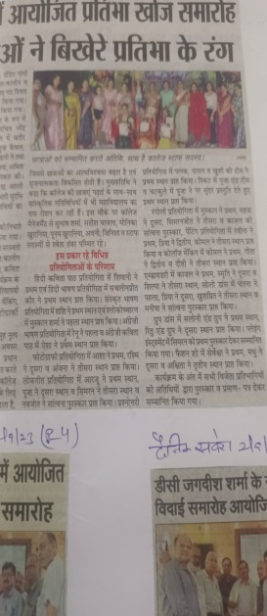
59 | English | Poetic Symposium  (Talent show) | IG(PG)MMV  KAITHAL |  | 3 |  | Shashi M.A (final year) (eng) Roll no. 06  Aesha M.A ( final year) ( eng)  Rollno 01  Muskan BCA (final year) 19 | 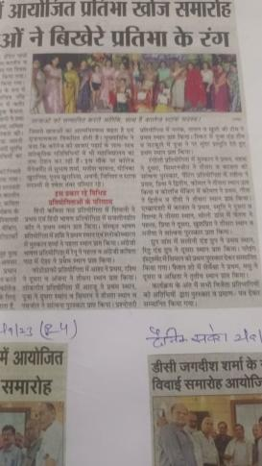
60 | English | International Online Essay Writing Competition  07-02-2024 | C.I.S.K.M.V |  | 3 |  | Muskan(Hindi) B.A IInd  1221962002134 Sanjana B.AIInd (Sanskrit)  1221962002184Sachleenpreet  (english) B.A.M.C IIIrd  1211963009037 | 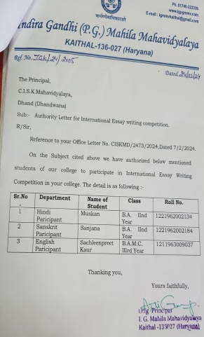
61 | English | National level Online Essay Writing Compettiton  12-03-2024 | SGHS College ShriJiwan Nagar. |  | 1 |  | Prachi  M.A (final)  22196152012 | 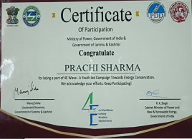
62 | ComputerScience | PPT  Competitio n Topic onArtificialIntelligence,Internetof Things,5G,  WirelessTechnology(31.10.202  2) | I.G.M.M.V.  Kaithal | ArtificialIntelligence,Internetof Things,5G,  WirelessTechnology | 10 | Professional Ethics | 1stPositionMuskan(1211962011019) BCAII,  2ndPosition  Komal BCA I,  3rdPositionTamnna(121963015036  )  BSc. I | 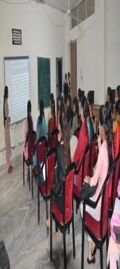
63 | ComputerScience | DistrictLevelPPTCompetition topic on“Protection of WomenagainstDomesticViolence(06.02.202  3) | Dr.B.R.  AmbedkarCollegeKaithal | ProtectionofWomenagainstDomesticViolence | 2 | Professional Ethics | 1stPositionAnju(1211962011003),  Muskan(1211962011019)  BCA II | 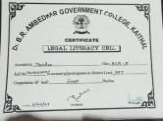
64 | ComputerScience | LogosRecognitionCompetition(17.03.202  3) | I.G.M.M.V.  Kaithal | TechnicalLogos | 30 | Professional Ethics | - | 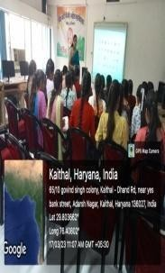
65 | ComputerScience | PPT  Competition(21.03.202  3) | I.G.M.M.V.  Kaithal | 5G  Technology,AI,  CyberSecurity | 15 | Professional Ethics | 1stPositionMuskan(1211962011019) BCAII,  2ndPosition  Shalu BCA I,  3rdPositionSimranBAII | 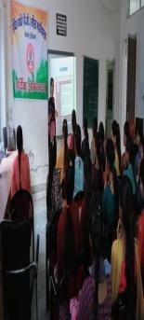
66 | ComputerScience | OnlineNationalLevelPosterMakingCompetitio n Topic on“AddictionofMobilePhone”(28.03.202  3) | G.V.M.  GirlsCollege,Sonipat | AddictionofMobilePhone | 2 | Professional Ethics | 2nd PositionBhawna,3rdPosition  Bhawna M.ScFinal | 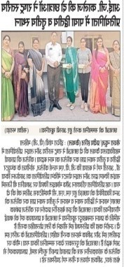
67 | ComputerScience | State LevelCulturalFest(08.04.202  3) | DayanandMahilaMahavidyalaya,Kurukshetra | CyberAttacks | 1 | Professional Ethics | Participation,Muskan(1211962011019)  BCA II | 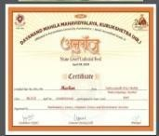
68 | ComputerScience | DivisionLevelCompetition(18.04.202  3) | Pt. ChiranjiLalSharmaGovt.  College,Karnal | DomesticViolenceAgainstWomen | 2 | Gender | 3rdPositionMuskan(1211962011019),  Anju(1211962011003)BCAII | 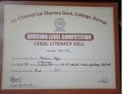
69 | ComputerScie  nce | State LevelBusinessPlanCompetition (21.04.202  3) | S.A.JAIN(PG)  College,Ambala | PlasticRoads | 4 | Professional Ethics | Consolation,AnjuRani(1211962011003),BCAII | 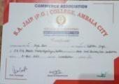
70 | ComputerScience | State LevelLegalLiteracyCompetition(25.04.202  3) | Shri MataMansaDeviGovt.  SanskritMahavidyalaya,Panchkula | DomesticViolenceAgainstWomen | 1 | Gender | 3rdPositionMuskan(1211962011019)  BCA II | 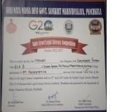
71 | Co  mputerScience | State Level  BusinessPlanCompetition(26.04.202  3) | Maharaj  AgrasenMahavidyalaya,Jagadhri | Plastic  Roads | 1 | Professiona  l Ethics | (Participation)  Muskan BCA II | 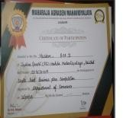
72 | ComputerScience | State LevelBusinessPlanCompetition(26.04.202  3) | MaharajAgrasenMahavidyalaya,Jagadhri | PlasticRoads | 2 | Professional Ethics | Participation,  Simran BA II | 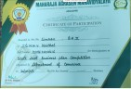
73 | ComputerScience | OnlineNationalLevelPosterMakingCompetitio n Topic on“InternationalLabourDay”(27.04.202  3 –  02.05.2023  ) | M.D.S.D  College,Ambala | International LabourDay | 1 | Professional Ethics | 1stPosition  Muskan BCA II | 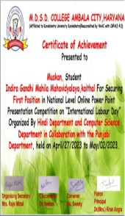
74 | Computer Science | Group Discussion  29.01.2024 | I.G.(P.G.)M.M.V, Kaithal | Social Media – Bane and Boon  &  Cyber Security | 20 | - | 20 students | 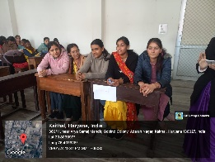
75 | Computer Science | Expert Lecture on How to Earn Digitally?  26.02.2024 | I.G.(P.G.)M.M.V, Kaithal | How to Earn Digitally | 150 | - | 150 students | 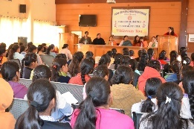
76 | Sexual Harassment and Grievance Cell in collaboration with Computer Science Department | PowerPoint Presentation on ‘Sexual Harassment’  (7.10.2023) | I.G.M.M.V. KAITHAL | The Impact of Sexual Harassment on Victims | 4  (Shivani,  Vritika,  Komal,  Muskan) | Gender | Ist position  (Muskan) | 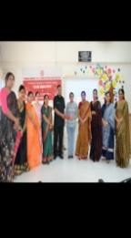
77 | Home Science | Healthy Month  24-09-2023 | Organised by I.G.(PG).M.M.V Kaithal. | Healthy Recipe | 30 |  | 1st - Saloni & Priya B.A 2nd- Dimple & Neha B.A 3rd - Diksha & Palak B.A Consolatio - Diksha & Pinky | 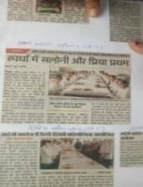
78 | Home Science | Karva Chauth  31-10-2023 | Organised by I.G.(PG).M.M.V Kaithal. | Mehandi | 15 |  | 1st - Indira Devi B.A 2nd2nd- Sonia B.A 3rd3rd - Simran B.A 2nd
79 | Home Science | Importance of Vote  22-11-2023 | Organised by India Election Commission at I.G.(PG).M.M.V Kaithal. | Rangoli | 24 |  | 1st - Team ( Indira Gandhi Mahila Mahavidhalya ) 2nd - Team ( RajkiyaPoltecnicCheeka ) 3rd - Team ( NIILM University Keodak ) | 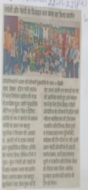
80 | Home Science | Importance of Vote  22-11-2023 | Organisedby India Election Commission at I.G.(PG).M.M.V Kaithal. | Mehandi | 24 |  | 1st - Team ( Indira Gandhi Mahila Mahavidhalya ) 2nd - Team ( I.T.I. Kalayat )3rd - Team ( RajkiyaPoltecnicCheeka ) | 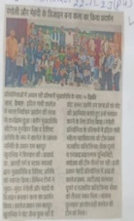
81 | Commercial Art | WildLife Photography | National Level Wild Life Photography Competition organized by Biology & Prakriti Association of Dyal Singh College , Karnal on the occasion of Earth Day .  26-04-2023  Result -01-06-2023 | Wildlife | 01 |  | IInd Prize  Nikita  B.A 3rd 120196002343 | 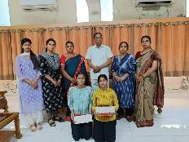  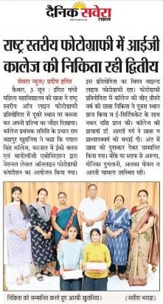
82 | Commercial Art | Slogan Writing | State Level Online Slogan Writing & Poster Making Competition organized by Department of Economics, English, Pol. Science & NCC with the collaboration of the Ministry of Jal Shakti, Govt. of India, Ministry of Education & Department of Babu Anant Ram Janta College, Kaul.  29-04-2023 | Save Earth | 02 |  | IInd Prize  Komal  B.A 1st 1221963002010
101 | Commercial Art | Poster Making  13/08/2023 | Poster Making & Slogan Writing & Logo Designing Competition organized by IG College under Anti Ragging Cell. | Anti Ragging | 08 |  | Ist Position  Komal  B.A IInd1221963002010  IInd Position Priya  B.A IIIrd1211962002068 | 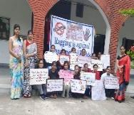
102 | Commercial Art | Logo Designing  14/08/2023 | Poster Making & Slogan Writing & Logo Designing Competition organized by IG College under Anti Ragging Cell. | Anti Ragging | 07 |  | Ist Prize  Ravina  B.A IInd1211962002406  IInd Prize  Karmjit  B.A IInd 1221962002201 | 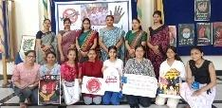
103 | Commercial Art | Slogan Writing  16/08/2023 | Poster Making & Slogan Writing & Logo Designing Competition organized by IG College under Anti Ragging Cell. | Anti Ragging | 05 |  | Ist Prize  Bhumi  B.A Ist  322 | 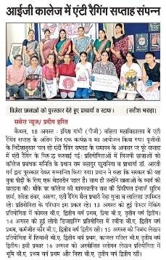
104 | Commercial Art | Mehndi | Home Science Department of IGMMV Kaithal organized Mehndi Competition on the occasion of TeejFestval  18/08/2023 | Karva Chauth | 80 |  | IIIrd Prize  Ravina  B.A IInd  1211962002406 | 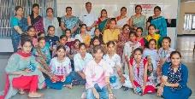  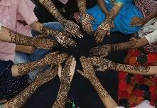  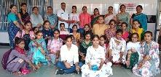
105 | Commercial Art | Thali Decotion | Department of Commercial art organized Thali Decoration & Rakhi Making competition on the occasion of Rakshabandhan.  28/08/2023 | Rakshabandhan | 16 |  | Ist Position  Mehak  B.A IInd 1221962002200  IIndPositionKomal  B.A IInd  1221963002010  IIIrd Position  Vandana  B.A IInd 1221963002060 | 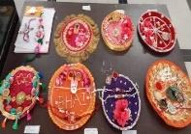
106 | Commercial Art | Rakhi Making | Department of Commercial art organized Thali Decoration & Rakhi Making competition on the occasion of Rakshabandhan.  28/08/2023 |  | 15 |  | IstPositionKomal  B.A IInd  1221963002010  IInd Position  Seema  B.A IInd  1221962002343  IIIrd Position  Indra  B.A IIIrd  1211962002068 | 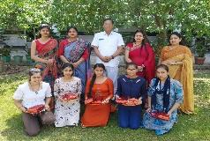
107 | Commercial Art | Collage Making | IGMMV, Kaithal organized Talent Hunt  29/08/2023 | Portrait | 13 |  | Ist Position  Komal  B.A IInd  1221963002010  IInd Position Geeta  B.A IInd  1221962002086  IIIrd Position  Deepti  B.A Ist  1231349317 | 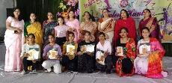
108 | Commercial Art | Painting Competition |  | Modern Art | 27 |  | Ist Position  Ravina  B.A IInd  1221962002406  IInd Position  Priya  B.A IIIrd  1211962002068  IIIrd Position  Komal  B.A IInd  1221963002010 | 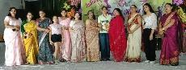
109 | Commercial Art | Slogan Writing | Govt. PG College, Naraingarh, Ambala organise Inter-College IT Fest “Tech Srishti” Nurturing  30/09/2023 |  | 02 |  | Ist Position  Komal  B.A IInd  1221963002010  Participation  Mahak  B.A II  1221962002200 | 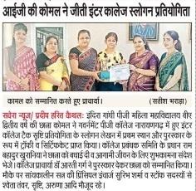
110 | Commercial Art | Rangoli | Govt. PG College, Naraingarh, Ambala organise Inter-College IT Fest “Tech Srishti” Nurturing  30/09/2023 |  | 02 |  | Participation Ravina  B.A IInd  1221962002406  Participation  Seema  B.A IInd  1221962002343
111 | Commercial Art | Collage Making | Three Days Literary & Fine Art Workshop organized by Youth & Cultural Affairs Department of Kurukshetra University , Kurukshetra  From  10/10/2023 to 12/10/2023 |  | 01 |  | Komal  B.A IInd  1221963002010 | 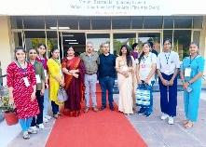
112 | Commercial Art | Poster Making | Three Days Literary & Fine Art Workshop organized by Youth & Cultural Affairs Department of Kurukshetra University , Kurukshetra  From  10/10/2023 to 12/10/2023 |  | 01 |  | Ravina  B.A IInd  1221962002406 | 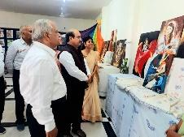  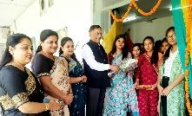  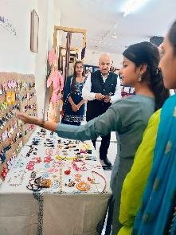  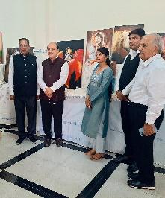
113 | Commercial Art | Clay Modelling | Three Days Literary & Fine Art Workshop organized by Youth & Cultural Affairs Department of Kurukshetra University , Kurukshetra  From  10/10/2023 to 12/10/2023 |  | 01 |  | Priya  B.A IIIrd  1211962002068 | 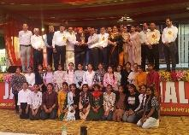  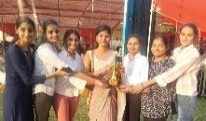  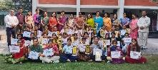
114 | Commercial Art | Rangoli | Three Days Literary & Fine Art Workshop organized by Youth & Cultural Affairs Department of Kurukshetra University , Kurukshetra  From  10/10/2023 to 12/10/2023 |  | 01 |  | Seema  B.A IInd  1221962002343 | 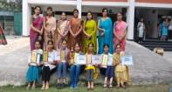
115 | Commercial Art | Cartooning | Three Days Literary & Fine Art Workshop organized by Youth & Cultural Affairs Department of Kurukshetra University , Kurukshetra  From  10/10/2023 to 12/10/2023 |  | 01 |  | Geeta  B.A IInd  1221962002086
116 | Commercial Art | On the Spot Painting | Three Days Literary & Fine Art Workshop organized by Youth & Cultural Affairs Department of Kurukshetra University , Kurukshetra  From  10/10/2023 to 12/10/2023 |  | 01 |  | Ankita  B.A IInd  1221962002359
117 | Commercial Art | Mehndi | Three Days Literary & Fine Art Workshop organized by Youth & Cultural Affairs Department of Kurukshetra University , Kurukshetra  From  10/10/2023 to 12/10/2023 |  | 01 |  | Deepti  B.A Ist  1231349317
118 | Commercial Art | Handmade -Mini Canvas, Jewellery, Diary covers, bags , Canvas Paintings, Illustrations, Layouts, Posters and more | Three Days Art Exhibition organized by Department of Commercial Art of IGMMV, Kaithal, on the Day of Convocation Chief Guest Prof. Somnath Sachdeva Vice Chancelor KUK.  14/10/2023 to 16/10/2023 |  | 25 |  | In this Exhibition Students Sold Items of Rs. 3000/-
119 | Commercial Art | Poster Making | Zonal Youth Festival (Kurukshetra Zone) organized by Jat College, Kaithal ,suponsored by Department of Youth & Cultural Affairs, KUK.  25/10/2023 to 27/10/2023  Commercial Art won Overall Fine Art Trophy. |  | 01 |  | Commended (IIndPosition )  Ravina  B.A IInd  1221962002406
120 | Commercial Art | Clay Modelling | Zonal Youth Festival (Kurukshetra Zone) organized by Jat College, Kaithal ,suponsored by Department of Youth & Cultural Affairs, KUK.  25/10/2023 to 27/10/2023  Commercial Art won Overall Fine Art Trophy |  | 01 |  | commended(IInd Position)  Priya  B.A IIIrd  1211962002068
121 | Commercial Art | On the Spot Painting | Zonal Youth Festival (Kurukshetra Zone) organized by Jat College, Kaithal ,suponsored by Department of Youth & Cultural Affairs, KUK.  25/10/2023 to 27/10/2023  Commercial Art won Overall Fine Art Trophy |  | 01 |  | Recommended(Ist Position)  Priya  B.A IIIrd  1211962002068
122 | Commercial Art | Collage Making | Zonal Youth Festival (Kurukshetra Zone) organized by Jat College, Kaithal ,suponsored by Department of Youth & Cultural Affairs, KUK.  25/10/2023 to 27/10/2023  Commercial Art won Overall Fine Art Trophy |  | 01 |  | Recommended(Ist Position)  Komal  B.A IInd  1221963002010
123 | Commercial Art | Installation | Zonal Youth Festival (Kurukshetra Zone) organized by Jat College, Kaithal ,suponsored by Department of Youth & Cultural Affairs, KUK.  25/10/2023 to 27/10/2023  Commercial Art won Overall Fine Art Trophy |  | 04 |  | Recommended(Ist Position)  1.Komal  B.A IInd  1221963002010 2.Ravina  B.A IInd  1221962002406  3. Khushi  B.AIII  1211962002020  4. Muskan B.AIII  121196202002
124 | Commercial Art | On the spot photography | Zonal Youth Festival (Kurukshetra Zone) organized by Jat College, Kaithal ,suponsored by Department of Youth & Cultural Affairs, KUK.  25/10/2023 to 27/10/2023  Commercial Art won Overall Fine Art Trophy |  | 01 |  | commended(IInd Position)  Asha  B.A III  1211963009038
125 | Commercial Art | Mehndi | Zonal Youth Festival (Kurukshetra Zone) organized by Jat College, Kaithal ,suponsored by Department of Youth & Cultural Affairs, KUK.  25/10/2023 to 27/10/2023  Commercial Art won Overall Fine Art Trophy |  | 01 |  | Participation Deepti  B.A Ist  1231349317
126 | Commercial Art | Rangoli | Zonal Youth Festival (Kurukshetra Zone) organized by Jat College, Kaithal ,suponsored by Department of Youth & Cultural Affairs, KUK.  25/10/2023 to 27/10/2023  Commercial Art won Overall Fine Art Trophy |  | 01 |  | Participation  Seema  B.A IInd  1221962002343
127 | Commercial Art | Cartooning | Zonal Youth Festival (Kurukshetra Zone) organized by Jat College, Kaithal ,suponsored by Department of Youth & Cultural Affairs, KUK.  25/10/2023 to 27/10/2023  Commercial Art won Overall Fine Art Trophy |  | 01 |  | Participation Geeta  B.A IInd  1221962002086
128 | Commercial Art | On the Spot Painting | Ratnawali , Haryana Day State Level Festival organized by Kurukshetra University, Kurukshetra.  30/10/2023 | Haryanvi Culture | 02 |  | Participation  1.Komal  B.A IInd  1221963002010  2. Ravina B.AIInd  1221962002406
129 | Commercial Art | Painting Exhibition | Ratnawali , Haryana Day State Level Festival organized by Kurukshetra University, Kurukshetra.  30/10/2023 |  | 02 |  | IIIrdPosition(Rs. 1600/- Cash Prize with Certificate)  Priya  B.A IIIrd  1211962002068  Participation  Khushi  B.AIII  1211962002020
130 | Commercial Art | Rangoli Competition | Commercial Art Department organized Rangoli Competition on the occasion of Diwali. |  | 29 |  | Ist Position  Priya  B.A IInd  1211962002068IInd Position Komal  B.A IInd1221963002010  IIIrd Position  Mehak  B.A IInd 1221962002200 | 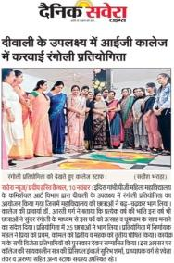
131 | Commercial Art | Rangoli Competition | India Election commission organized District Level Rangoli & Mehndi competition at IGMMV, Kaithal | Voter’s Day | 03 |  | Ist Position  Komal  B.A IInd  1221963002010Mehak  B.A IInd 1221962002200Seema  B.A IInd  1221962002343 |   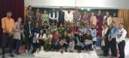
132 | Commercial Art | Mehndi | India Election commission organized District Level Rangoli & Mehndi competition at IGMMV, Kaithal |  | 02 |  | Ist Position  Ravina  B.A IInd  1221962002406Sonia  B.A IIIrd  1211962002361 | 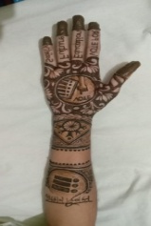  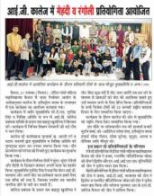
133 | Commercial Art | Poster Making  27/01/2024 | 44th Inter Zonal Youth Festival (Kurukshetra Zone) organized by DAV (PG) College, Karnal ,suponsored by Department of Youth & Cultural Affairs, KUK.  27/01/2024 to 29/01/2024 | Topic- Mobile Phones effect on life | 01 |  | Commended (IIIrdPosition )  Ravina  B.A IInd  1221962002406 | 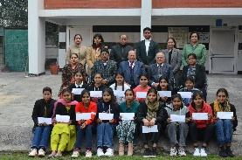
134 | Commercial Art | Clay Modelling  28/01/2024 | 44th Inter Zonal Youth Festival (Kurukshetra Zone) organized by DAV (PG) College, Karnal ,suponsored by Department of Youth & Cultural Affairs, KUK.  27/01/2024 to 29/01/2024 | Topic-Folk Dance | 01 |  | Commended  (IIIrd Position)  Priya  B.A IIIrd  1211962002068
135 | Commercial Art | On the Spot Painting | 44th Inter Zonal Youth Festival (Kurukshetra Zone) organized by DAV (PG) College, Karnal ,suponsored by Department of Youth & Cultural Affairs, KUK.  27/01/2024 to 29/01/2024 | Live Painting | 01 |  | Commended  (IIIrd Position)  Priya  B.A IIIrd  1211962002068
136 | Commercial Art | Collage Making | 44th Inter Zonal Youth Festival (Kurukshetra Zone) organized by DAV (PG) College, Karnal ,suponsored by Department of Youth & Cultural Affairs, KUK.  27/01/2024 to 29/01/2024 |  | 01 |  | Commended  (IInd Position)  Komal  B.A IInd  1221963002010
137 | Commercial Art | Installation | 44th Inter Zonal Youth Festival (Kurukshetra Zone) organized by DAV (PG) College, Karnal ,suponsored by Department of Youth & Cultural Affairs, KUK.  27/01/2024 to 29/01/2024 |  | 04 |  | 1.Komal (participant)  B.A IInd  1221963002010 2.Ravina (participant  B.A IInd  1221962002406  3. Khushi (participant)  B.AIII  1211962002020  4. Muskan (participant )B.AIII  121196202002
138 | Commercial Art | Poster Making  Topic- Human Trafficking | National Level Online Poster Making Contest organized by Social Work Department of Guru Nanak Khalsa College, Yamunanagar.  31-01-2024 | Human Trafficking | 04 |  | Priya  B.A IIIrd  1211962002068  (Ist Position E-Certificate & Rs.700/-)
139 | Commercial Art | Rangoli Making  24-01-2024 | Electoral Literacy Club & Legal Literacy Cell of Mukund Lal National College Yamunanagar organized Online National Level Poster Making, Slogan writing & Rangoli Making Competition on the occasion of National Voter’s Day. |  | 02 |  | Ravina  B.A IInd  1221962002406  ( Ist Position E-Certificate & Rs.500/-) | 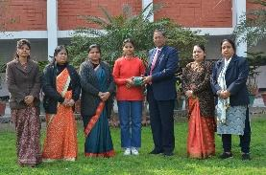  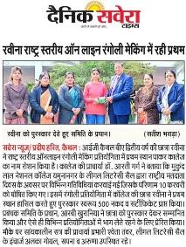
140 | Commercial Art | Poster Making 30-01-2024 | All India Jat Heroes’ Memorial College, Rohtak organized Online National Level Poster Making Competition on the theme Cleanliness, Hygiene and Environmental Conciousness organized by Women Cell. |  | 02 |  | Karamjit Kaur  B.A II  1221963002021  ( Ist Position E-Certificate) | 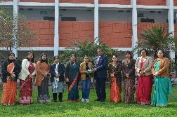  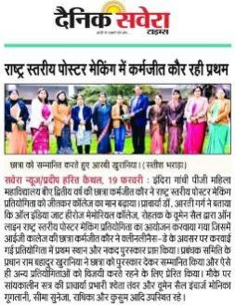
141 | Commercial Art | Poster Making 01-02-2024  Topics: HIV/AIDS  Causes, Spread, and Prevention  Stigma of HIV in Society  Let's Stop HIV Together | Red Ribbon Club of DAV College (Lahore), Ambala City organizes "State Level Inter-College Poster Making and Speech Competition"  01-02-2024 | HIV/AIDS Causes , Spread and Prevention  Stigma of HIV in Society  Let’s Stop HIV Together | 02 |  | Komal  B.A IInd  1221963002010  (2nd Position E-Certificate & Trophy)  Ravina  B.A IInd  1221962002406  ( IIIrd Position E-Certificate & Trophy) | 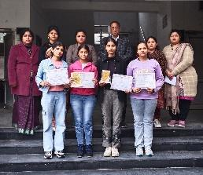
142 | Commercial Art | Poster Making 29-02-2024 | National Level Poster Making Competition organized by Arya(PG) College, Panipat under Legal Literacy Cell & Women Development Center. |  | 02 |  | Priya  B.A IIIrd  1211962002068  (Ist Position E-Certificate &Trophy ) | 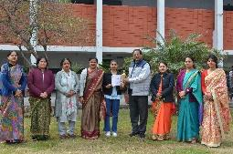  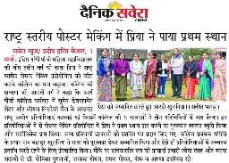
143 | Commercial Art | Face Painting Competition  05-03-2024 | Commercial Art Department of IG(PG)MMV, Kaithal organized Face Painting Competition. | Topic- Nature & Technology  Addiction of Social Media | 54 |  | Geeta  B.A IInd  1221962002086/Sunita  B.A IInd  (IstPosition )  Komal  B.A IInd  1221963002010  Pooja  B.A IInd  (2nd Position)  Deepti  B.A Ist  1231349317  Isha  B.A IInd  (IIIrd Position)  Consolation  Muskan /Komal BA IIIrd  Khushi/Mahak  BA IIIrd | 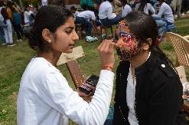  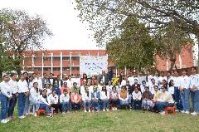
144 | Commercial Art | Collage Making  07-03-2024 | Tika Ram College of Education, Sonipat organized Inter College Collage Making Competition under the women-cell on the occasion of International Women's Day. | Theme: Wings of a Woman | 02 |  | Ravina  B.A IInd  1221962002406  ( IIIrd Position E-Certificate & Rs.500/-) | 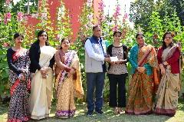
145 | Commercial Art | Poster Making  15-03-2024 | Mata Sundri Khalsa Girls College, Nissing (Karnal) organized Online State Level Inter College Fest on  2nd March 2024. | Theme: Drug Addiction | 02 |  | Priya  B.A IIIrd  1211962002068  (Ist Position E-Certificate & Rs.700/- ) | 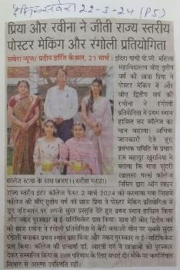  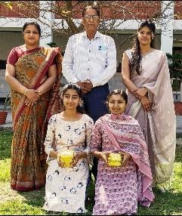
146 | Commercial Art | Rangoli Competition | Mata Sundri Khalsa Girls College, Nissing (Karnal) organized Online State Level Inter College Fest on 2nd March 2024. | Theme: Save Girl Child | 02 |  | Ravina  B.A IInd  1221962002406  ( Ist Position E-Certificate & Rs.700/-)
147 | Commercial Art | Slogan Writing  Theme: Gender Sensitisation  Mental health of Women | Indira Gandhi (PG) Mahila Mahavidyalaya, Kaithal organizes State Level Slogan Writing Competition on the occasion of International Women’s Day.  07/03/2024 |  | 02 |  | Priya  B.A IIIrd  1211962002068  (IInd Position E-Certificate & Rs.300/- ) | 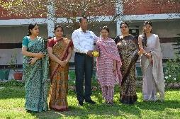
148 | Commercial Art | Rangoli Making Competition | Commerce Department of RKSD college organized State Level Competiton.  10/04/2024 |  | 01 |  | Ravina  B.A IInd  1221962002406  ( Ist Position Certificate & Rs.700/-) | 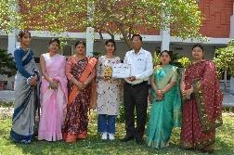
149 | Commercial Art | Wall Painting | Electorol Club of IGMMV College organized Wall Painting Competitions under SAVEEP.  07-05-2024 |  | 04 |  | Ravina  B.A IInd  1221962002406  Komal  B.A IInd  1221963002010  Deepti  B.A I  1231349317  Anju  B.A I | 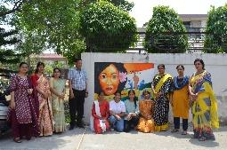  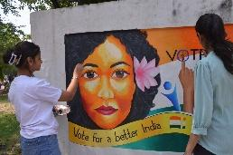
150 | Commercial Art | On the Spot Painting  Slogan Writing | State Level Legal Literacy Cell competitions by Govt. College for Women, Panchkula.  30-07-2024 |  | 02  01 |  | Ravina  B.A IIIrd  1221962002406  ( Ist Position Certificate )  Ankush  B.A II  12312464065  (IIIrd Position  Certificate)  Komal  B.A IIIrd  1221963002010  ( Ist Position Certificate ) | 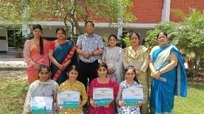  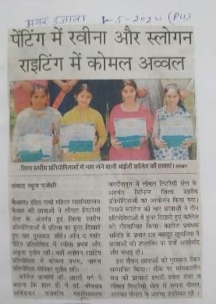
151 | Political Science | State Level Online essay writing competition 26-1-2024 | Dyal Singh College Karnal | Roll of the Youth in Social Activities in India | 2 |  | 1st Position  Sukhraj BA(Evening) Final Year | 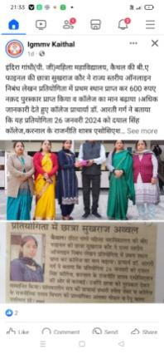
152 | Poltical Science | On the spot Painting Competition  18/04/2024 | IG(PG) MMV, Kaithal | FemalFoeticide  Human Rights  Save Girl Child | 3 | - | Ravina BA II R-406  First Position  Nidhi BA I R-320  2nd Position  Ankush  BA I R-065  3rd Position
153 | Poltical Science | On the spot Slogan Competition  18/04/2024 | IG(PG) MMV, Kaithal | FemalFoeticide  Human Rights  Save Girl Child | 25 | - | Komal BA 2nd 1st Position  Mahak BA 2nd  2nd Position  Deepti BA 1st 3rd Position
154 | History Deptt. | Quiz | I.G.M.M.V.  Kaithal | Ancient Indian History | 24 | Social Value | Ist  Neha (1231349055) &Varsha(1231349361)  IInd  Mehak(1231349050)& Bharti(1231349140)  IIIrd  Shivani(1232464001)&Manju(1231350037) | 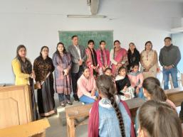  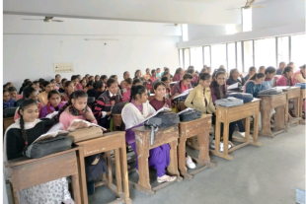  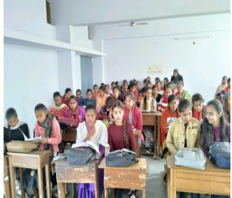
155 | History Deptt  History Deptt. | Essay Writing Com.  Declamation | I.G.M.M.V.  Kaithal  I.G.M.M.V .Kaithal | G-20 Summit  Shahidi Diwas (23 March) | 35  20 | Human Value  Historical Values | Ist  Mukesh Devi (1211962002134)  IInd  Simran (1211962002216)  IIIrd  Amrita (2231925016) & Sakhi (1211962002054) | 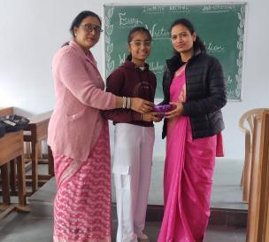  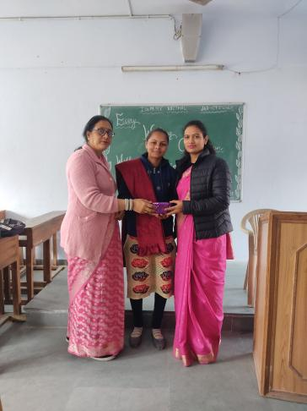  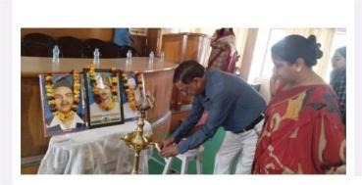  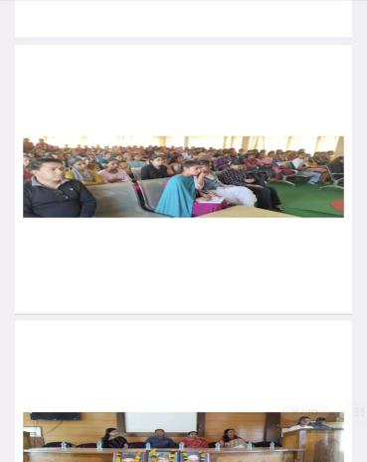
156 | History Deptt | Historical Visit | - G.M.M.V Kaithal | Historical Visit | 45 | Social Values |  | 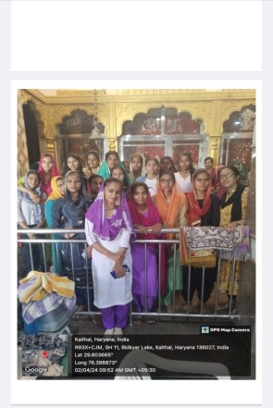  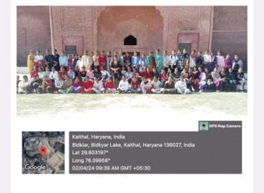
157 | History Deptt | EducationalVisit | - G.M.M.V .Kaithal | Educational  Visit | 40 | Educational Values |  | 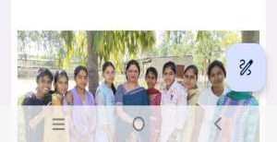  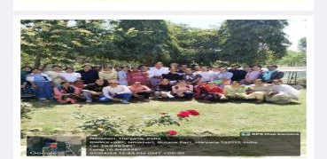
158 | Geography | World Ocean Day  05/04/2024 | IG(PG)MMV, Kaithal | Model Making | 5 | Remote Sensing Pratham | Ritika  BA III  12096002403  Ritu  BA III  12096002093  1st Position  Lock Tak Lake  2nd Position  Komal  120199002037  Kajal  120199002290  BhukampMapi Yantra  3rd Position  Rinku  Devi  120199002231 | 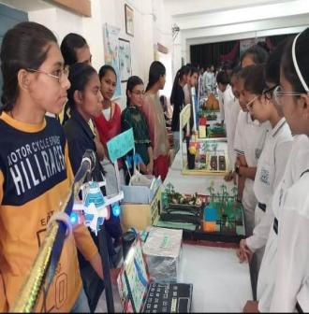  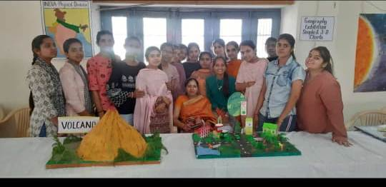
159 | Chemistry | District level Quiz  Competition | DrBhim Rao Ambedkar Govt. College ,  Kaithal |  | 6 |  | Sheetal (Bsc 3RD )  Ritika  (Bsc 3RD )  Kafi  (Bsc2nd)  4TH position
160 | Chemistry | World Ozone Day | IGMMV Kaithal | Preserving Ozone | 5 |  | Kajal (Bsc2nd)  1st position  Reema (Bsc 1st )  2nd Position  Muskan  (Bsc1st )  1st Position  Preeti(Bsc2nd)  2nd Position  Shiwani  (Bsc1st )  3rd Position | 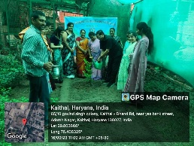
161 | Chemistry | ChandaryaanUtsav | IGMMV  Kaithal | India on moon ,  New India on moon | All Bsc students |  | Preeti ,Muskan( Bsc 2nd ) 1st Position  Tanisha ,Muskan ( Bsc 2nd )  2nd Position  Shweta (Bsc 1st )  Shalu (Bsc2^{nd)}  3rd Position | 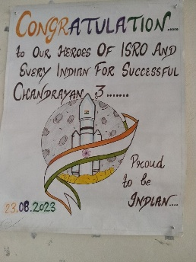
162 | Chemistry | District level Essay Writing  Competition | DrBhim Rao Ambedkar Govt. College ,  Kaithal | Impact of technology on Telecommunication | 5 |  | Shiwani (selected for state Level )
163 | Chemistry | Zonal Level Quiz Competition | Gandhi Memorial National College, Ambala |  | 3 |  | Sheetal (Bsc 3rd )  Ritika (Bsc 3rd )  Kafi (Bsc 3rd ) | 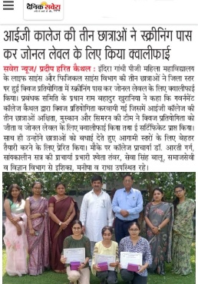
164 | Chemistry | District level Quiz  Competition | DrBhim Rao Ambedkar Govt. College ,  Kaithal |  | 6 |  | Muskan (Bsc 3rd )  Akshita (Bsc 3rd )  Simran (Bsc 2nd) Selected for Zonal level
165 | Physics | District level Quiz  Competition | DrBhim Rao Ambedkar Govt. College ,  Kaithal |  | 6 |  | Sheetal (Bsc 3RD )  Ritika  (Bsc 3RD )  Kafi  (Bsc2nd)  4TH position
166 | Physics | World Ozone Day | IGMMV Kaithal | Preserving Ozone | 5 |  | Kajal (Bsc2nd)  1st position  Reema (Bsc 1st )  2nd Position  Muskan  (Bsc1st )  1st Position  Preeti(Bsc2nd)  2nd Position  Shiwani  (Bsc1st )  3rd Position
167 | Physics | World Ozone Day | IGMMV Kaithal | Preserving Ozone | 5 |  | Kajal(Bsc2nd)  1st position  Reema (Bsc 1st )  2nd Position  Muskan  (Bsc1st )  1st Position  Preeti(Bsc2nd)  2nd Position  Shiwani  (Bsc1st )  3rd Position
168 | Physics | District level Essay Writing  Competition | DrBhim Rao Ambedkar Govt. College ,  Kaithal | Impact of technology on Telecommunication | 5 |  | Shiwani (selected for state Level )
169 | Physics | Zonal Level Quiz Competition | Gandhi Memorial National College, Ambala |  | 3 |  | Sheetal (Bsc 3rd )  Ritika (Bsc 3rd )  Kafi (Bsc 3rd )
170 | Physics | District level Quiz  Competition | DrBhim Rao Ambedkar Govt. College ,  Kaithal |  | 6 |  | Muskan (Bsc 3rd )  Akshita (Bsc 3rd )  Simran (Bsc 2nd) Selected for Zonal level
171 | Zoology | District level Quiz  Competition | DrBhim Rao Ambedkar Govt. College ,  Kaithal |  | 6 |  | Sheetal (Bsc 3RD )  Ritika  (Bsc 3RD )  Kafi  (Bsc2nd)  4TH position
172 | Zoology | World Ozone Day | IGMMV Kaithal | Preserving Ozone | 5 |  | Kajal (Bsc2nd)  1st position  Reema (Bsc 1st )  2nd Position  Muskan  (Bsc1st )  1st Position  Preeti(Bsc2nd)  2nd Position  Shiwani  (Bsc1st )  3rd Position
173 | Sanskrit  Department | Havan on Session  Opening  Ceremony  Date -24/07/2023 | Sanskrit  Department | New Session(2023-24)  Opening | 250 | Session  Opening | All Governig Body and Staff Members with persent students |   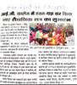
174 | Sanskrit  Department | Taent Hunt  Date 29/08/2023 | Culture and Youth Activity cell | Sanskrit Shlokochcharan | 06 | Aware and motivate | 1stPossition | 
175 | Sanskrit  Department | Taent Hunt  Date  29/08/2023 | Culture and Youth Activity cell | Sanskrit Sambhashanam | 06 | Aware and motivate | 1stPossition
176 | Sanskrit  Department | 46th Zonal Youth Festival (Kurukshetra Zone)  Date- 25/10/2023 | Jat College, kaithal | Sanskrit Natak | 07 | Aware and motivate | Participate | 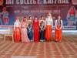
177 | Sanskrit  Department | 46th Zonal Youth Festival (Kurukshetra Zone)  Date -25/10/2023 | Jat College, kaithal | Sanskrit Sambhashanam | 01 | Aware and motivate | 2ndPossition | 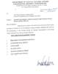
178 | Sanskrit Department | Shrimad bhagwatGeeta’shlok path  Date – 23-12-2023 | Sanskrit Department | Shlok Path | 50 | Geeta jayanti | Princpal and some faculty members with present students | 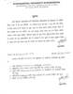  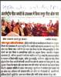
179 | Sanskrit  Department | Havan on Session  Opening  Ceremony  Date -06/02/2024 | Sanskrit  Department | Founder’s Day | 300 |  | All Governig Body and Staff Members with persent students | 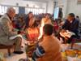  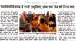
180 | Sanskrit Department | One Day Sanskrit Work- Shop  Date – 19-03-2024 | Sanskrit Department Collaboration with Maharshi Valmiki Sanskitvishvvidyalaya, Mundri , Kaithal Haryana | Yog dwaratnavprabandhan | 100 | Aware and motivate | President of Governing Body ,Princpal , Faculty Members of MVSV and Sanskrit Department | 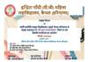    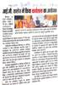
181 | Mass Communication | Elocution  (26.10.2023) | 46th North Zonal Youth Festival,Jat College Kaithal | Burning of crops is extremely dangerous to environment | 01 | Social Values | 1st Position Sachleen Preet Kaur  BAMC III  1211963009037 | 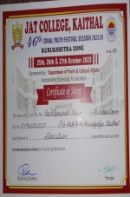
182 | Mass Communication | On the spot photography  (27.10.2023) | 46th North Zonal Youth Festival,Jat College Kaithal | Moments of youth festival | 01 | Social Values | 2nd Position Asha  BAMC III  211963009038 | 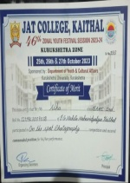
183 | Mass Communication | Digital Awareness (impact of social media and awareness of Cyber Crime)  (20.07.2023) | Amar Ujala,Kaithal | Cyber crimes | BMC I ,BMC II,  BMC III students | Social Values | Participation | 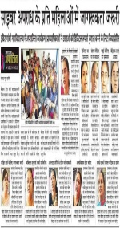
184 | Mass Communication | Poster Making Competition  (30.10.2023) | Mass Communication Department | Impact of social media on society ,  Mobile phone addiction | 20 | Gender Values | 1st Position Ritu  BAMC III  1211963009039  2nd Position Komal  BAMC I  1231351025  3rd Position Anjali  BAMC II  1221963009003  Consoltaion=Simran  BAMC II  1221963009017 | 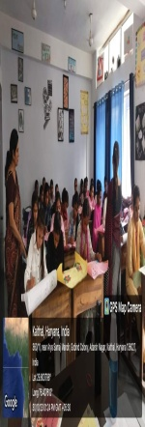
185 | Mass Communication | News Reading Competition  (02.11.2023) | Mass Communication | National and international news | 10 | Social Values | 1st Position Sachleen Preet Kaur  BAMC III  1211963009037  1st Position Ritu  BAMC III  1211963009039  2nd Position Gurpreet BAMC III 1211963009034  2nd Position Bulbul  BAMC I  1231351002  3rd Position Suruchi  BAMC I  1231351024 | 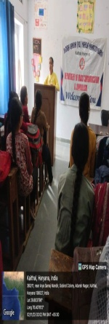
186 | Mass Communication | Speech Competition  (22.11.2023) | District Election Office ,Kaithal  Venue=R.K.S.D(P.G)College Kaithal | "Nothing like voting,I vote for sure" | 01 | Human Values | 1st Position Sachleen Preet Kaur  BAMC III  1211963009037 | 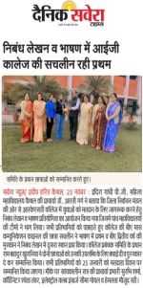
187 | Mass Communication | Elocation competition  (28.01.2024) | 44th inter journal Youth Festival  Venue = DAV (PG)college,  Karnal | Mother of democracy: Indian civilization and values | 01 | Social Values | 3rd Position  Sachleen Preet Kaur  BAMC III  1211963009037 | 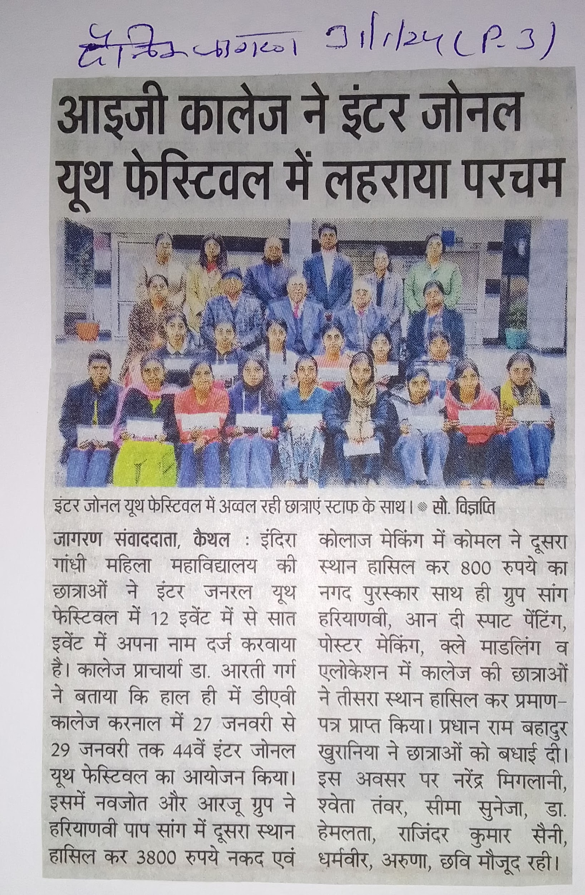
188 | Mass Communication | News anchoring competition  (11.03.2024) | 10th National media festival  Venue = Arya (PG) college,  Panipat | National and international news | 01 | Social Values | 2nd Position  Sachleen Preet Kaur  BAMC III  1211963009037 | 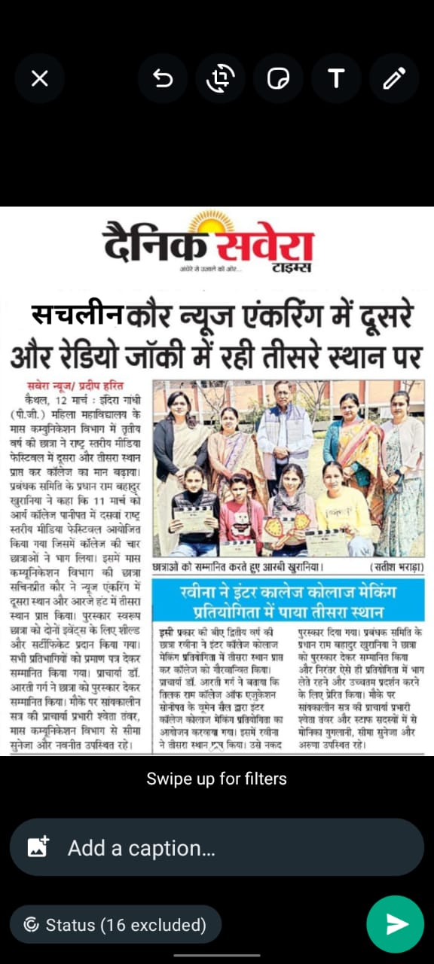
189 | Mass Communication | Radio jockey competition  (11.03.2024) | 10th National media festival  Venue = Arya (PG) college,  Panipat | Travelogue | 01 | Social Values | 3rd Position  Sachleen Preet Kaur  BAMC III  1211963009037
190 | Mass Communication | National level essay writing competition  (24.01.2024) | Online essay writing  Venue = Indira Gandhi (PG ) MahilaMahavidyalay Kaithal | Rights of girl child | 01 | Gender Values | 2nd Position  Sachleen Preet Kaur  BAMC III  1211963009037 | 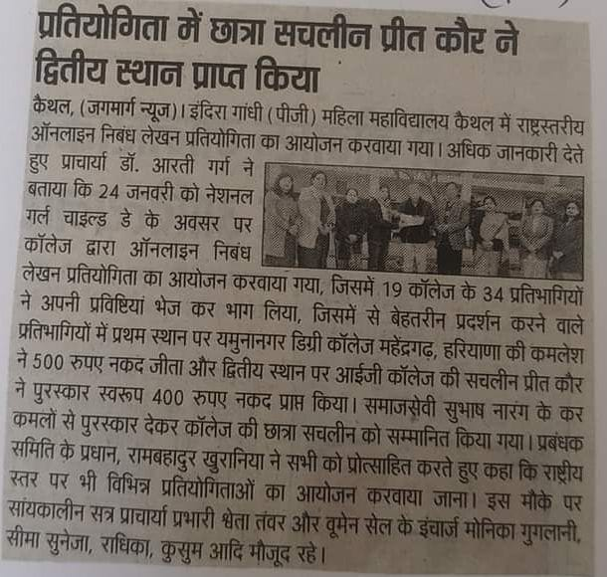
191 | Mass Communication | 54th athlete meat  400 meter race  (21.03.2024) | Physical health and education department  Venue = Indira Gandhi (PG ) MahilaMahavidyalay Kaithal | 400 meter race | 01 | Social Values | 3rd  position  Asha  BAMC III  1211963009038 | 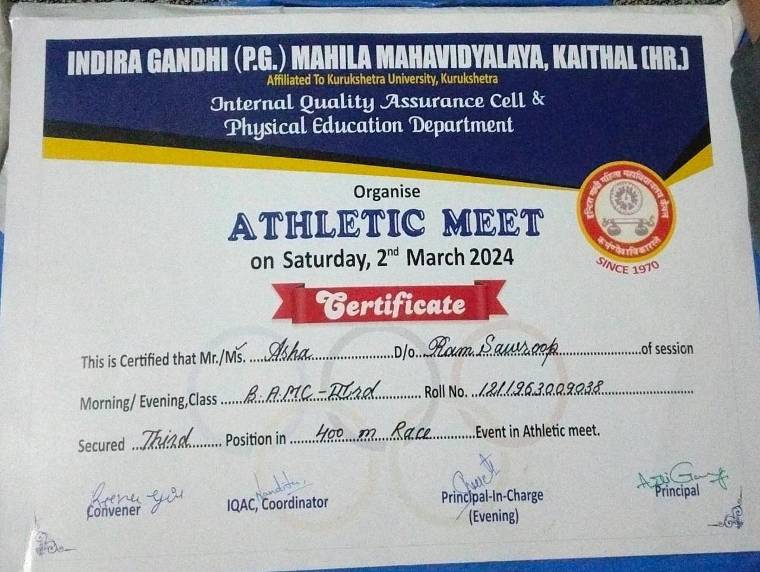
192 | Mass Communication | 54th athlete meat  800 meter race  (21.03.2024) | Physical health and education department  Venue = Indira Gandhi (PG ) MahilaMahavidyalay Kaithal | 800 meter race | 01 | Social Values | 1st position  Tanisha  BAMC II  1211963 009042 | 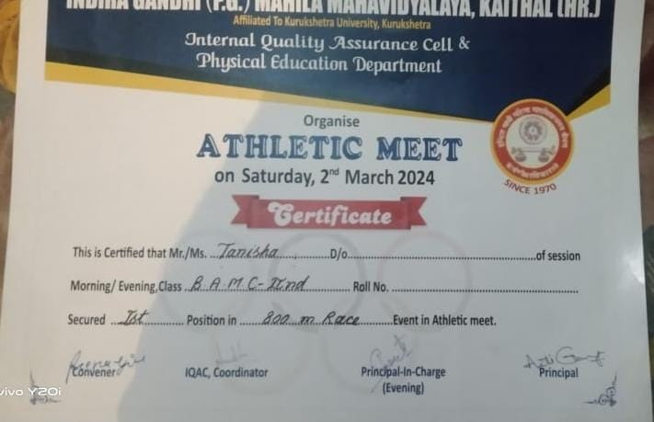
193 | Mass Communication | 54th athlete meat  100 meter race  (21.03.2024) | Physical health and education department  Venue = Indira Gandhi (PG ) MahilaMahavidyalay Kaithal | 100 meter race | 01 | Social Values | 3rd position  Mukesh  BAMC II  1211963 009047 | 
194 | Mass Communication | 54th athlete meat  4×200 meter relay race  (21.03.2024) | Physical health and education department  Venue = Indira Gandhi (PG ) MahilaMahavidyalay Kaithal | 4×200 meter relay race | 01 | Social Values | 2nd  position  Sneha  BAMC I  123135 1006 | 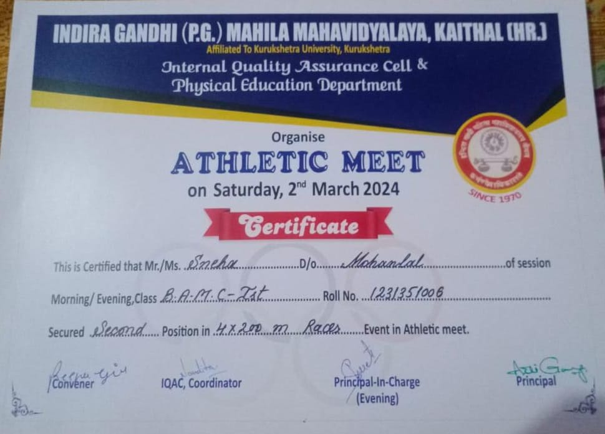
195 | Mass Communication | Slogan writing competition  (20.03.24) | Mass  communication | Digital India | 60 | Social Values | 1st position  Sachleen Preet Kaur  BAMC III  1211963009037  2nd position  Gurpreet  BAMC III  1211963009034  3rd position  Mamta  BAMC II  1231351026 | 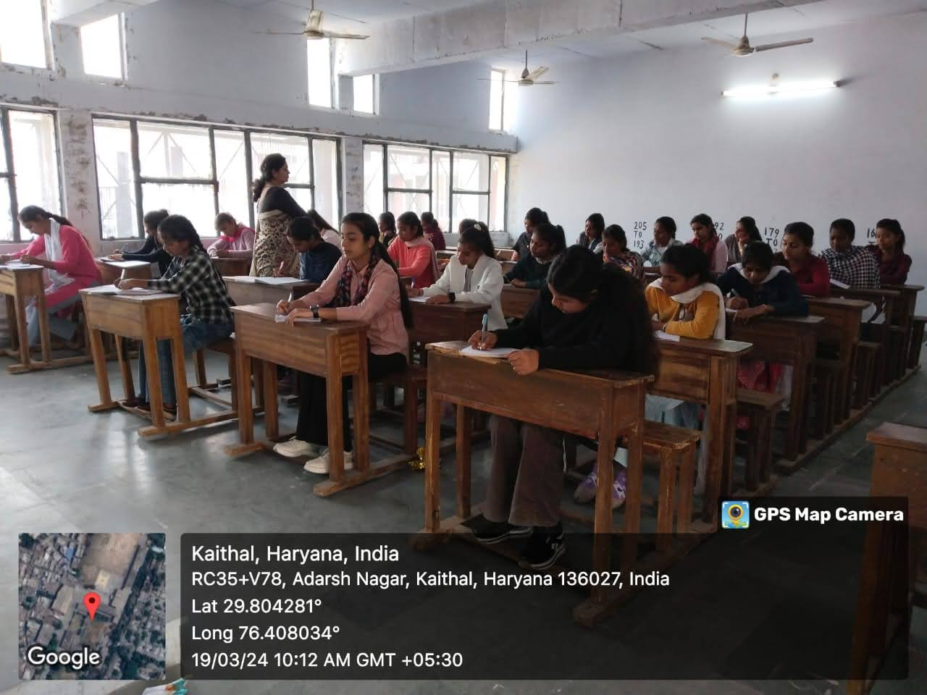
196 | Mass Communication | Photography competition  (27.03.2024) | Indira Gandhi (PG)Mahila Mahavidyalay Kaithal  National level cultural fest 2024 | Emotions | 20 | Social Values | 2nd position  Asha  BAMC III  1211963009038  Participated  Sachleen Preet Kaur  BAMC III  1211963009037
197 | Mass Communication | Reporting competition  (12.04.2024) | Mass Communication | IPL 2024 | 25 | Social Values | 1st position  Ritu  BAMC III  1211963009039  2nd position  Muskan BA public speaking  1231349258  3rd position  Tanisha  BAMC I  1231351009 | 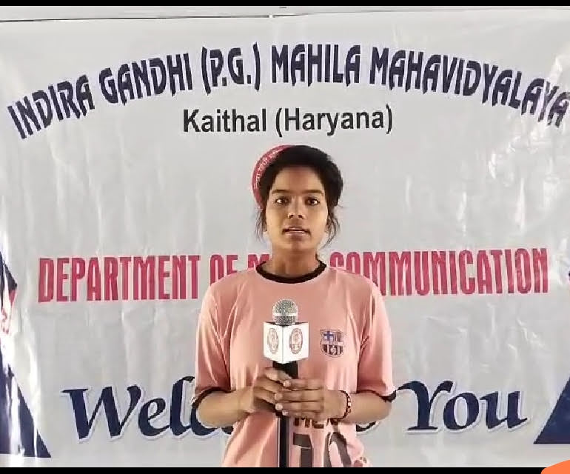
198 | Mass Communication | Radio jockey competition  (18.04.2024) | Mass Communication | Travelogue | 10 | Social Values | 1st position  Sachleen Preet Kaur  BAMC III  1211963009037  2nd position  Saloni  BA 1st( public speaking and anchoring)  1231349243  3rd  position  Ishu  BA 1st( public speaking and anchoring)  1231349243 | 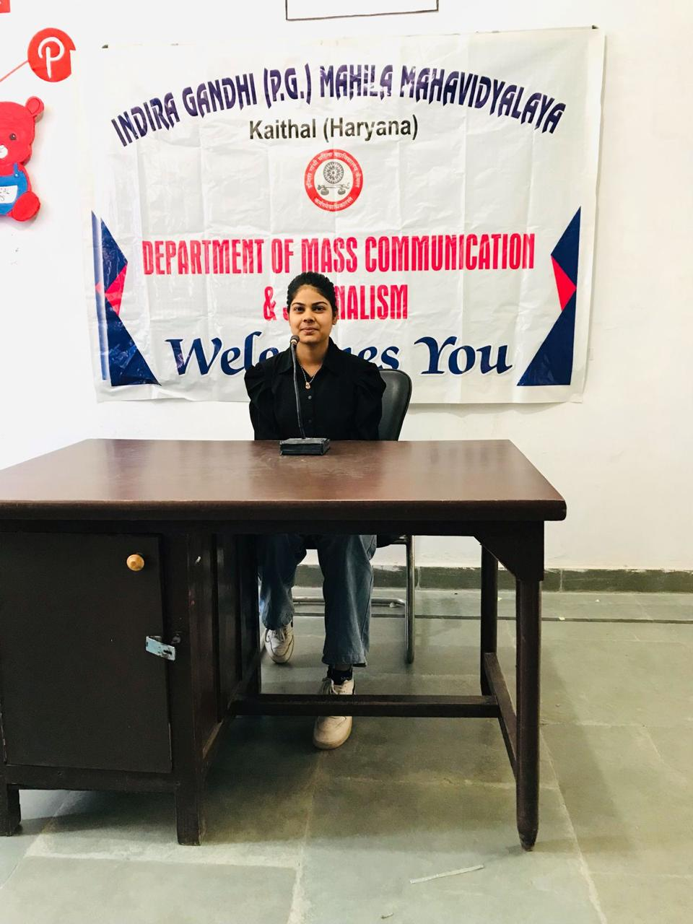

Research work activities of IGMMV faculty members (2023-2024)

Sr.  NO. | Name of the Teacher | Seminar/Conference/FDP/  Orientation Program | Organised by | Date | Participation/Presentation | Topic | Paper Title
1 | Dr. Silender | 07 Days National Workshop  Date -20-03-2024 to 30-03-2024 | Shri Sitaram Vaidic Adarsha Sanskrit Mahavidyalaya Kolkata, West Bangal | Shrimadbhagwatgeetayam Karmyog, Tasya Samajikpakshshach | 01 | Research Awearness | Paper Presentaion
2. | Dr. Arti Goel | One Day(05-03-2024) | Department of Economiscs & Women Cell  Rksd College Kaithal Haryana | Role of Women Empowement in Ecomnomic Development | 01 | Research Awearness | Paper Presentaion
3. | Dr. Arti Goel | One Day(26-12-2023) | Department of higher education, Panchkula Haryana | NIRF regarding | 01 | awareness | partipate
4. | Dr. Arti Goel | One Day(16-01-2024) | Workshop regarding NAAC | IQAC Cell | 1 | Workshop | Participation
5. | Mrs. Manisha | 10 Days Malaviya Mission Teacher Training Programme  Date -08-01-2024 to 17-01-2024 | (MM-TTC) Bhagat Phool Singh Mahila Mahavidyalaya, Sonipat Haryana | NEP 2020 Orientation & Sensitization programme | 01 | Research awareness | Paper Presentaion
6. | Dr. Shweta Gupta | 10 Days Malaviya Mission Teacher Training Programme  Date -(22-01-2024 to 03-02-2024) | (MM-TTC) Bhagat Phool Singh Mahila Mahavidyalaya, Sonipat Haryana | NEP 2020 Orientation & Sensitization programme | 01 | Research awareness | Paper Presentaion
7. | Ms. Ashu | 10 Days Malaviya Mission Teacher Training Programme  Date (06-05-2024 to 18-05-2024) | (MM-TTC) Bhagat Phool Singh Mahila Mahavidyalaya, Sonipat Haryana | NEP 2020 Orientation & Sensitization programme | 01 | Research awareness | Paper Presentaion
8. | Ms. Priyanka Bindlish | 10 Days Malaviya Mission Teacher Training Programme  Date (08-01-2024 to 20-01-2024) | (MM-TTC) Bhagat Phool Singh Mahila Mahavidyalaya, Sonipat Haryana | NEP 2020 Orientation & Sensitization programme | 01 | Research awareness | Paper Presentaion
9. | Ms. Nandita | 10 Days Malaviya Mission Teacher Training Programme  Date (08-01-2024 to 20-01-2024) | (MM-TTC) Bhagat Phool Singh Mahila Mahavidyalaya, Sonipat Haryana | NEP 2020 Orientation & Sensitization programme | 01 | Research awareness | Paper Presentaion
10 | Ms. Chetna Gupta | 10 Days Malaviya Mission Teacher Training Programme  Date (22-01-2024 to 03-02-2024) | (MM-TTC) Bhagat Phool Singh Mahila Mahavidyalaya, Sonipat Haryana | NEP 2020 Orientation & Sensitization programme | 01 | Research awareness | Paper Presentaion
11 | Ms. Monika Garg | 10 Days Malaviya Mission Teacher Training Programme  Date (22-01-2024 to 03-02-2024) | (MM-TTC) Bhagat Phool Singh Mahila Mahavidyalaya, Sonipat Haryana | NEP 2020 Orientation & Sensitization programme | 01 | Research awareness | Paper Presentaion
12. | Ms. Priyanka Sharma | 10 Days Malaviya Mission Teacher Training Programme  Date (08-01-2024 to 20-01-2024) | (MM-TTC) Bhagat Phool Singh Mahila Mahavidyalaya, Sonipat Haryana | NEP 2020 Orientation & Sensitization programme | 01 | Research awareness | Paper Presentaion
13. | Ms. Seema Suneja | 10 Days Malaviya Mission Teacher Training Programme  Date (03-01-2024 to 12-01-2024) | (MM-TTC) Bhagat Phool Singh Mahila Mahavidyalaya, Sonipat Haryana | NEP 2020 Orientation & Sensitization programme | 01 | Research awareness | Paper Presentaion
14. | Ms. Nandini Bagga | 10 Days Malaviya Mission Teacher Training Programme  Date (03-01-2024 to 12-01-2024) | (MM-TTC) Bhagat Phool Singh Mahila Mahavidyalaya, Sonipat Haryana | NEP 2020 Orientation & Sensitization programme | 01 | Research awareness | Paper Presentaion
15. | Dr. Monika Rani | One Day(22-08-2023) | Women Studies Research Center | She Leads A Vision for Future | 01 | Stree Shakti | Online Training Programme

